Quotient Rule Investigation - Week 6

All rational functions could be written as the product of powers, eg:
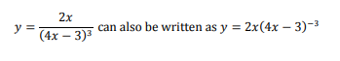
If this is the case, why should we ever use the quotient rule?
Your investigation this week is to demonstrate via 2 examples, one that is easier to differentiate using the product rule (by converting to powers), and one that is easier to differentiate using the quotient rule.
At the end make a general statement about when you should use each rule, (with regards to rational functions).

