Week 5 Investigation:
Use the Chain Rule and your best setting out and working to:

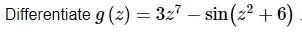

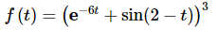
Differentiate

