By the end of this week, you should be able to:

• distinguish between discrete and continuous random variables (CRV)
• understand probability density functions and cumulative distributions for continuous random variables
• compute the central tendency and variability (spread) of continuous distributions
• understand the assumptions on which the normal model is based
• understand the probability limits of almost certainly and very probably,
that is, the three and two sigma limits

Week
Term
2020
9-11
4

SMM4
Continuous Random Variables
Goals

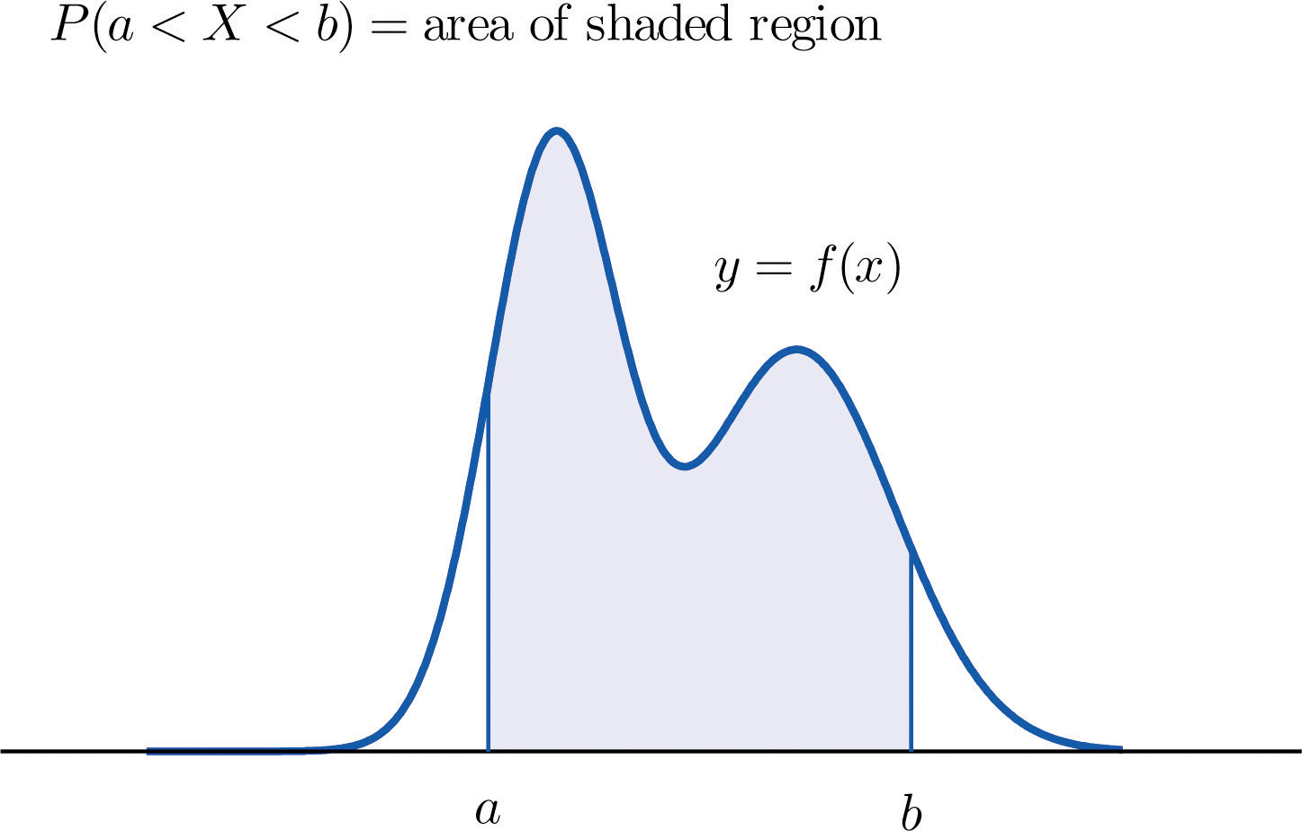

Theoretical Components

Practical Components

Maths Quest 12 Mathematical Methods, Chapter 12

Continuous Random Variables

Exercises 12A to 12D

Normal Distribution

Exercise 12E to 12G

Do as many as you can.

Resources:
- Mathspace.co
- Maths Quest 12 Mathematical Methods, Chapter 12
- Week 9-11 handout on google classroom
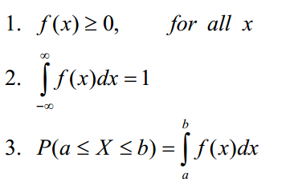

Video Lecture:
https://drive.google.com/file/d/10Dg5uwChqL7aHpOmoDkyTWJW-bCeoNEB/view

https://drive.google.com/file/d/1EOmdhj5X-lme4XoXLdAn4oXOv99JlYWm/view

https://drive.google.com/file/d/1EMKO1vgDuhLsPVJYKBUNtPw-qhZC5CEO/view

https://drive.google.com/file/d/1HC_JPK9fEMSVKJCetp3UOy_uFf9fLN_6/view

Investigation

Week 9 – review and get ready for your exam

Week 11 – see next page

Quiz on mathspace

QFO
Quiz/Forum/Other

Question 1.
A random variable, X, has its frequency curve defined as:
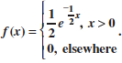
a Draw the graph of f(x).
b Show that f(x) is a probability density function.
c Find the probability, correct to 4 decimal places, that X is:
i smaller than 3
ii greater than 2.5
iii greater than 2.5, given that it is smaller than 3.

Question 2.

The wingspan of birds of a particular species has normal distribution with mean 50 cm and standard deviation 5 cm.

a) Find the probability that a randomly selected bird has a wingspan greater than 60 cm.

b) If the wingspan is measured to the nearest cm, find the probability that a randomly selected bird has a wingspan measured as 50 cm.

