2018 SMM2 Week 11 Investigation
Make sure you use CAS to help you with this investigation.
Part A
Here is a graph of the cubic function $y=x^{3}$.
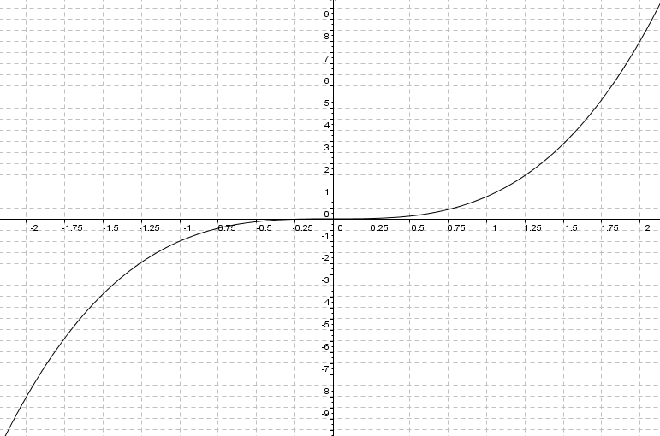
You are to draw (as best as possible by hand), tangents at the positions as indicated in this table, and calculate the gradient of those tangents (remember that gradient of a straight line is rise/run) and fill in the relevant row.
X (coordinate) | -2 | -1 | -0.5 | 0 | 0.5 | 1 | 2
Y (coordinate) | -8 | -1 | -1/8
Gradient of the tangent
(rise/run)
1dp accuracy

The next task is to draw a graph of x versus the gradient value. (on the x-axis use the same x-values, on the y - axis instead of drawing the graph $y=x^{3}$, you are going to draw a graph of the gradient). Plot the points (x, Gradient).
Write a comment: about what you have found.... (what does it look like?, what sort of function, can you find the equation of it?)
Use your own graph paper to do this...or… (https://incompetech.com/graphpaper/quickPicks/A4greySquareMulti.pdf)

PART 2
Now consider a whole new function $y=x^{3}+3$ What does the +3 do to this function?
Will it change the gradient at the points evaluated above? Why/Why not?
Write a statement about curves of the form $y=x^{3}+k$, and what the gradient function would be like. What does the k do? What effect does the k have on the gradient function?
Use a table similar to the one above – and again use your own graph paper to show the solution.

PART 3
Now consider a function of the form $y={2x}^{3}$. What does the "2" in this function "do"?
What do you think it will do to the gradient?
(as you did before, find some points and then find the gradient of the tangents at those points)
What can you deduce about the "2" in relation to the value of the gradient?

