Topic: Functions and Relations

* understand the concepts of relations and functions
* understand the inter-connectivity of the written, graphical and algebraic forms of relations
* develop mathematical models with various functions
* use algebraic methods and graphing software to identify the key features of linear and quadratic functions

This fortnight’s focus:

* Curve recognition, domain and range
* Quadratic functions, their graphs and features
* Quadratic skills (factorising, quadratic formula, completing the square, equations reducible to quadratics)
* Using CAS to sketch functions
* Complete Chapter 2 questions and last week’s brief
* Choose a partner and begin the assignment
* learn to use your ClassPad calculator

**Week**

**Term**

**2020**

13/14

2

Goals

**Learning Brief SMM1: Functions and Graphs**

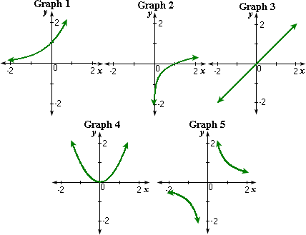

Practical Components

Theoretical Components

Please attempt the following questions from Chapter 2 pdf:  
**2E Solving quadratic equations**   
Q2(a, d, g, h), Q3(a, d, g, j), Qs 8, 10, 12

**2F Solving quadratic equations – completing the square**

Q2 (all), Q8 (all)

**2G Quadratic formula**   
Q1 a, h Q2(all),Qs8,10,13   
**2H Discriminant** Q5(all)   
**2I** Questions 6 and 7   
**2K Using CAS to solve quadratics** 😊  
**2L Simultaneous quadratic and linear equations**   
Qs 1(j, l, n, p), Qs3-5, Qs7-10 

Please try more questions if you need and see Aaron for assistance. A CAS calculator will be a necessity for some of these questions.

You will need to have a good working knowledge of domain and range, functions and relations for the assignment this term. Make sure you have completed all the tasks on [www.mathspace.co](http://www.mathspace.co) to date.

Quadratics:

You need to know about dilation, vertical translation, horizontal translation, vertex, axis of symmetry, reflection, roots, intercepts

Forms: Base form 𝑦 = 𝑥2

General form 𝑦 = 𝑎𝑥2 +𝑏𝑥 +𝑐

Vertex (h,k) form 𝑦 = 𝑎(𝑥 −ℎ)2 + 𝑘

Fully factorised form 𝑦 = (𝑎𝑥 − 𝑚)(𝑓𝑥 −𝑛)

Be able to **sketch** quadratic functions quickly, easily and with accuracy (from the base form, h,k form and fully factorised form)

Find the equation form of a quadratic knowing certain criteria of from a graph.

Turning point or vertex is at

<http://www.mathsisfun.com/algebra/quadratic-equation-real-world.html>

More functions and their graphs:

<http://www.intmath.com/functions-and-graphs/4-graph-of-function.php>

<http://tutorial.math.lamar.edu/Classes/CalcI/CommonGraphs.aspx>

<http://tutorial.math.lamar.edu/Classes/Alg/GraphFunctions.aspx>

Investigation

**Week 13/14**

Complete the mathspace quiz

QFO

Quiz/Forum/Other

[Investigation quiz](https://mathspace.co/student/tasks/TopicCustomTask-326309/)