Algebra

Q1. Simplify, where possible, by collecting like terms.

a) 17x – x b) x² + 10x² c) 2ba + 3ba

d) 9a + 13a – 19a e) 4p²q + 3p²q – 5pq² – p^{q2} f) 4p⁵ + 5p⁴ – p⁵ – 6p⁴

Q2. Expand and simplify where possible.

a) 4(2x + 3y – 1) b) 5 – 4(x – 2) c) 6x –(4 – 4x)

d) 4(x + 3) + 3(x – 1) e) 7(p – 1) – 3(p -2) f) x(x + 6) – 3x(3 – x)

g) a(b + c) – b(c + a) h) 2x(1 – x) + 3(x + 2) i) -4(x + 3) – 5x(x + 1)

Q3. Simplify

a) 4 × 3x b) 3x × 7x c) 3d × (-2d)

d) 7m² × 5n e) pq × pr² f) xyz² × xy²

g) 7x × 4y 5z h) 6mn × (-3mn) × 2m i) 2ab × 3bc × 7ac

Q4. Simplify

a) $\frac{27x^{2}}{3x}$ b) $\frac{a^{2 }b}{a}$ c) $\frac{5p}{10pq}$

Q5. Solve these equations

a) p + 8 = 16 b) y – 4 = 17 c) 11y = 132

d) 10r = -140 e) $\frac{x}{7}$ = 2 f) 3x – 9 = 6

g) 13d + 9 = 126 h) 7m + 8 = 50 i) 8x – 3 = -11

j) 3 – 4x = 15 k) 11 = -4 – 3x l) $\frac{x}{2}$ + 3 = 8

m) 6x + 2 = 2x + 18 n) 5 – 7x = 3x + 7 o) 3(x + 1) – 2(x – 4) = 14

p) 2(x – 1) = 3(x + 5) – 17 q) $\frac{x-1}{2}$ = 8 r) $\frac{1+2x}{7}$ = 7

Q6. For a = -3, b = 3 and c = 2 evaluate

a) a + b + c b) a – b – c c) 3a + 2c

d) $\sqrt{a+4b}$ e) b² + c f) a² - b

Q7.

a) Find v given u = 5, a = 10, t = 7 and v = u + at

b) Find s given that u = -3, t = 5, a = 10 and s = ut + $\frac{1}{2}$at²

c) Find a given that R = 8, d = 24 and a = $\frac{2Rn}{n+1}$

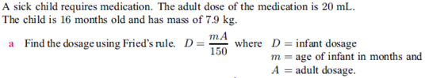
Q8.

Matrices

Q1. For the following matrices;

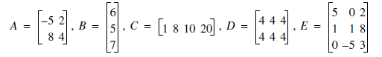
a) Write down the order of each matrix.

b) Write down the value of;
(i) A₂₂ (ii) E₃₂ (iii) E₂₃

c) Write down the result of the folowing operations.

(i) 2A (ii) -3E (iii) E – D

Q2. Solve the following matrix equation.
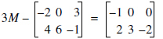
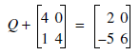
a) b)

Q3. Explain why the following matrix equation has no solution.

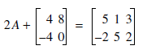

Q4. Write a matrix for the following road map.

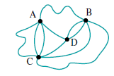

Q5. Two people shared the work of a telephone poll surveying voting intentions. The results of each person’s survey are given in matrix form.

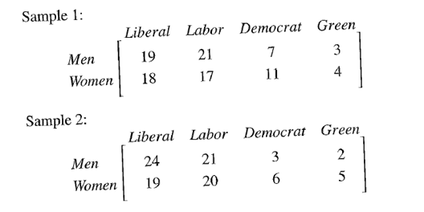
a) Write a matrix showing the overall result of the survey (add the surveys). Call this matrix S.

b) For the summative matrix, what is the meaning of the element;

(i) S₂₂ _{(ii)} S₁₄

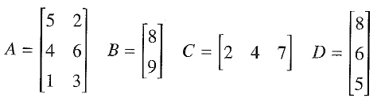
Q6. For the following matrices

(i) decide whether the matrix multiplication in each question is defined

(ii) if matrix multiplication is defined, give the order of the answer matrix

(iii) do the matrix multiplication

a) BA

b) AB

c) AC

Q7. For the following matrices, find the products:

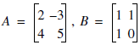

a) AB b) BA

Q8. In AFL football, 6 points are awarded for a goal and 1 point for a behind. The scores in two games were:
Carlton 18 – 12 defeated Essendon 14 – 15 and West Coast 10 – 14 defeated Sydney 9 – 16.
a) Write down the results in a 4 × 2 matrix.

b) Write down the 2 × 1 matrix for the points.

c) Use matrix multiplication to find the total number of points scored by each team.

Area and Volume

Q1. Label the hypotenuse, opposite and adjacent sides in the triangles below.

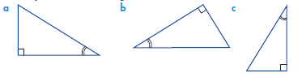

Q2. Write Pythagoras’ theorem for the triangles below.

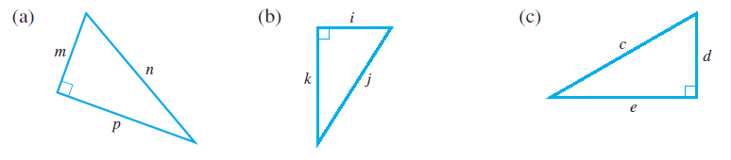

Q3. Determine if these triangles are right angled.

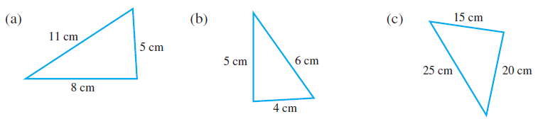

Q4. Find the length of the hypotenuse (to one decimal place).

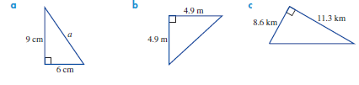

Q5. Find the length of the unknown side (to one decimal place).

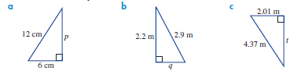

Q6. Find the length of the indicated side.
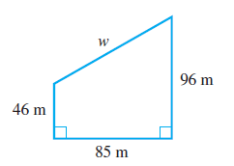

Q7.
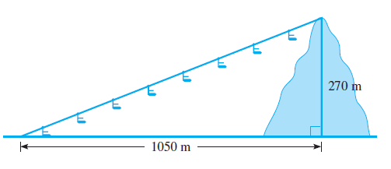
a) A chairlift takes skiers up to the top of a hill
270 m high and 1050 m away. How long is its
Cable?

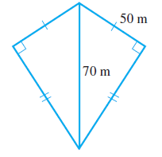
b) Calculate the perimeter of this figure.

c) A television antenna is 12 m high. To support it, wires are attached to the ground 5 m
from the foot of the antenna. Find the length of each wire.

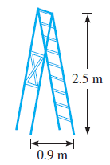
d) When opened out, the top of a stepladder is 2.5 m above the
ground and its feet are 0.9 m apart. How long is the
stepladder (correct to 2 decimal places)?

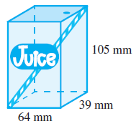
e) A small fruit-juice Tetrapak has dimensions
64 mm × 39 mm × 105 mm. Show that the length
of the longest straw that can fit into the pack is
approximately 129 mm.

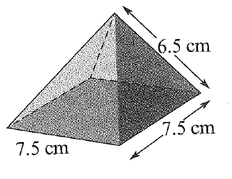
f) In the pyramid shown, find the length of the diagonal
on the base and use this to find the height of the
pyramid.

Q8. Complete the following.

a) 70 mm = cm b) 5000 m = km c) 9 cm = mm

d) 9.2 km = m e) 11.25 m = cm f) 86 mm = cm

Q9. Calculate the perimeter of the following shapes.
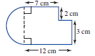
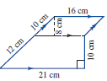
a) b)

Q10. Complete the following.

a) 5 m² = cm² b) 6800 cm² = m² c) 2495 mm² = cm²

d) 6 km² = ha e) 320 ha = m² f) 2500 cm² = mm²

Q11. Find the area of the following shapes.

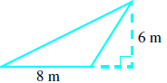
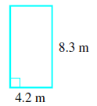
a) b)

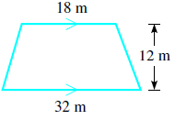
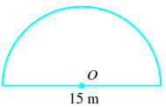
c) d)

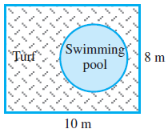
Q12.
a) A circular swimming pool with diameter 5 m is to be
placed in a rectangular yard, and the rest of the yard
is to be covered with new turf. How much will it cost
to turf the yard if 1 m2 costs $3.50?

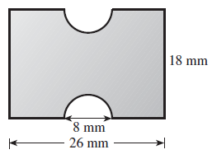
b) Two semicircles are cut from a sheet of tin as shown.
What area of tin remains (to the nearest mm2)?

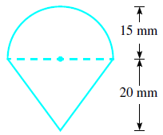
c) Find the area of this shape.

Q13. Calculate the total surface area of the following shapes.
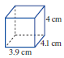
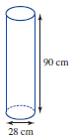
a) b)

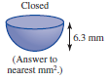
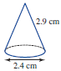
c) d)

Q14. Complete the following.

a) 7 m³ = cm³ b) 240 cm³ = mm³

c) 8500 cm³ = m³ d) 4 500 000 mm³ = m³

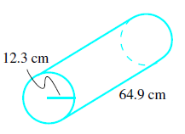
Q15. Calculate the following volumes.
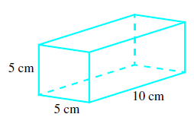
a) b)

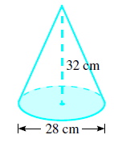
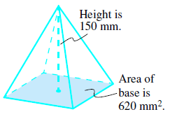
c) d)

Q16

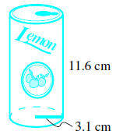
a)
(i) What is the volume of this soft drink can?

(ii) What is its capacity?

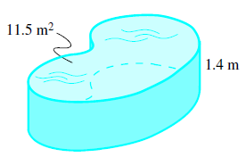
b) A kidney-shaped swimming pool has a cross-section
of 11.5 m2 and a constant depth of 1.4 m. How many
kilolitres of water does the pool hold?

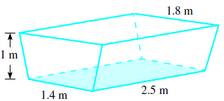
c) A rubbish skip in the shape of a trapezoidal
prism is delivered to a building site. What
volume of rubbish will it hold?

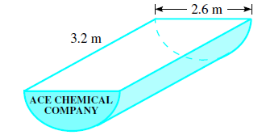
d) A semicircular chemical vat is filled to capacity.
How many litres of acid will it contain?

