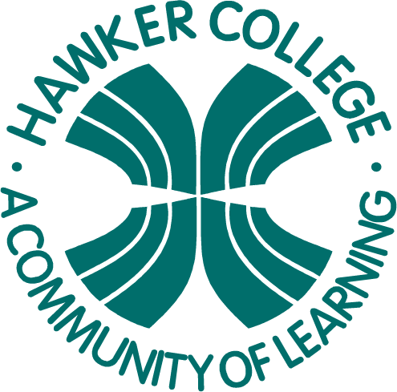

**MA1**

Consumer Arithmetic, Algebra & Matrices, Shape & Measurement

Goals

Learning Brief

**Week**

**Term**

**2020**

16

2

Unit goals

* Understand the concepts and techniques introduced in consumer arithmetic, algebra and matrices, and shape and measurement.
* Apply reasoning skills and solve practical problems .

This week:

* Nets of 3-dimensional shapes
* Surface area
* Volume
* Capacity

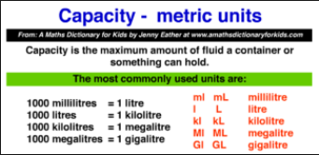

Theoretical Components

Practical Components

There are questions to be answered in the booklet *Week 16 Notes & Exercises*

**Resources**:

For this week the theory work is in the *PDF file:*

Week *16* Notes & Exercises

**Knowledge Checklist**

* Names of 3dimensional shapes
* Nets
* Total surface area
* Units of volume
* Converting between units
* Volume of pyramids, cylinders, cones, spheres
* Units of capacity
* Interchanging units of volume and capacity

**Order**

1. Complete the questions in the *Booklet*
2. Upload your completed booklet for marking.

Investigation

On HawkerMaths and attached to the booklet

On Mathspace

On-line Quiz