Three-dimensional objects

Prisms

Prisms are 3-D figures that have a constant cross-section in one direction. This constant cross-section is parallel to the face which is called the base of the prism. The name of the prism comes from the shape of its base.
Common examples of prisms are:

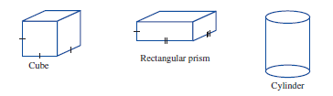
Non-prisms

Non-prisms do not have a constant cross-section in any direction. The two types of 3-D object that we will study in this category are pyramids and spheres.

Pyramids

In pyramids, the cross-section parallel to the base reduces in size as the cross-section progresses from the base to the apex.
Common examples of pyramids are:

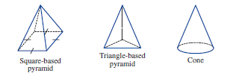

Spheres

A sphere has no flat faces. When spheres are sliced, the flat surface exposed is always circular.
Common examples are:

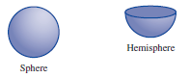

Two properties which three-dimensional figures possess are surface area and volume.

Surface area

The surface area of a 3-D object represents the total area of all its exposed faces. To find the surface area, we must calculate the area of each face of the object, as identified by its net, then add all these areas to find the total.
The units used for total surface area (TSA) are the same as those used for area.

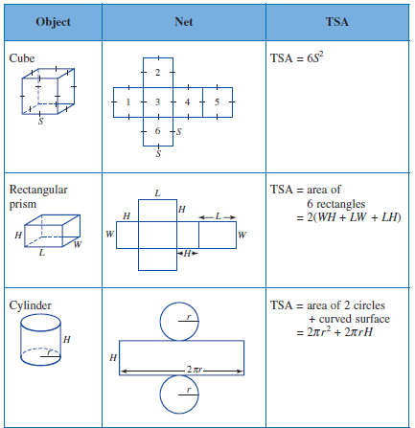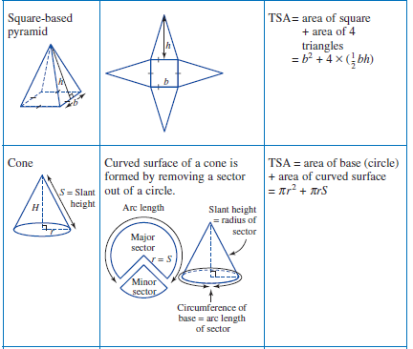
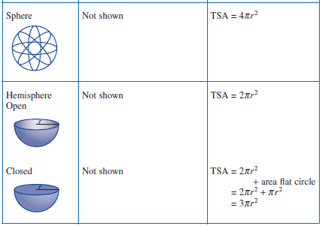

Examples
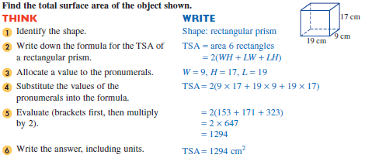
1.

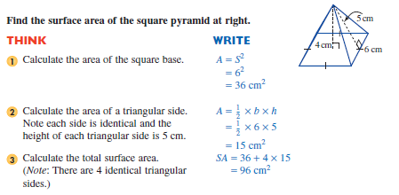

2.

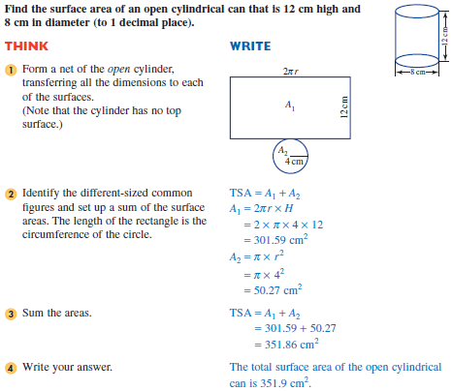
3.

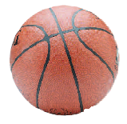
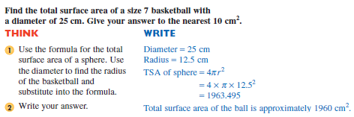
4.

Exercise Set 1

Q1. Name each solid in the top row then match it with a net in the bottom row.

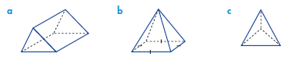

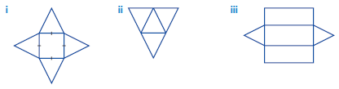

Q2. Draw the net of each of the following solids.

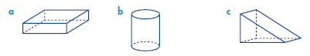

Q3. Find the total surface area of each of the figures below.
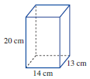
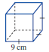
a) b)

Q4.
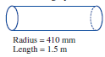
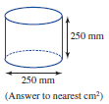
a) b)

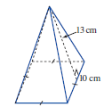
Q5. Calculate the surface area of
the square pyramid.

Q6. Calculate the surface area of the cone and sphere.
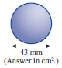
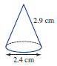
a) b)

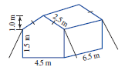
Q7. What is the total area of canvas needed for the tent
(including the base) shown in the diagram at right?
Give the answer to the nearest m²

Volume

The volume of a 3-D object represents the amount of space contained in, or occupied by, the object. The units used to measure volume are those of cubic measure: mm³, cm³, m³.
Constructing our conversion ladder will enable us to convert from one unit to another.

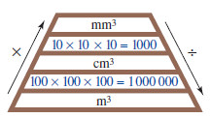

Example

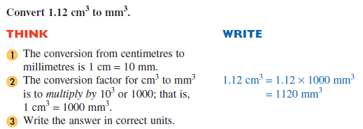

Volume of prisms

The volume of a prism is given by the following formula:
Volume of a prism = cross-sectional area × height of the prism
The height is the dimension perpendicular to the cross-sectional area.

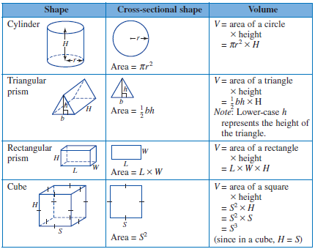
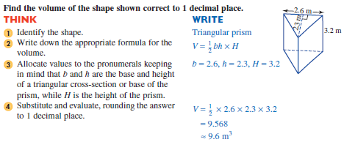
Example

Volume of pyramids

As we have seen previously, a pyramid has a flat base at one end, and tapers to a point at the other. Some examples of pyramids are shown below. A cone is really a circle based pyramid.

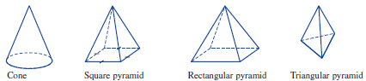

A pyramid does not have a uniform cross-section. The cross-sectional area becomes smaller as it nears the apex (point). The internal capacity or volume of a tapered object is a fraction of the volume of a prism. Mathematicians found this fraction to be a third ($\frac{1}{3}).$ They defined the base of a pyramid to be the flat end opposite the apex. To calculate the volume of a pyramid we find the area of the flat end, multiply this by the height of the pyramid (which must be perpendicular to the base) and then multiply by ($\frac{1}{3})$ or divide by 3.

Volume of a pyramid = $\frac{1}{3}$ × area of base × height of object

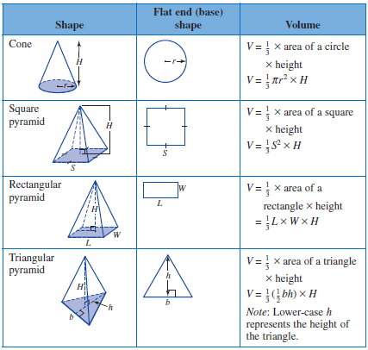

Example
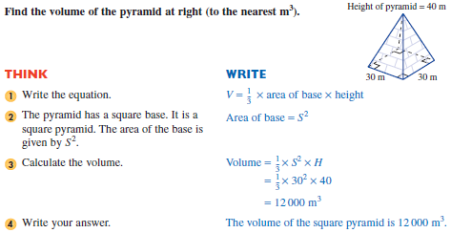
1.

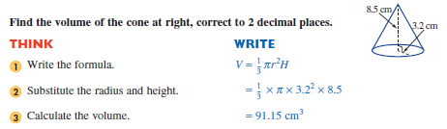
2.

Volume of spheres

The volume of a sphere of radius r is given by the following formula:

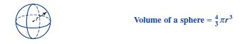

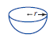

A hemisphere is half of a sphere. Its volume, therefore, is half of the volume of a sphere.

Exercise Set 2

Q1. Convert the volumes to the units specified.

a) 4800 cm³ to m³ b) 23 cm³ to mm³

c) 0.000 57 m³ to cm³ d) 250 000 mm³ to cm³

Q2. Calculate the volume of the shapes shown.
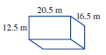
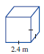
a) b)

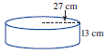
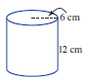
c) d)

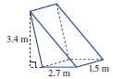
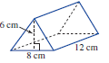
e) f)

Q3. For each of the following pyramids, calculate the volume by first calculating the area of the base shape.

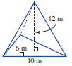
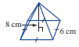
a) b)

Q4. Find the volume of the following cone and sphere.
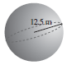
a) b)

d = 30 cm, h = 60 cm

Q5. Find the total volume of the six ice-creams.

Cone height = 6 cm
Diameter = 6 cm

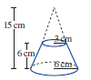
Q6. Find the volume of this truncated cone.

Q7. At right is a diagram of a concrete slab for a house.
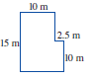
a) Calculate the area of the slab.

b) The slab is to be 10 cm thick. Calculate the volume of concrete needed for the slab.
(Hint: Write 10 cm as 0.1 m.)

c) Concrete costs $145.50/m3 to lay. Calculate the cost of this slab.

Capacity

The capacity of a 3-D object refers to the quantity of solid, liquid or gas it could hold. The units used to measure capacity are millilitres (mL), litres (L) and kilolitres (kL). The conversion ladder for capacity units is as follows:

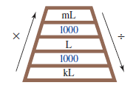

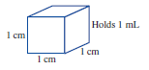
In capacity units, 1 mL represents the amount
of liquid which a 1 cm cube could hold. Two useful
conversion relationships are:

1 cm³ 1 mL and for larger units 1 m³ 1 kL

Example

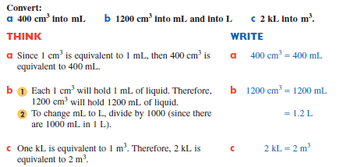

Exercise Set 3

Q1. Convert the following units as indicated.

a) 750 cm³ = mL b) 800 cm³ = L

c) 40 000 cm³ = L d) 4.2 m³ = kL

e) 6 m³ = cm³ = mL = L

f) 20L = mL = cm³

Q2. Calculate the volume and capacity of the prisms shown.
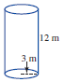
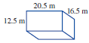
a) b)

Q3. A refrigerator is in the shape of a rectangular prism. The internal dimensions of the
prism are 60 cm by 60 cm by 140 cm.
a) Find the volume of the refrigerator in cm³.

b) The capacity of a refrigerator is measured in litres. If 1 cm³ = 1 mL, find the capacity of the refrigerator in litres.

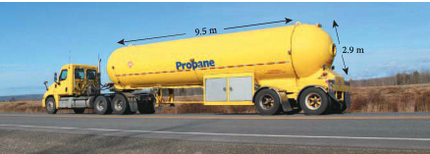
Q5. The tank on this truck consists of two hemispheres and a cylinder. The diameter is 2.9 m and the length of the cylinder is 9.5 m. Calculate the volume of the tank in kilolitres.

