MA1
Consumer Arithmetic, Algebra & Matrices, Shape & Measurement

Goals

Learning Brief
Week
Term
2020
15
2
Unit goals
- Understand the concepts and techniques introduced in consumer arithmetic, algebra and matrices, and shape and measurement.
- Apply reasoning skills and solve practical problems.
This week:
- The Metric system
- Converting units
- Perimeter (of composite shapes)
- Area (of composite shapes)

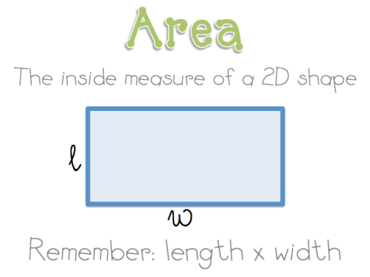
Theoretical Components

Practical Components

There are questions to be answered in the booklet Week 15 Notes & Exercises

Order of Work to complete
- Complete the questions in Google Classroom
- Mathspace task
- Upload your completed booklets for marking.

Resources:
For this week the theory work is in the GC file:
Week 15 Notes & Exercises

Reference sheet
Hawkermaths.com
https://www.hawkermaths.com/uploads/1/1/7/0/11707964/4._geometry_shapes_and_solids.pdf

Dotty paper for investigation:
https://nrich.maths.org/content/id/8506/10mmDots%20square.pdf

Knowledge Checklist
- Common units in the metric system
- Perimeter
- Composite
- Area
- Names of shapes

Investigation

See below

On Mathspace
On-line Quiz

Week 15 Investigation
To work on this problem you may want to print out some dotty paper (Link for you!)
When the dots on square dotty paper are joined by straight lines the enclosed figures have dots on their perimeter (p) and often internal (i) ones as well.
Figures can be described in this way: (p,i).
For example, the red square has a (p,i) of (4,0), the grey triangle (3,1), the green triangle (5,0) and the blue hexagon (6,4):

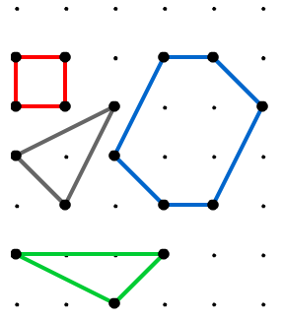
Each figure you produce will always enclose an area (A) of the square dotty paper.
The examples in the diagram have areas of 1, 1.5, and 6 square units.
Check that you agree.
Draw more figures in the table below and keep a record of their perimeter points (p), interior points (i) and areas (A).
Can you find a relationship between these three variables?
Shape | Points (p) | Interior points (i) | Area (A)
Red

Brown | 3 | 1 | 1 ½
Blue

Green

