The Metric System
In the late 18th century the French Academy of Sciences developed a standardised measurement system to replace the wide range of complicated, different and unrelated measurements that existed at the time. This new system was based on standard units and powers of 10. This is the metric system.
In the metric system, the metre is the basic unit for measuring length. Originally one metre was defined as to be one ten-millionth of the distance from the equator to the North Pole at sea level. All other length measurements are based on the length of 1 metre.
Everything in maths that relates to the ‘real world’ has units. If there is a point to it there are units attached to it. Sometimes the units could be people, buildings, cars, food, shapes…. Basically units relate to the WHAT in mathematics, and you should ALWAYS use them. This helps to convey a clear message to the reader about WHAT you are talking about.
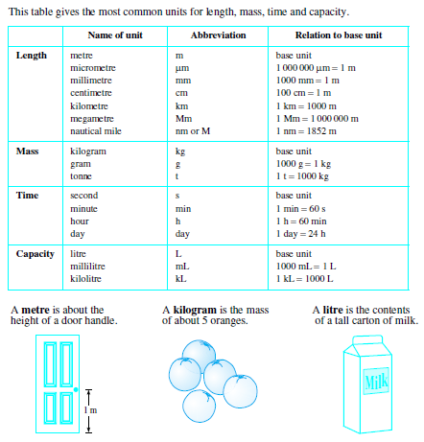
Common Length Measurements
Distances are usually measured in one of the following units
Millimetres (mm) Centimetres (cm) Metres (m) Kilometres (km)
You would be used to most of these through previous experiences in measuring heights, lengths, drawing with your rulers, measuring objects or distances between places.
1cm = 10mm
1 m = 100cm = 1000mm
1km = 1000m = 100 000cm = 1 000 000mm

To move from larger length units to smaller length units multiply by the appropriate number for each step eg (10, 100, 1000)
To move from smaller length units to larger length units divide by the appropriate number for each step eg (10, 100, 1000)
Example
1. Change 6.4km into cm.
I suggest moving through each step.
Km m cm
6.4 6.4 x 1000 m
6400m 6400 x 100cm
640 000cm
2. Convert 148900mm into m
148900 ÷ 10 (into cm) ÷ 100 (into m) = 148.9m

Exercise Set 1
Q1.
- 48mm = ____________
= ____________ cm
- 41.5cm = ____________
= ____________ mm
- 74mm = ____________
= ____________ cm
- 64.8cm = ____________
= ____________ mm
- 505cm = ____________
= ____________m

f) 7557m = ____________
= ____________ km
g) 2.843km = ____________
= ____________m

Perimeter
The perimeter represents the distance around the boundary of a figure. (We are assuming that all the figures we are dealing with are closed; that is, they begin and end at the same point.) Any line inside the boundary is ignored when calculating the perimeter. The units used to measure perimeter are those of linear measure: millimetre (mm), centimetre (cm), metre (m) and kilometre (km).

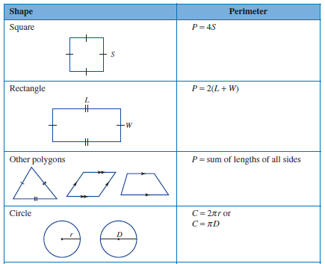

Perimeter of Composite Shapes

In many instances, figures are not of one distinct shape; they may be composed of several shapes.
The perimeter of such shapes is still the distance around the boundary of the composite figure.
Remember to ignore any lines inside the figure.
It is often helpful to start at one point in the figure, work your way around the boundary in a clockwise or anticlockwise direction, identifying shapes and adding the lengths of all sides, until you reach your starting point.

Example

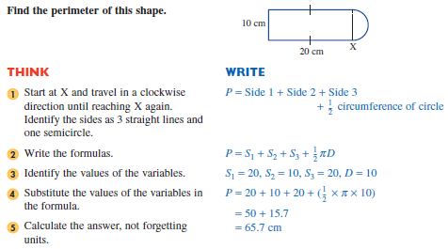

Exercise Set 2

Q1. Find the perimeters of the following figures (to the nearest whole units).
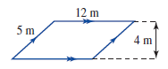
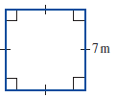
a) b)

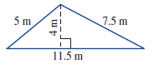
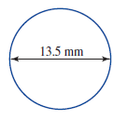
c) d)

Q2. Find the perimeter of these composite shapes.
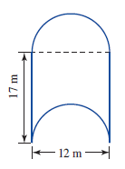
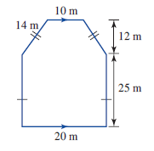
a) b)

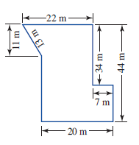
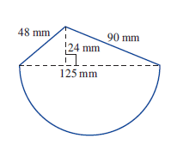
c) d)

Area

Area represents the amount of space within the boundary of a closed figure. The units used to measure area are those of square measure: mm², cm², m² and km². There are two units of area which are not square units — the hectare (ha) in the metric system and the acre in the imperial system.

To obtain the conversion factors for square measures,
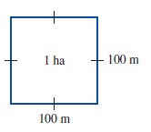
it is necessary to square the linear measure conversion
factors. As previously, we multiply when converting to
a smaller unit and divide when converting to a larger unit.

One hectare is equivalent to the area of a square of side
length 100 metres.
So 1 ha = 100 m × 100 m
That is 1 ha = 10 000 m²

Example

a) Change 250 mm² to cm² b) Change 5 km² to m²
Small to large, so divide Large to small, so multiply
250 ÷ (100 100) 5× (1000 × 1000)
250 ÷ 10000 = 2.5 m² 5 × 1000000 = 5 000 000 m²
Which also equals 5 000 000 ÷ 10 000 = 500 ha

We’ll now review familiar formulas used to find the areas of common shapes.

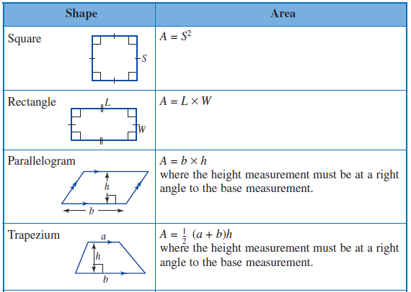
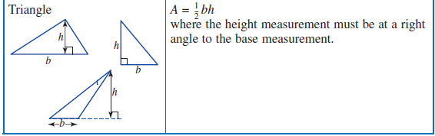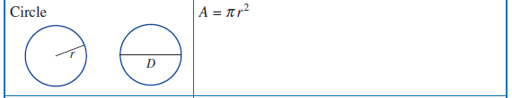

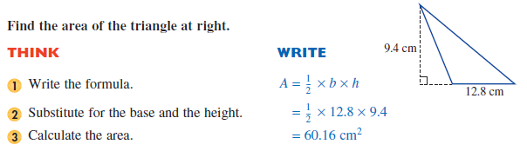
Examples

1.

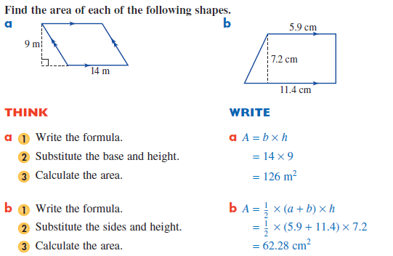
2.

Areas of Composite Shapes

The term composite means made up of distinct parts. Composite figures in geometry are figures comprising a number of distinct shapes. Depending upon the composite figure, to find the overall area you may need to add these individual shapes or subtract one from another.
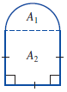
For example, the composite figure in the diagram at right has been formed using a semicircle and a square.

The area of this shape can be found as follows:
Area of total figure = Area of a semicircle (A1) + Area of a square (A2)

When finding the area of a composite figure, follow the steps given below.
1. Identify the basic shapes that make up the total figure and number them.
2. Write the expression for the total area in terms of individual shapes.
3. Calculate the area of each individual shape.
4. Add or subtract areas to find the total area of the given shape.

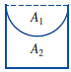
In the diagram above, we added the areas of the square and the semicircle.
If the diagram had been shown as at right, we would have subtracted the
area of the semicircle from that of the square.

Exercise Set 3

Q1. Convert

a) 70 mm² to cm² b) 3 m² to cm²

c) 2.5 km² to m² d) 6000 cm² to m²

Q2. Find the area of each of the figures below.

a) b)
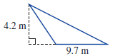
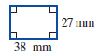

c) d)
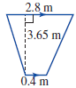
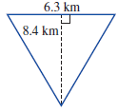

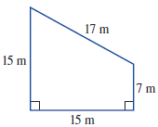
Q3. Find the area of this shape.

Q4. Find the shaded area in each of the following.

a) b)
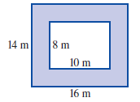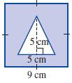

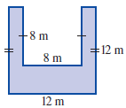
c) d)
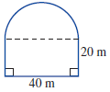

Q7. A rectangular garden in a park is 15 m long and 12 m wide. A concrete path 1.5 m wide is to be laid around the garden.
a) Draw a diagram of the garden and the path.
b) Find the area of the garden.
c) What are the dimensions of the rectangle formed by the path?
d) Find the area of concrete needed for the path.

