A right-angled triangle is a triangle with one angle of 90° ie a right angle.
In a right-angled triangle, the side opposite the right angle is called the hypotenuse.
The other two sides are named in relation to the angle in question, x° (other letters can be used).
The side furthest away from the angle is called the opposite side. The remaining side, which is next to the angle, is called the adjacent side.
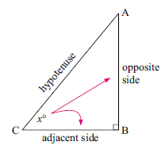
Exercise Set 1.
Q1. Label the sides of the following triangles (hypotenuse, opposite, adjacent).
a) b) c)
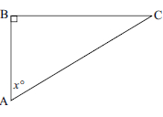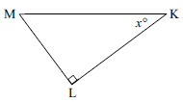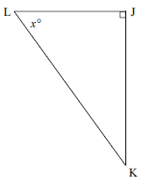

Pythagoras was a famous Greek mathematician and mystic but is now best known for his theorem about the sides of a triangle. He was born on Samos Island. It is believed that he was born about 580 BC and died about 500 BC.

When Pythagoras was a young man, he travelled to Egypt and Babylonia (Mesopotamia) where he learned much of his mathematics and developed an interest in investigating it further.

He founded a cult with the idea that ‘the essence of all things is a number’. This group believed that all nature could be expressed in terms of numbers.

He is credited with the discovery now known as ‘Pythagoras’ theorem’ which states that in a right-angled triangle, the sum of the squares of the the two shorter sides is equal to the square of the hypotenuse.
Remember: A right-angle is an angle of 90°. The hypotenuse is the side opposite the right-angle and is always the longest side.
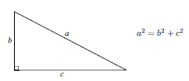
Thus, if we know the lengths of two sides we can calculate the length of the third side. We can also determine if a triangle is a right-angled triangle.
(i) Determine if the following triangle is right-angled and if so sketch and mark the right angle.
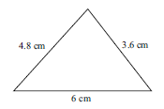
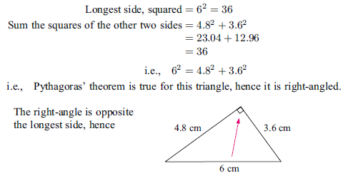

Exercise Set 2
Q1. Determine which of these triangles are right-angled and if so mark the angle accordingly.
a) b) c)
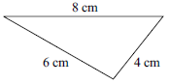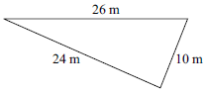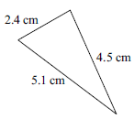

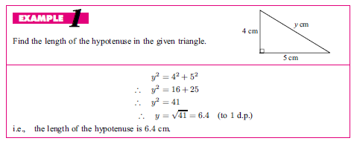

Q2. Find the length of the hypotenuse, correct to one decimal place.
a) b) c)
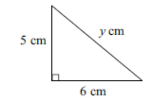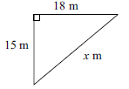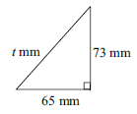

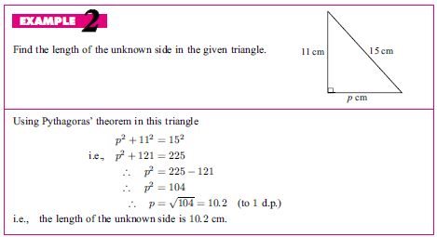

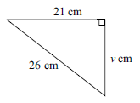
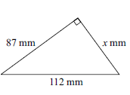
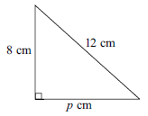
Q3. Find the length of the unknown side.
a) b) c)

Q4. Find the value of the pronumeral in each of these figures, use 2 decimal places.
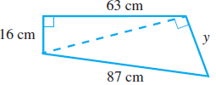
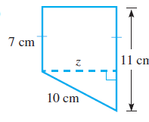
a) b)

Pythagorean triads (or Pythagorean triples) are sets of 3 numbers which satisfy Pythagoras’ theorem.

A right-angled triangle with side lengths of 3 cm, 4 cm and 5 cm satisfies Pythagoras’ theorem, so the numbers 3, 4 and 5 form a Pythagorean triad or triple.

In fact, any multiple of these numbers, for example 6, 8 and 10, forms a Pythagorean triad.

Some other triads are: 5, 12, 13 and 8, 15, 17 and 9, 40, 41 as the first two numbers squared and added equals the third number squared.

Q5. Which of the following are Pythagorean triads.

a) 9, 12, 15 b) 4, 5, 6 c) 30, 40, 50

d) 14, 20, 30 e) 10, 24, 26 f) 12, 16, 20

Q6. Complete the following triads. Assume the numbers are in ascending order.

a) 9, _____, 15 b ____, 24, 25 c) 11, 60, ____

Using Pythagoras

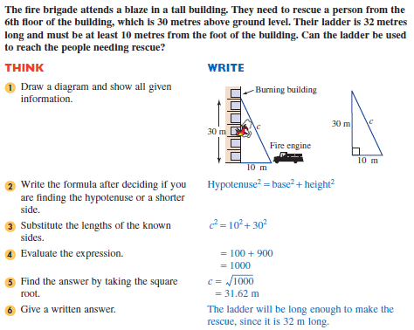

Exercise Set 3

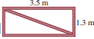
Q1. A rectangular gate is 3.5 m long and 1.3 m wide. The gate
is to be strengthened by a diagonal brace as shown at right.
How long should the brace be (correct to 2 decimal places)?

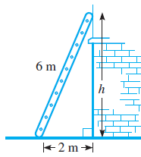
Q2. A 6 m ladder leans against a house so that its base is 2 m
out from the bottom of the house. How far up the house
does the ladder reach (to the nearest centimetre)?

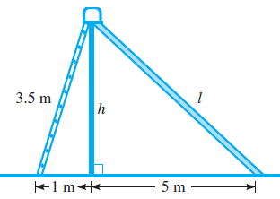
Q3. A playground slide is made up of two right
triangles. Find, correct to the nearest centimetre:
(a) h, the height of the slide
(b) l, the length of the slide

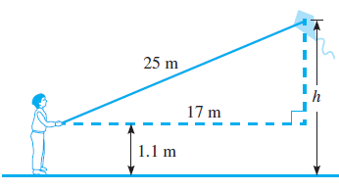
Q4. This diagram shows a boy flying a kite.
How high is the kite above the ground
(correct to 1 decimal place)?

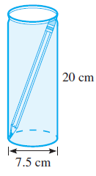
Q5. Jackie wants to use an old tennis-ball can as a pencil case. If
this can has a diameter of 7.5 cm and a height of 20 cm, what
is the length of the longest pencil that will fit inside the can
(to the nearest millimetre)?

Pythagoras in Three Dimensions

We can extend the application of Pythagoras’ Theorem into 3 dimensions. These questions always involve at least two steps.

Example 1

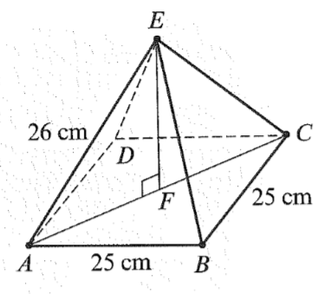
Find the height EF of the square pyramid shown.

This needs to be done using two steps.

First, find the length of the diagonal AC. To do
This use triangle ABC.

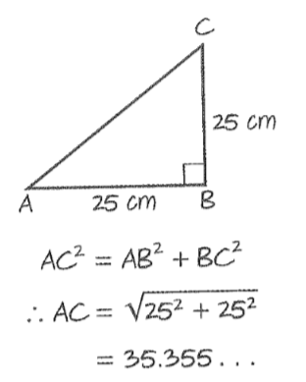
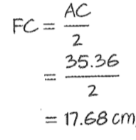
Then use triangle EFC to find the height. To find length FC the length AC is halved.
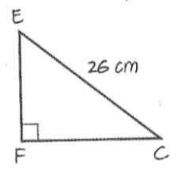
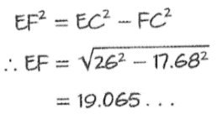
Use Pythagoras’
theorem

The height EF is 19.1m.

Example 2

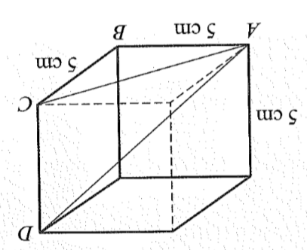
The cube on the right has sides of length 5cm.

Find the length:

- AC
- AD

To find AC use triangle ABC.

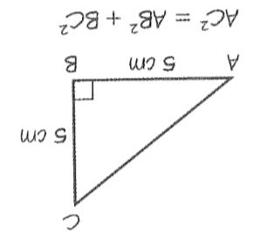
Using Pythagoras’ theorem

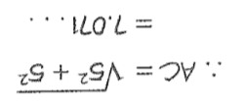

The length AC is 7.1cm

To find AD use triangle ACD.
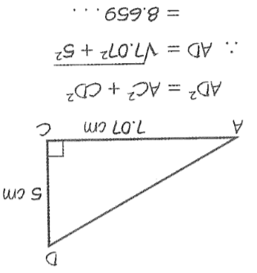

The length of AD is 8.7cm

AD is the ‘longest’ diagonal in the cube. An interpretation could be….the longest rod that would fit in the box
is 8.7cm long.

Exercise Set 4.

Q1. Calculate the height of this cone.
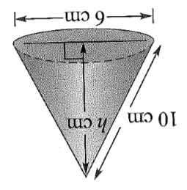

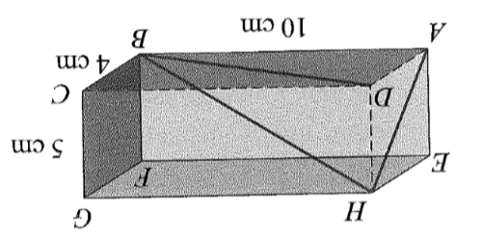
Q2. For this cuboid, calculate the lengths:

- DB
- BH
- AH

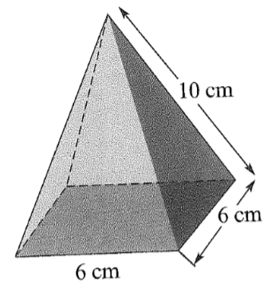
Q3. For the square-based pyramid shown, find:

- The length of the diagonal of the base.
- The height of the pyramid.

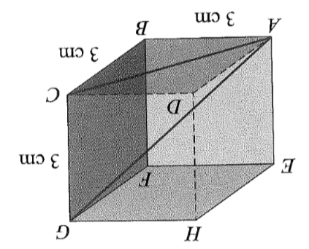
Q4. For the cube shown, find:

- AC
- AG

Q5. Chris wants to use a rectangular pencil box. What is the length of the longest pencil that would fit inside the
box shown?
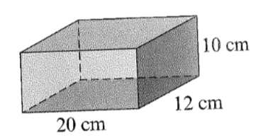

Q6. In a primate enclosure at the zoo, a rope is to be attached from the bottom corner of the enclosure to the opposite top corner for the monkeys to swing and climb on. If the enclosure measures 8m by 10m by 12m, what is the length of the rope. Make sure you draw a diagram.

