MA1 Week 14 Investigation
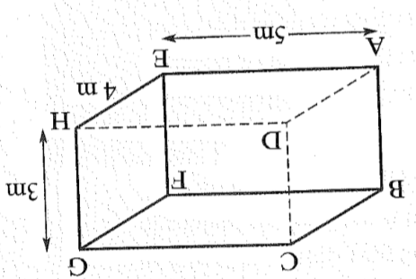
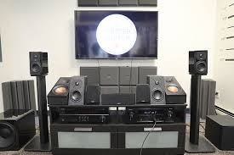

A new home entertainment system needs to set in a room with dimensions 4m × 5m × 3m as shown in the diagram.
Expensive cabling is used to wire the room from corner A to corner G.

- What is the length of cabling required to
go from A from A to E to H to G?

- What length of cabling is required to go
from A from A to F to G?

- What length of cabling is required to go
from A to E to G?

- If cabling costs $25.50 per metre, which is the cheaper option?

