ESSENTIAL Mathematics 3

Week 16 and 17 NOTES and exercises

Linear Modelling (continued)
Exercise 1
Q1. Sam is collecting data on the growth of her plants. The table shows the data she has collected so far
Day (d) | 2 | 4 | 6 | 8 | 10
Height of plant (h cm) | 5 | 7 | 9 | 11 | 13

- Draw this linear function on the graph below
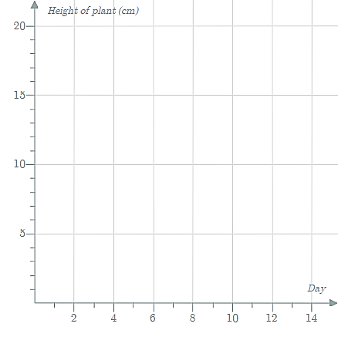
- Write an equation that represents the height of the plant, h cm.

- How tall is the plant when Sam started to collect data?

- On which day will the plant be 10 cm tall?

Q2. The graph shows the relationship between water temperatures and surface air temperatures.
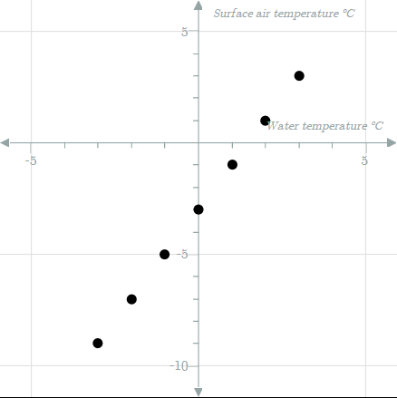
- Complete the table of values
Water temperature (ºC) | -3 | -2 | -1 | 0 | 1 | 2 | 3
Surface air temperature (ºC)

- Which of the following equations accurately represents the surface air temperature, ºC.
i) $y = x-3$ ii) $y = x-2$

iii) $y = 2x-3$ iv) $y = 3x-3$

- What is the surface air temperature when the water temperature is 15ºC?

- What is the water temperature when the surface air temperature is 25ºC?

Q3. The table shows a diver’s descent below the surface at a constant rate over a period of 5 minutes.
Number of minutes passed (x) | 0 | 1 | 2 | 3 | 4
Depth of the diver in metres (y) | 0 | 1.5 | 3 | 4.5 | 6

- Write an equation representing the depth of the diver in metres.

- What is the depth of the diver after 8 minutes?

- How long will it take the diver to reach a depth of 13.5?

- Draw this linear function on a graph.
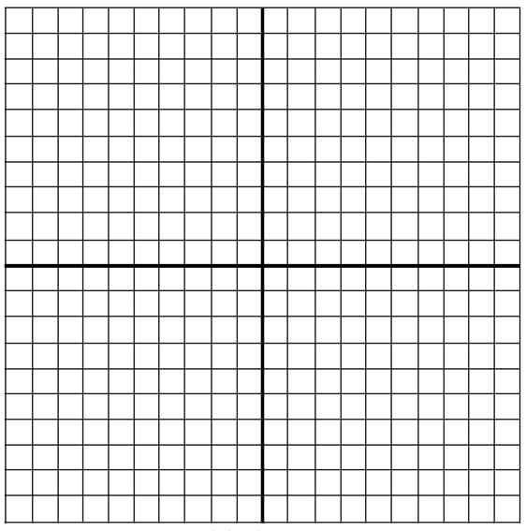
2020 EM3 Week 16 Investigation
Question 1
Petrol costs a certain amount per litre. The table shows the cost of various amounts of petrol.
Number of litres (x) | 0 | 10 | 20 | 30 | 40
Cost of petrol (y) | 0 | 16.40 | 32.80 | 49.20 | 65.60

- Write an equation linking the number of litres of petrol pumped (x) and the cost of the petrol (y)

- How much does petrol cost per litre?

- How much would 47 litres of petrol cost at this unit price?

- In the equation, y = 1.64 x, what does 1.64 represent?

Question 2
There are 20 litres of water in a rainwater tank. It rains for a period of 24 hours and during this time, the tank fills up at a rate of 8 litres per hour.
- Complete the table of values:
Number of hours passed (x) | 0 | 1 | 2 | 3 | 4 | 4.5 | 10
Amount of water in tank (y)

- Write an algebraic relationship linking the number of hours passed (x) and the amount of water in the tank (y).

- Plot the points on the number plane.

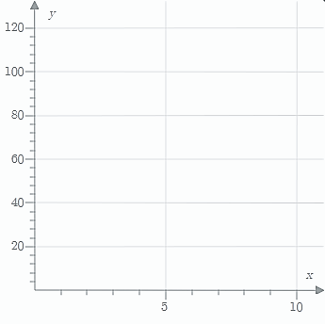

Scatterplots
The manager of a small ski resort has a problem. He wishes to be able to predict the number of skiers using his resort each weekend in advance so that he can organise additional resort staffing and catering if needed. He knows that good deep snow will attract skiers in big numbers but scant covering is unlikely to attract a crowd. To investigate the situation further he collects the following data over twelve consecutive weekends at his resort.

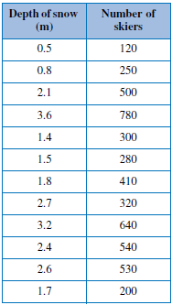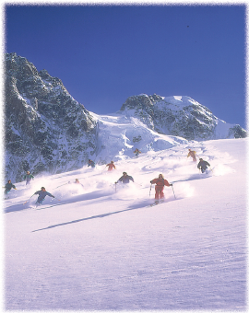

The data in this example are known as bivariate data. For each item (weekend), two variables are considered (depth of snow and number of skiers). When analysing bivariate data we are interested in examining the relationship between the two variables. In the case of the ski resort data we might be interested in finding out:
- are visitor numbers related to depth of snow?
- if there is a relationship, then is it always true or is it just a guide? In other words, how strong is the relationship?
- is it possible to predict the likely number of skiers if the depth of snow is known?
- how much confidence could be placed in the prediction?

To help answer these questions the data can be graphed on a scatterplot. Each of the data points is represented by a single visible point on the graph.

See the next page:
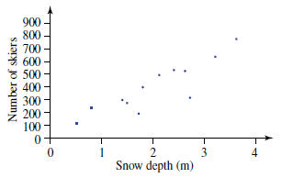

When drawing a scatterplot it is important to choose the correct variable to assign to each of the axis. In this situation we are assuming that the number of skiers depends on the amount of snow. It is called the dependent variable.

The snow depth affects the number of skiers (rather than the other way around) and it is called the independent variable. The independent variable is always placed on the x-axis.

The dependent variable is the variable that responds to changes in the independent variable.

Notice how the scatterplot for the ski resort data shows a general upward trend. It is not a perfectly straight line but it is still clear that a general trend or relationship has formed: as the depth of snow increases, so too the number of skiers also increases.

When one variable increases with another it is said that there is a positive correlation between the variables.

Relationships can show either positive or negative correlation. Consider the following example in which 10 Year 11 students were surveyed to find out the amount of time that they spent doing exercise each week. This was compared with their blood cholesterol level.

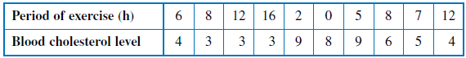

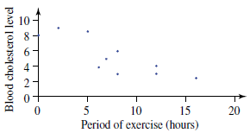

In this example there seems to be a general downward trend. As the amount of exercise increases, the blood cholesterol decreases.

When one variable decreases while the other is increasing it is said that a negative correlation exists between the variables.

Notice that in this case the points are not as closely aligned as in the previous example. We could say that the relationship (or correlation) between the variables is only a weak relationship. In general terms, the closer that the points are to forming a straight line, the stronger the relationship is between the variables.

Sometimes we find that there is no relationship between the variables. Consider the example in which a researcher was looking for a link between people’s heights and their IQs (intelligence quotients). The points appear to be randomly dispersed across the scatterplot. In cases like this it can be concluded that there is no clear relationship between the variables.

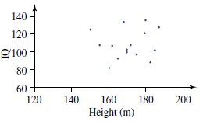
Exercise 1

For each of the following pairs of variables, identify the I = independent variable and the
D = dependent variable. If it is not possible to identify this, then write ‘not appropriate’.

a) The age of an AFL footballer and his annual salary

I

D

b) The growth of a plant and the amount of fertiliser it receives

I

D

c) The number of books read in a week and the eye colour of the readers

I

D

d) The voting intentions of a woman and her weekly consumption of red meat

I

D

e) The number of members in a household and the size of the house

I

D

f) The month of the year and the electricity bill for that month

I

D

g) The mark obtained for a maths test and the number of hours spent preparing for the test

I

D

h) The cost of grapes (in dollars per kilogram) and the season of the year

I

D

Drawing Conclusions/Causation

When data are graphed, we can often estimate by eye (rather than measure) the type of correlation involved. Our ability to make these qualitative judgements can be seen from the following examples, which summarise the different types of correlation that might appear in a scatterplot.

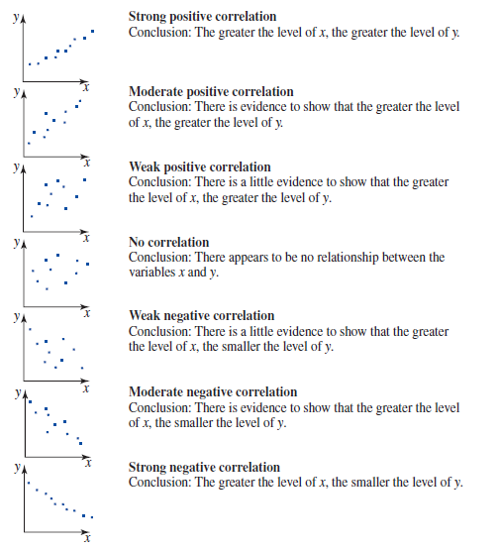
Notice how the conclusion drawn for each of the scatterplots is slightly different. If the correlation is a strong one then the resulting conclusion can be more definite than if it were weak.
When drawing conclusions from a scatterplot or in summarising its trend it is important to avoid using statements like ‘x causes y’. Just because there is a strong relationship between two variables it does not mean that one variable causes the other.
In fact, a strong correlation might have resulted because variable y is causing changes in x, or it could be that there is some third factor that is causing changes in both variables x and y.
To illustrate this point a Dutch researcher compared the human birth rate (births per 1000 population) in different areas with the stork population in those areas. He found that there was a strong positive correlation between the stork population in the different areas and the human birth rate in those areas. What could he conclude? That storks cause babies? Absolutely not! His conclusion could only be along the lines of ‘the greater the stork population, the greater the human birth rate’. In this case there was a third factor that was causing the apparent relationship. Storks have a preference for nesting in rural areas and for social demographic reasons rural dwellers tend to have larger families than their cosmopolitan counterparts. In other words, the land usage of the areas was causing changes in both the stork population and the human birth rate.

Exercise 2

Q1. Match the following scatterplots with the correlation it shows.

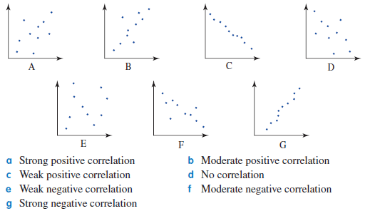

Q2. A pie seller at a football match notices that there seems to be a relationship between the number of pies that he sells and the temperature of the day. He records the following data.

a) Draw a scatterplot of the data. Use graph paper.

b) State the type of correlation that the scatterplot shows and draw a suitable conclusion from the graph.

c) Suggest why the plot is not perfectly linear.

Q3. A researcher is investigating the effect of living in air-conditioned buildings upon general health. She records the following data.

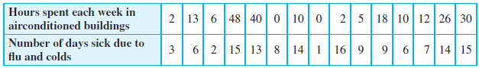

a) Plot the data on a scatterplot. Use graph paper.

b) State the type of correlation the graph shows and draw a suitable conclusion from it.

c) The researcher finishes her experimental report by concluding that air-conditioning is the cause of poor health. Is she correct to say: ‘. . . is the cause’ of poor health? What other factors could have influenced the relationship shown by the scatterplot?

Drawing a Straight Line Through the Set of Points

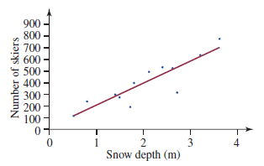

To help analyse a scatterplot, we need to fit a straight line through the whole set of points. The process of fitting a line to a set of points is often referred to as regression.
It can be seen that it is not possible to rule a single straight line through all the points. We are looking for the straight line which most closely fits the data; that is, the line of best fit.
The positioning of this line by eye will clearly rely upon some careful judgement.

Exercise 3

Go back to Q2 and Q3 in Exercise 2 and fit a line of best fit to the scatterplots.

Making Predictions

We can use our line of best fit to make predictions about our data. Below is the scatterplot (with the line of best fit) for the depth of snow and the number of skiers.

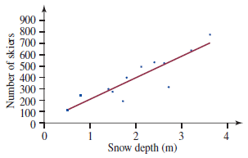

We can use the line of best fit to find the number of skiers when the snow depth was 3 m.

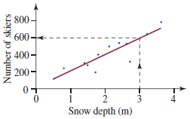

By using a ruler to draw a vertical and horizontal line we can see that there would be 600 skiers.

Likewise we can predict the depth of snow needed to draw a crowd of 400 skiers.

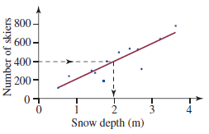
The snow needs to be 2 m deep to draw a crowd of 400 skiers.

Using the data in this way is called interpolation.
We can also extend our line of best fit to make predictions beyond the data collected. This is called extrapolation.

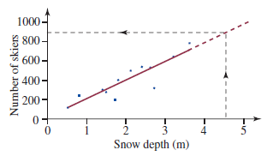

By extrapolating the line of best fit beyond 4 m we can predict that 4.5 m would draw approximately 900 skiers.

You must be very careful making predictions this way. In the above example we are assuming that the relation between snow depth and number of skiers continues in a smooth (linear) upward trend. This may not be the case.

Exercise 4

Q1. A manufacturer who is interested in minimising the cost of training gives 15 of his machine operators different amounts of training. He then measures the number of machine errors made by each of the operators. The results are shown in the table below.

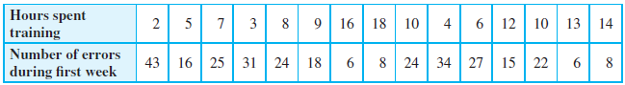

a) Draw a scatterplot of this data. Here the hours spent training is the independent variable and goes on the x axis. The number of errors is the dependent variable and goes on the y axis. Go up by 5s. Start both axis at zero.

b) Draw the line of best fit and extrapolate in both directions. Use graph paper.

c) Use this line to answer the following questions.

(i) If an operator had zero hours of training, how many errors would you expect?

(ii) How many hours of training would you need before you would be confident of making no errors?

Q2. The heights (in centimetres) of 21 Aussie Rules football players were recorded against the number of marks they took in a game of football. The data are shown in the following table.

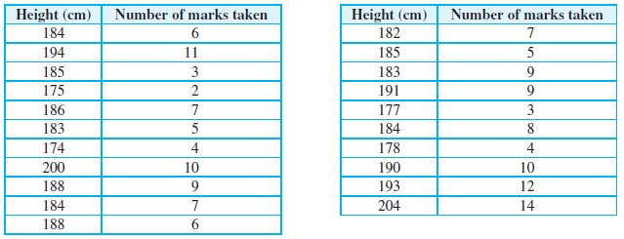

a) Draw a scatterplot for this data. Let height be the independent variable – it goes on the x axis. Start at 0 and go up by 20. Number of marks is the dependent variable and it goes on the y axis. Start at 0 and go up by 2. Use graph paper.

b) Draw a line of best fit and extrapolate in both directions.

c) Answer the following:

(i) How tall do you need to be to make 18 marks?

(ii) If a player made no marks predict their height.

d) What is the problem with these results?

Q3. The following table shows the fare charged by a bus company for journeys of differing length.

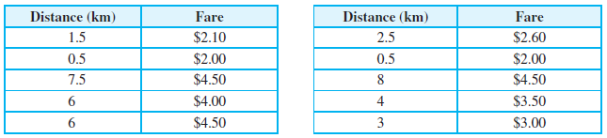

a) Represent the data using a scatterplot. Draw the trend line (line of best fit) and extrapolate the line in both directions.

b) According to the trend line estimate the cost for travelling 10 km.

c) Use the trend line to find the cost of travelling 0 km. Comment on this result – what does it mean?.

2019 EM3 Week 17 Investigation
Checklist. Are you up to date with your investigations and mathspace this semester?
Get your briefs ready for the Test in Test week – open book!!

Week | Check Investigations | Mathspace
1
2
3
4
5
6
7
9
10
11
12
13
14
15
16

Signed by Chantal/Toby/Aaron: ……………………………………..

