ESSENTIAL Mathematics 3

Week 14 and 15 NOTES and exercises

The Cartesian Plane
The Cartesian plane consists of two directed lines that perpendicularly intersect at a point called the origin.
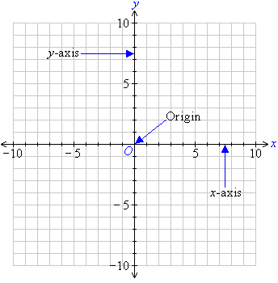
The horizontal line is called the x-axis and the vertical line is called the y-axis.
The position of any point on the Cartesian plane is described by using two numbers: (x, y). The first number, x, is the horizontal position of the point from the origin. It is called the x-coordinate. The second number, y, is the vertical position of the point from the origin. It is called the y-coordinate. Since a specific order is used to represent the coordinates, they are called ordered pairs.
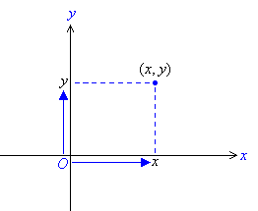
For example, the ordered pair (5, 8) represents a point 5 units to the right of the origin in the direction of the x-axis and 8 units above the origin in the direction of the y-axis as shown in the diagram below.
The x-coordinate of point P is 5, and the y-coordinate of point P is 8.
The coordinates of point P are (5, 8).
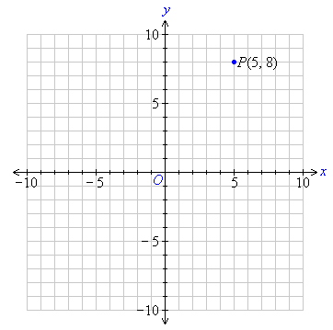
Example: What are the co-ordinates of the letters in the diagram below.
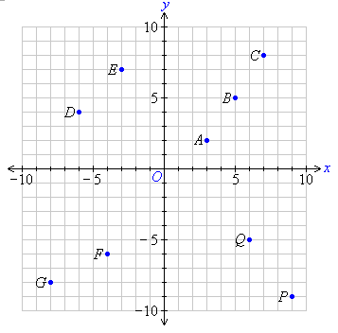
A is 3 units to the right of and 2 units above the origin. So, point A is (3, 2).
D is 6 units to the left of and 4 units above the origin. So, point D is (–6, 4).
F is 4 units to the left of and 6 units below the origin. So, point F is (–4, –6).
Exercise 1
Q1. Write the co-ordinates of the other letters
B C E

G P Q

Q2. a) On the graph paper provided draw a number plane with both axis (lines) extending from -6 to 6.
b) On this Cartesian plane, mark the following points.
A (3,1) B (-4, 3) C (-3, 4)
D (-2, -2) E (0, -2) F (1, -5)
G (4, -4) H (-3, 0) I (-6, 0)
Plotting Graphs From Ordered Pairs
We can use ordered pairs to draw straight lines. Such lines are called linear graphs. The ordered pairs are often arranged in tables.
Example:
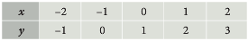
The ordered pairs are (-2, -1) (-1, 0) (0, 1) (1, 2) (2, 3)
When the points are plotted on the Cartesian plane and joined by a line we get;
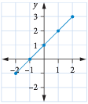
Exercise 2
From the following tables write down the ordered pairs, plot the points on a Cartesian plane (ie draw axes on graph paper) and join the points.
A B
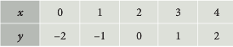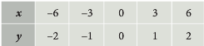

C D
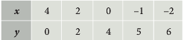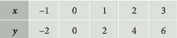

From Rules to Graphs
If we are given an algebraic rule (equation) we can complete a table of values and use this to draw a graph.
Example: Construct a table of values for the rule: y = x + 2
We draw a table and choose some x values.
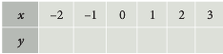
Calculate the y values by substituting the x values into the rule.
y = -2 + 2 = 0
y = -1 + 2 = 1
y = 0 + 2 = 2
y = 1 + 2 = 3
y = 2 + 2 = 4
y = 3 + 2 = 5
Complete the table.
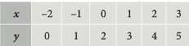
A rule that is represented by a straight line when we graph it on a number plane is called a linear equation or a linear function
Example: Draw the graph of the linear function y = x + 2
We use the completed table above to write the ordered pairs.
(-2, 0) (-1, 1) (0,2) (1, 3) (2, 4) (3, 5)
The points are plotted on the number plane.

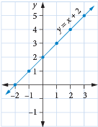

Exercise 3
Q1. Construct a table of values for each of the following rules. Use x values of -2 to 3.
a) y = x – 4
x | -2 | -1 | 0 | 1 | 2 | 3
y

b) y = 2x
x | -2 | -1 | 0 | 1 | 2 | 3
y

c) y = x + 3
x | -2 | -1 | 0 | 1 | 2 | 3
y

d) y $= \frac{x}{2}$
x | -2 | -1 | 0 | 1 | 2 | 3
y

Q2. Complete a table of values for the rule y = 2x – 4. Plot this linear function on the graph paper provided.
x | -2 | -1 | 0 | 1 | 2 | 3
y

Q3. Draw a graph of the linear function y = 3x. Use the graph paper provided.

Linear Modelling
Many real-life applications, such as fees charged for services, cost of manufacturing or running a business, patterns in nature, sporting records and so on, follow linear relationships. These relationships may take the form of a linear equation; for example, F = 50 + 30t may be used by a tradesperson to calculate her fee (in dollars) for t hours of work.
Here, F is the fee in dollars, and t the time in hours. The 50 represents an initial fee for simply turning up, while the 30t is the amount charged for the time spent on the job.
For example, if t = 2 hours, 30t = 60, so the total charge for the work would be $(50 + 60) = $110. Equations like F = 50 + 30t are sometimes referred to as ‘linear models’.
These linear functions can always be graphed as straight lines.
Example:
Mick is an electrician. He charges $60 per hour.
We can use C for charge and h for the hours worked.
Thus C = 60h We can draw up a table of values.
h | 0 | 1 | 2 | 3 | 4
C | 0 | 60 | 120 | 180 | 240

We could also plot this as a straight line graph.

Example:
A generator company charges a $200 delivery fee, and a rental fee of $1500 per day.
Use T for total charge, D for delivery fee and d for the number of days. This gives
T = D + 1500d or
T = 200 + 1500d For example, if the hire was for 4 days the total charge would be;
T = 200 + 1500 × 4
= 200 + 6000
= $6200

Exercise 4
Q1. Zoe is a receptionist. She earns $18 per hour.
a) Write an equation that represents her pay, $P

b) Complete the table of values for 0 to 7
h | 0 | 1 | 2 | 3 | 4 | 5
P

c) Graph this linear function (use graph paper).

d) Why does the graph go through the point (0, 0)?

Q2. Hawkes Landscaping sells garden soil. The charge is $60 plus $28 per tonne to deliver up to 25 tonnes.
a) Write a linear equation for the cost $C of n tonnes of soil. Remember to include the delivery fee.

b) Complete the table of values.
Number of tonnes, n | 0 | 1 | 2 | 3 | 4 | 5 | 10 | 15 | 20 | 25
Cost of soil

Total cost including delivery, C

c) Why do you think the company limits this pricing system to deliveries up to 25 tonnes?

Break-even is the point where a business’ costs are the same as the money it receives from sales. Knowing the break-even point is essential to making a profit. If a business is not making a profit, it won’t last long!

Example

A small business’s total fixed costs are $1200 per week and its variable costs are $10 per item it produces. Each item produced is sold for $30. How many items does the business need to sell each week to breakeven?

A graph is the easiest way to solve this problem. The blue line shows the business’s cost of producing different numbers of items. The green line shows the income the business receives from selling different numbers of items. The red point, where the lines cross, is the business’s break-even point.

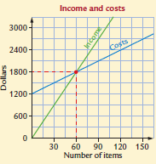

When the business sells 60 items per week, the income and costs are equal. If the business sells more than 60 items, it will make a profit. If it sells less than 60 items, it will make a loss.

Exercise 5

Q1. Sharon has a dog-washing business. The graph shows her weekly expenses and income.

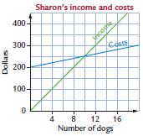

a) Explain how you know that Sharon’s fixed costs are $200 per week.

b) How much does Sharon charge for washing dogs?

c) How many dogs does Sharon have to wash each week to break even?

d) How much profit does Sharon make in a week if she washes 16 dogs?

Q2. Marcia sells bunches of flowers from her street flower stall. She sells each bunch for $15.

a) Complete this table of values to show the money she will receive from selling different numbers of bunches of flowers.

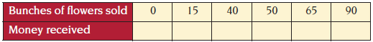

b) The graph shows Marcia’s weekly costs for selling flowers. Use the data from the table to show Marcia’s income line on it.
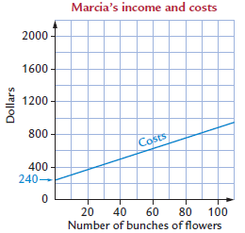

c) How many bunches of flowers does Marcia need to sell each week to break even?

d) How much are Marcia’s fixed costs per week?

e) Calculate Marcia’s profit when she sells 80 bunches of flowers.

Q3. During the summer tourist season, David shows tourists the sights of his area in a horse-drawn carriage. This graph shows his weekly costs and income. Use the graph to answer the following questions.

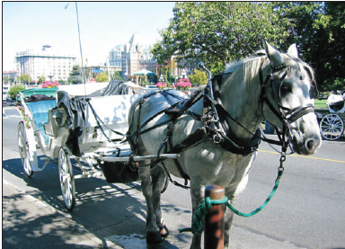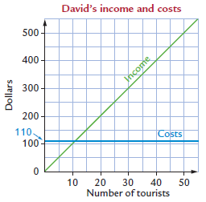

a) How much does David charge each tourist he takes in his carriage?

b) How many tourists does he need to drive each week to break even?

c) Suggest a reason why David’s cost line is horizontal.

EM3 Week 13 and 14 Investigation
Jon’s coffee shop will be open for 7 days per week and during Friday night shopping.

From his market research, Jon determined that his monthly rent will be $7400 and his other monthly fixed costs will total $2100.

He plans to work in the shop himself and to have four employees working a total of 120 hours per month (altogether, not each) at $15 per hour.

Jon’s superannuation payment for labour is $162 per month.

Jon thinks that it will cost 46 cents to make a cup of coffee and 52 cents (each item) to make cakes and muffins. He plans to have an opening price of $5.20 for a coffee with cake or muffin.

Jon’s target number of sales per month is 3650.

Calculate the number of sales required to break even: use total cost of monthly expenses divided by (price of typical coffee and cake subtract cost of ingredients).

Calculate Gross profit after GST: use (target number of sales × price of coffee and cake × 10/11) subtract total cost of monthly expenses subtract (target number of sales × ingredient costs)

Note: ×10/11 is the way of including GST.

PTO to complete the table
