ESSENTIAL Mathematics 3

NOTES and exercises Week 11

Scale Drawings

A scale drawing is usually a reduction of a real object, such as a building, but can be an enlargement of a very small object, such as a computer chip.
Scales on a diagram are usually given as;
- A statement such as 1 cm represents 2 m
- A ratio such as 1:100

Example

Kel is using a map with the scale 1 cm representing 2 km. How far would he have to walk if the distance on the map is 6 cm?

We need to multiply the scaled distance by the scale. 6 × 2 km = 12 km.

Exercise 1

Q1. By measurement and calculation, find the real length of these objects.

a) b)
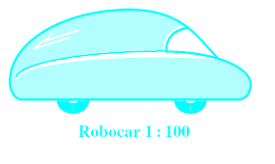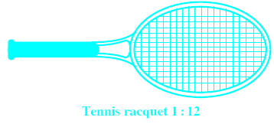

c)
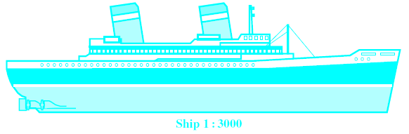

d) e)
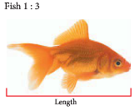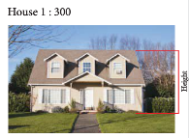

Q2. A house is drawn to scale as shown.
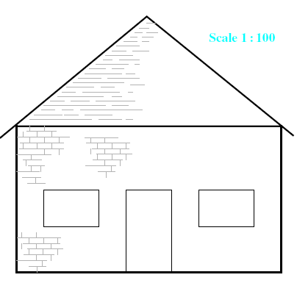
a) What does the scale of 1:100 mean?

b) If the height of the door in the drawing is 18 mm, what is its actual height?

c) Find the actual width of:

i. the house

ii. a window

d) Find the actual height above ground level of:

i. the ceiling

ii. the peak of the roof

Q3. When the ratio for the scale is given in the reverse order, this means that the object is smaller than the scale drawing. In this case we divide by the scale. This drawing of a screw is drawn to a scale 5:1.

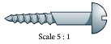
Scaled length of the screw = cm

Actual length of the screw = ÷ 5

= cm

Q4. By measurement and calculation, find the real length of these objects.

a) b)
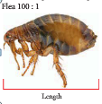Scale 100:1

c) d)
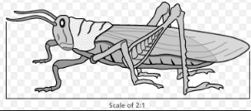
Scale 2:1

e) f)
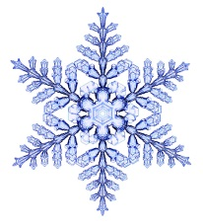

Bacteria 100:1 Snowflake 25:1

Floor Plans

Plans for buildings are one of the most common uses of scale diagrams.
Each house, office block, school or any other building must have plans drawn up before it can be built.
House plans use many different symbols and abbreviations. They are either drawn to scale or have measurements written on them.
Measurements on building plans are usually shown in millimetres to avoid the use of decimal points as decimal points can lead to errors in printing and reading.

Exercise 2

Q1. Use this floorplan to answer questions in parts a to k.

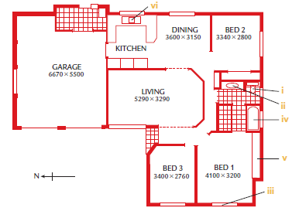

a) What does each of these features on the plan represent?

b) Three areas on the plan are covered in small squares. What do the areas have in common?

c) How many bedrooms are in the house?

d) Which bedrooms have built-in wardrobes

e) Where is the laundry?

f) How many doorways lead into the bathroom?

g) Which room is 5·29 m long and 3·29 m wide?

h) What are the dimensions of the garage, in metres?

i) Can a person standing at the front door see into the bathroom?

j) Which rooms will get sun in the morning?

k) Which rooms will get no direct sunlight?

Q2. Use this house plan to answer the questions in parts a to j.

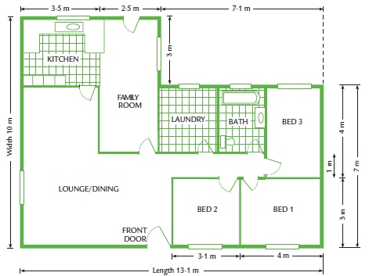

a) How many doors are shown on the plan?

b) What are the length and width of the house?

c) Calculate the width of the kitchen.

d) Calculate the floor area of the house.

e) What is the ratio of the area of bedroom 1 to the area of bedroom 2?

f) What percentage of the floor area of the house is the area of bedroom 1?

g) The builder is going to put tiles on the family room floor.
i) What is the area of the family room floor?

ii) The builder always buys 10% more than the floor area when he buys tiles. How many square metres of tiles will he buy for the family room?

h) The roof guttering, which goes all the way around the house, will cost $24.75 per metre. Calculate the cost of the guttering

i) The floor area of the house is 25% of the area of the block of land. What fraction is the same as 25%?

i. How many times bigger than the area of the house is the area of the block of land?

ii. Calculate the area of the block of land.

j) The block of land is a rectangle. What could the dimensions of the block be?

Q3. Match each word in the left column to its correct meaning in the right column.

 | Word |  | Meaning
1 | Centimetre | A | A unit used to measure long distances
2 | Enlarge | B | The relationship between a real-life object and its diagram
3 | House plans | C | A unit used to measure medium lengths
4 | Kilometre | D | To make a drawing or object larger
5 | Metre | E | Something used to illustrate aspects of a house plan
6 | Millimetre | F | A unit used to measure small lengths
7 | Reduce | G | A diagram showing rooms and measurements
8 | Scale | H | A unit used to measure very small lengths
9 | Symbols | I | To make a drawing or object smaller

Producing Scale Drawings
When we want to make scale drawings, we usually start with a rough sketch that has the measurements we need on it. We then choose a scale and draw the objects accurately.
We can also use our scale drawings to find other measurements.
Example 1
This is rough sketch of Farmer Fred’s field. How to draw a scale drawing of Farmer Fred’s field..?
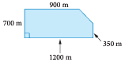
A suitable scale to use is 1 cm = 200 m
We can use this to calculate the scaled length for each measurement by dividing by the scale.
900 ÷ 200 = 4.5 cm 700 ÷ 200 = 3.5 cm 1200 ÷ 200 = 6 cm 350 ÷ 200 = 1.75 cm
Then use these measurements to draw the scale drawing.

Example 2
Sue is going on a bushwalk from her camping site. She walks 2.5 km due East then 1.9 km due Northwest.
a) Draw a scale diagram of Sue’s walk
b) By measurement calculate how far Sue is from her camp site.
A suitable scale is 1 cm = 0.5 km
2.5 ÷ 0.5 = 5 cm 1.9 ÷ 0.5 = 3.8 cm The angle between West and Northwest is 45˚.
Construct a diagram using a ruler and protractor.
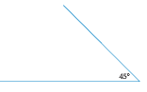
Complete the triangle and measure the third side. This turns out to be 3.5 cm.
3.5 × 0.5 = 1.75 thus Sue is 1.75 km from her camp site.
Exercise 3

Answer the following questions on blank paper. You will need to draw accurately.

Q1. This diagram is not to scale. Make a scale drawing of this field using 1 cm = 500 m.
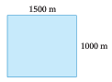

Q2. Keith and Rob are setting off on a hike. They walk 5 km due West of their starting point and then turn and walk 7 km South. They stop for lunch and then walk another 6 km in a North-easterly direction before stopping for afternoon tea.
a) Make a scale diagram of their walk using a scale of 1 cm = 1 km.
b) How far are they from their starting point?

Q3. Construct a scale diagram to calculate the actual height of the hot air balloon above the ground. Use a scale of 1 cm = 50 m.
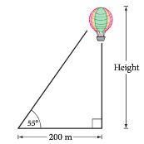

Q4. An old woden gate needs a diagonal brace for support. Construct a scale drawing of the gate and find the actual length of the brace. Use a scale of 1 cm = 40 cm.
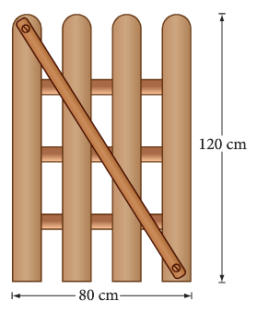

Q5. Michael wants to swim across the river. Draw a diagram and calculate the width of the river. Use a scale of 1 cm = 10 m.

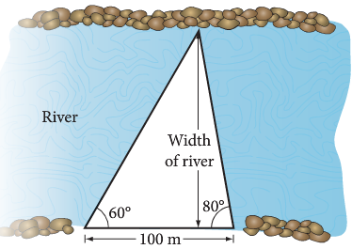

Q6. A golf course has a large lake as an obstacle. Most golfers follow the dog leg around the lake. How far is it in a straight line across the lake, from the tee to the hole?

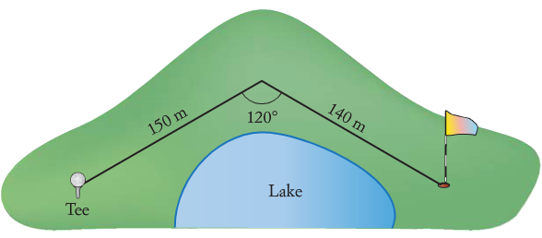

EM3 Week 11 Investigation
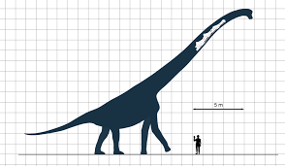
1. In the scale drawing above, what is the dimension of each square?

2. What is the height of the man?

3. What is the height of the sauropod?

4. Measure the height of the sauropod in cm.

5. Use these measurements to calculate the scale of this drawing. Show working.

6. The man’s height is what percentage of the sauropod’s height? Show working.

