

**Week**

**Term**

**2020**

16/17

2

**EM3**

Measurement, scales, plans and models, and data collection

Goals

Learning Brief

This week and next week we are going to:

* apply further graphical concepts
* describe the patterns and features of bivariate data
* describe the association between the two variables, identifying the dependent (y) and independent variable(x)
* find the line of best fit
* use the line of best fit to make predictions by interpolation or extrapolation

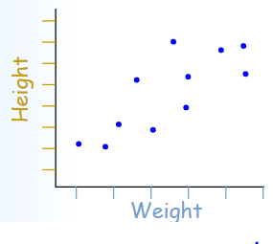

Practical Components

Theoretical Components

**Resources**:

*Mathspace.co*

*PDF file*: Week 16 and 17 Notes and Exercises

**Knowledge Checklist**

* Bivariate data
* Scatterplots
* Independent and dependent variables
* Correlation/causation
* Line of best fit

**Order**

1. Work through notes and exercises
2. Ask for help as you need
3. Complete the journal and investigation
4. Show your teacher the completed work for checking.

Complete the exercises in the Notes and Exercise booklet.

There is a mathspace.co task and exercise set for you to complete

* **Further Graphs**

Have you completed all the mathsace.co tasks?

Investigation/Journal

See attachment at the end of the Notes and Exercises for Week 17 Investigation.

QFO

Quiz/Forum/Other

Week 16: Complete brief for this week.

Week 17: Are all your briefs and uploads of the briefs up-to-date? ☺