

**Week**

**Term**

**2020**

14/15

2

**EM3**

Measurement, scales, plans and models, and data collection

Goals

Learning Brief

This week and next week we are going to:

* apply the sine and cosine ratio to find unknown angles and sides in right angled triangles
* plot Cartesian co-ordinates
* generate tables for linear equations
* graph linear equations
* use linear modelling in a practical concept such as Break-even Analysis

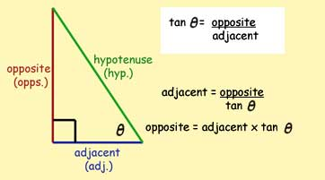

Practical Components

Theoretical Components

**Resources**:

*PDF file*: Week 14/15 Notes and Exercises

This is a good link to view for finding the angle using the tangent ratio:

<https://www.youtube.com/watch?v=LeIolWAuCEQ>

**Knowledge Checklist**

* Investigating the trig ratios further – sine and cosine
* Plot points and straight lines
* Apply linear modelling

**Order**

1. Work through the mathspace task
2. Work through the Week 13 and 14 notes and exercises
3. Complete the investigation.
4. Upload the completed booklet and your investigation for checking.

There are five Exercises in this fortnight’s booklet.

There are mathspace.co tasks for this Brief.

* Finding side length using sine and cosine ratios

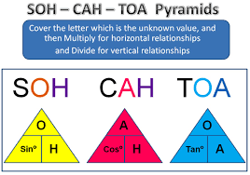

Investigation/Journal

Investigation: Break-Even Analysis

QFO

Quiz/Forum/Other