EM2
Representing and comparing data, Percentages, Rates and ratios, Time and motion

Goals

Week
Term
2019
9
4

In this Brief we are looking at:
- Different types of maps including “Mud Maps”
- Compass direction
- Compass reading
- Touring maps and applications

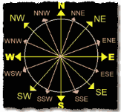

Practical Components

Theoretical Components

There are 5 Exercise Sets in this week’s booklet.

Resources:
PDF file: Week 9 Notes and Exercises

Knowledge Checklist
A mud map is a sketch or drawing of where places are. You should put in places of interest and approximate distances. – you have been given an example in the notes.

The clip below is a good overview of how to read a compass.

http://www.youtube.com/watch?v=cUbPQQxSFWM

You will need to go outside (with a compass) to do the practical activity.

Touring maps – they show the distance between places, but like the mud map are not necessarily drawn to scale.

Investigation

On HawkerMaths (and included in Week 09 Notes and Exercises).

None for this week
QFO
Quiz/Forum/Other

ESSENTIAL Mathematics 2

Week 09 NOTES and exercises

A rough, free-hand drawing that shows approximately where places are is called a mud map.

Example

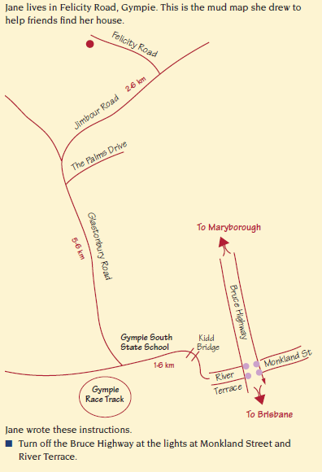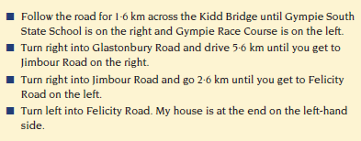

Including compass directions on a mud map can make the map easier to follow. Previously you used basic compass directions. Now it’s time to use a magnetic compass to give more accurate directions.

There is a wide range of commercially available compasses and they have several features in common: a needle that points to north and an indication of other directions. This photograph shows a modern compass.

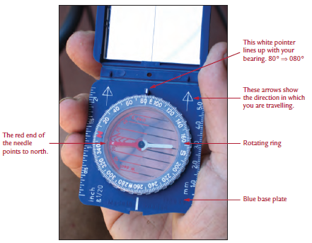

Measuring a direction

Follow these simple steps to find the direction in which you are travelling.
Step1: Hold the compass in front of you with the arrows on the base plate pointing to the direction in which you are travelling. You must have the arrows pointing straight in front of you. If you don’t, the direction will be wrong.
Step2: Move the rotating ring until the red arrow on the base plate is directly under the red end of the needle.
Step3: Look at the white pointer at the top of the compass. This will be lined up with the bearing of the direction in which you are travelling. In the photograph, the person holding the compass is walking on a bearing of 080°.

Modern compasses have numbers from 0° to 360° around the outside. These numbers are used to specify direction. North is zero degrees and the degrees go around the compass in a clockwise direction.
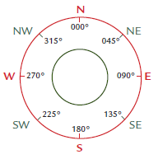
To avoid any confusion or misunderstanding three digits are always used for direction. Although the direction east is at 90°, in navigation it is referred to as the direction 090°. This diagram shows some
directions and their bearings.

Example

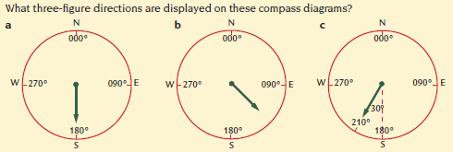

Exercise Set 1

Q1. Write the directions shown in these diagrams in two different ways.

a) b) c)
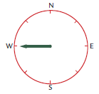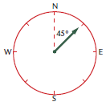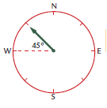

d) e) f)
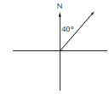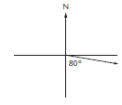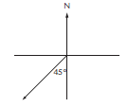

g) h) i)
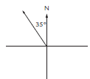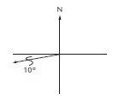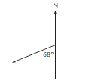

Q2. Write these directions as three-figure bearings.

a) b) c)
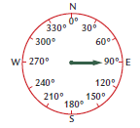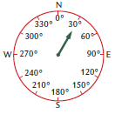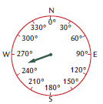

d) e) f)
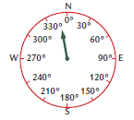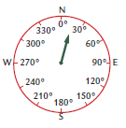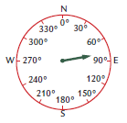

Geoff is a member of the Gympie Historical Steam Trains Club. Next weekend history and steam train enthusiasts are coming to Gympie to ride on, and photograph, the Mary Valley Heritage Railway.
Geoff constructed this mud map to help visitors to the area find good photography sites and other interesting local attractions.

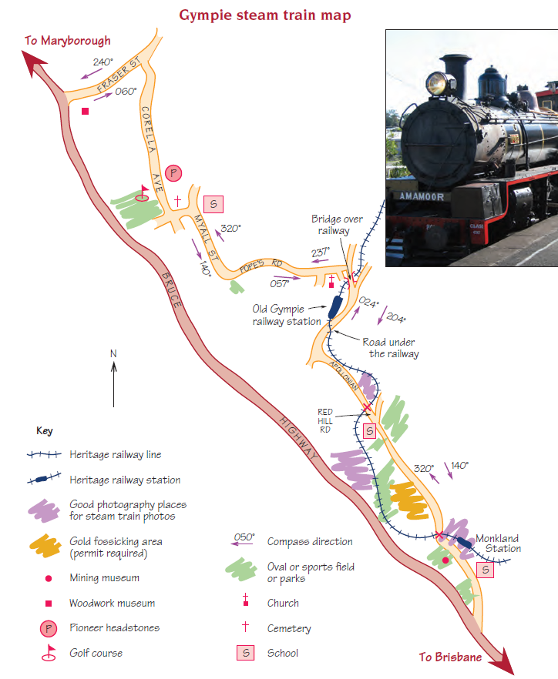

Exercise Set 3
Q1. Why do you think Geoff showed some schools and parks on his map?

Q2. Why did Geoff show two compass bearings on each section of the road?

Mardi works in a Gympie tourist agency. She is designing a historical buildings walking tour of the area for visitors to Gympie.
Gympie Historical Walk
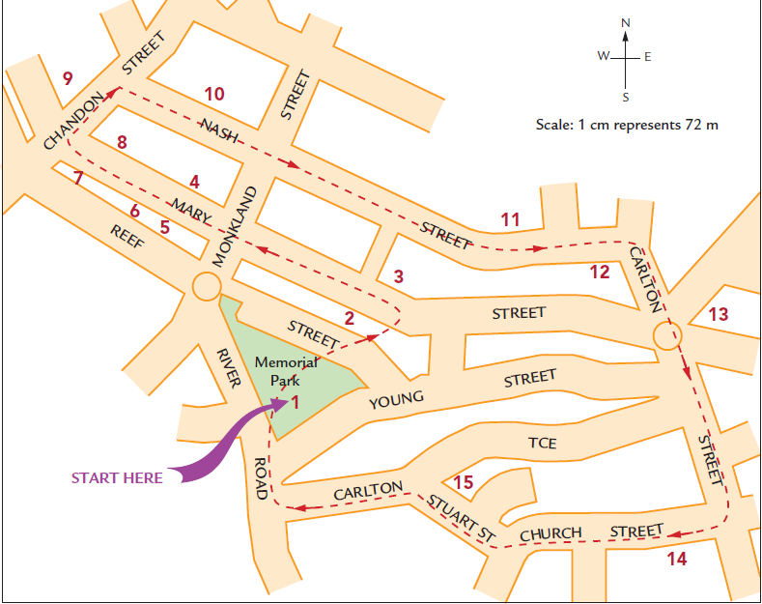
Key
- Bandstand in Memorial Park
- The Memorial Gates
- Mosaic amphitheatre
4. Old Bank of Queensland building, 1892
5. Victoria House, 1892
6. Numbers 216 and 218 in Mary St show typical ornate 1880’s buildings
7. Gympie Stock Exchange building, 1888
8. Smithfield Chambers Building, 1895
9. Old Gympie Post Office
10. Historic School of Arts building (now the town library)
11. The Lutheran Church
12. Restored Terrace buildings
13. Gympie Town Hall
14. St Patrick’s Catholic Church
15. Example of classic Queensland home architecture.

Exercise Set 4
Q1. On the map a distance of 1 cm represents 60 metres. Explain how you can calculate that the length of the historical walking tour is approximately 2.7 kilometres.

Q2. Mardi thinks that typical tourists on this tour will walk at an average speed of 2 km/h and that they will stop at each building for 5 minutes.
- Use the formula $Time= \frac{distance}{speed}$ to calculate the approximate time typical tourists will take to walk the tour if they don’t stop to look at any buildings.

- Establish the total time typical tourists will spend looking at buildings.

- Approximately how long do you think Mardi should tell tourists to allow for this walking tour?

Q3. Mardi has some photographs of buildings on the walk. On the map she would like to show the places where she took the photos. On the attached map of the Gympie Historical Walk show the places where the photos were taken on the walk.
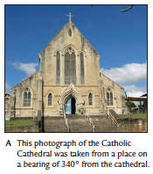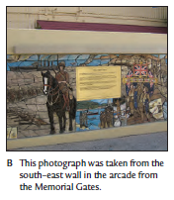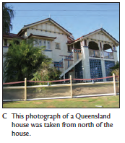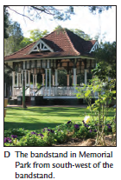
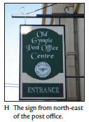
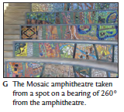
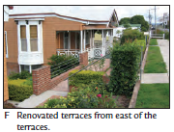

Q4. Mardi thinks that some tourists might like a shorter walking tour. Use the Gympie Historical Walk to show a shorter tour on the map. Include details of the length of the walk and the approximate time people should allow to complete the walk.
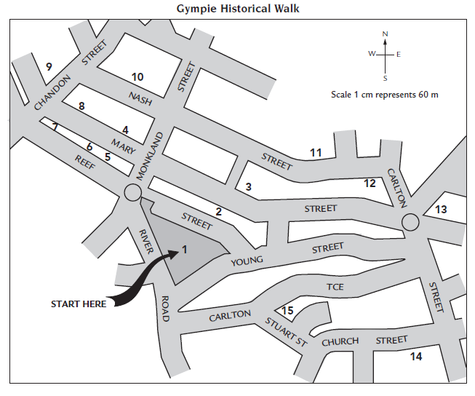

Australia is a vast, open country and distances between neighbouring towns can be huge. Distances between locations can be calculated from the information shown on touring maps.

Example
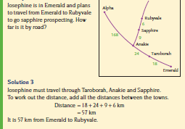
Exercise Set 5
Use the touring map to answer the questions 1 to 7. All distances are in kilometres.
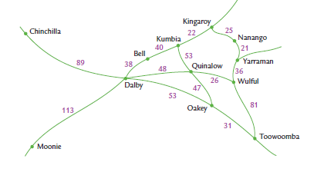
Q1. How far is it from Kingaroy to Wulful?

Q2. Calculate the distance from Oakley to Kumbia.

Q3. How much further is it to travel from Dalby to Wulful via Toowoomba than via Quinalow?

Q4. Keith takes 2 hours to ride his bike from Kumbia to Dalby. Use the formula
$speed= \frac{distance travelled}{time taken}$ to calculate his average speed.

Q5. How long will it take to travel from Chinchilla at an average speed of 71 km/h?

Q6. Before Lois left Kingaroy to travel to Toowoomba she set her car’s trip meter to zero. Between which two places was she when the trip meter showed she had travelled 68 km?

Q7. When Anna left Moonie her car’s odometer showed 062 453. What was the reading when she arrived at Chinchilla?

Q8. The table below shows some of the distances between Augathella, Charleville, Cunnamulla, Mitchell, Morvan and Roma. The mud map shows the relative positions of the towns.
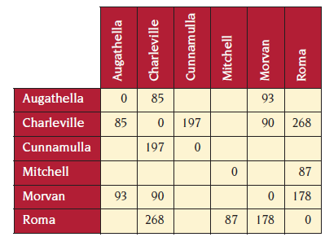
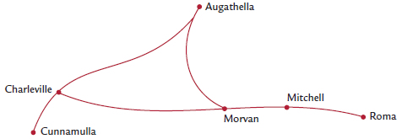

a) Use the distances in the table to write the distances between locations on the mud map.
b) Complete the missing values in the table.

2019 EM2 Week 09 Investigation
Your task is to draw a Mud Map of your travel route from home to Hawker College. Make sure you include approximate distances and the names of all relevant roads/streets/items of interest that would help someone with the directions if they did not know the way (as per the example).

