EM2
Representing and comparing data, Percentages, Rates and ratios, Time and motion

Goals

Week
Term
2019
2
3
Unit Goals
- Understand the concepts and techniques used in representing and comparing data, percentages, rates and ratios, and time and motion
- Apply reasoning skills and solve practical problems in representing and comparing data, percentages, rates and ratios, and time and motion
- Communicate their arguments and strategies when solving mathematical and statistical problems using appropriate mathematical or statistical language
- Interpret mathematical and statistical information and ascertain the reasonableness of their solutions to problems
This Week
- Outliers
- Measures of ‘average’ – mode, median, average
- Frequency tables

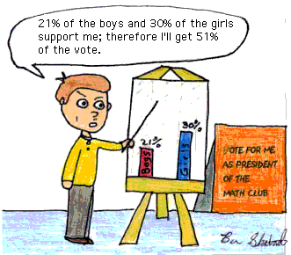

Practical Components

Theoretical Components

There are 3 Exercise Sets in this week’s booklet.

Resources:
PDF file: Week 2 Notes and Exercises

Knowledge Checklist
- Numerical data and outliers
- Mode
- Median
- Mean
- Frequency tables

Order
- Work through the Week 2 notes
- Work through the Exercise Sets
- Complete the Journal
- Come and see me and make sure you are up to date.

Journal

Journal this week for week 1 and 2

No quiz for this week
QFO
Quiz/Forum/Other

ESSENTIAL Mathematics 2

Week 2 NOTES and exercises

NUMERICAL DATA and OUTLIERS
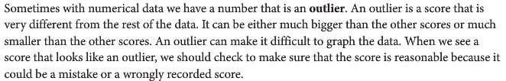
Example
Peter asked eight friends about the amount of pocket money they received each week. The results were:
$20 $32 $32 $40 $18 $32 $18 $175
To identifier we need to write the data in order.

18, 18, 20, 32, 32, 32, 40, 175

Choose the score that is either much bigger or much smaller than the other scores.
The outlier here is $175 because it is much bigger than the other scores.

Exercise Set 1
Q1. For each set of data, identify the outlier. First arrange the numbers in order.
a) 12 15 28 19 15 14 16

b) 32 35 12 40 36 29 38 30

c) 7 5 6 8 7 1 8 6 9

Q2. The results on a Maths test for a Year 11 class are as follows.
55, 52, 50, 45, 55, 45, 60, 58, 75, 45, 49, 59, 58, 59, 56, 49, 31, 52
a) Place these results in order from highest to lowest.

b) What are the outliers in this data set?

Q3. Katrina went to the Census At School website and downloaded a sample of the heights of 25 Year 11 males in centimetres. There are the data.
175 176 185 176 25 184 197 161 186 169 171 172 182 165 179 180 167 169 198 167 170 180 182 173 220
a) Draw a stem and leaf plot for the data.

b) What are the outliers for this data?

c) For each outlier, decide if it is reasonable or if it is likely to be a wrongly recorded height. Explain your answer.

Statistics involves the collection of information. This is usually called data and collected in the form of numbers. This data is then organised – usually into tables and then analysed. This analysed data is used to pick out trends (eg is the average daily temperature rising) and importantly to make predictions (eg the average temperature of the earth in 50 years.
Most people are familiar with averages. Averages tell us something about a ‘typical’ amount.
Statisticians have three different ways to describe the typical amount. These ways are called the median, the mode and the mean.
Definitions
- When the scores are arranged in order, the median is the score in the middle.
- The most common score is called the mode.
- The mean is the statistical term for what most people call the average.
- The range is the difference between the largest score and the smallest score.
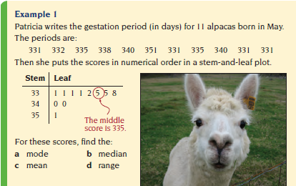
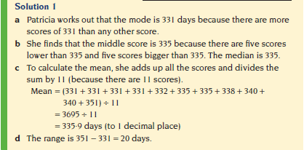
Exercise Set 2
Q1. Find the mode of each set of scores.
- 9, 7, 8, 7, 10, 7 b) 16, 17, 19, 19, 20, 20 20, 21, 23

c d)
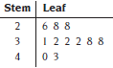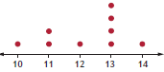

Q2. Arrange each set of scores from smallest to largest, and then work out the median.
- 8, 6, 9, 5, 7 b) 11, 19, 13, 17, 16, 10, 12

Q3. Calculate the mean of each set of scores.
- 28, 36, 30, 25, 21 b) 103, 6, 9, 28, 74, 92

Q4. This dot plot shows the number of trivia questions that the contestants at a trivia night are able to answer correctly.
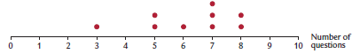
- How many contestants were there?

- Calculate the value of the:
- mode (ii) mean (iii) median (iv) range

Q5. Arrange the following numbers in order, construct a stem and leaf plot and find the mode, median and mean.
5 19 11 27 23 35 18 42 29
31 52 43 37 41 39 45 32 36

Q6. Wendy recorded the results of a spelling quiz using a stem and leaf plot.
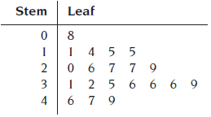
- How many students sat for the spelling quiz?

- What was the lowest score?

- What is the modal score?

- Calculate the median score.

- Calculate the mean of the quiz.

- Describe the difference between the median and the mean.

When there is a large set of data (lots of numbers) it is useful to organise the data into a frequency table.
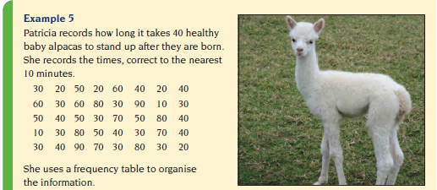
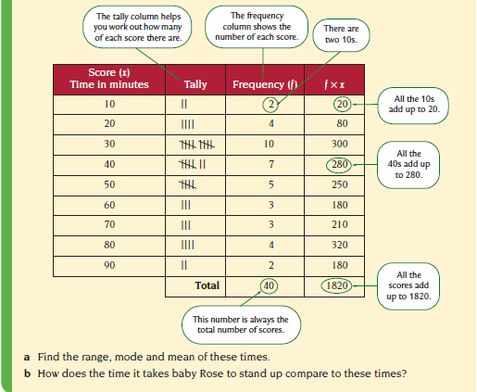
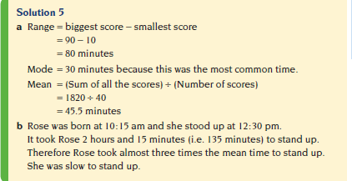
Exercise Set 3
Q1. Bob likes to go fishing. This frequency distribution table shows the number of fish he catches on each day during his 35-day fishing trip.
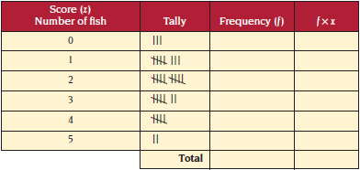
- Complete the table.
- What is the modal number of fish Bob catches each day?

- Calculate the range.

- What is the mean number of fish Bob catches? Give your answer to 1 decimal place.

Q2. Dirk records the number of email messages he receives each day. This is his record for April.
1 2 3 1 2 4 3 3 5 5 0 6 0 4 3
2 4 6 2 1 4 5 3 1 3 5 2 3 6 4
- Complete the frequency distribution table.
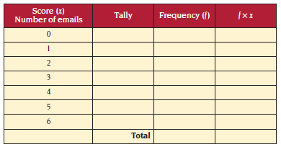
- Calculate the mean number of emails he receives each day.

- What is the mode number of emails he receives each day?

Q3. Minka records the number of goals her soccer team scores each match.
0 2 1 2 2 3 0 1 2 1
1 1 1 0 1 4 2 3 5 0
a) Construct a frequency distribution table and show the complete data.

b How many games does the team play?

c Calculate the mean number of goals the team scores each match.

