Week
Term
2019
10
4
EM2
Representing and comparing data, Percentages, Rates and ratios, Time and motion

Goals

In this Brief we are :
- Applying maps to whale watching at Hervey Bay.
- Looking at scale drawings

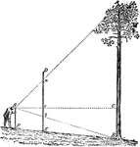

Practical Components

Theoretical Components

Resources:
PDF file: Week 10 Notes and Exercises

Knowledge Checklist
- Mud maps
- Grid references
- Reading graphs
- Percentages
- Scales
- Constructing scale drawings

The clip below shows Hervey Bay and humpback whales.

http://www.youtube.com/watch?v=h1z6Sz9Z1UA

Scale Drawings: These are used when the full sized item will not fit directly on your drawing paper. A scale is chosen to resize the drawing to fit on the page.

You should look at this link (about scaling):

http://www.youtube.com/watch?v=Cv7_CVD6_Yk

There are 3 Exercise Sets in this week’s booklet.

Journal

Journal this week,

None
QFO
Quiz/Forum/Other

Week 10 NOTES and exercises

Humpback whales migrate each winter up the east coast of Australia from Antarctica to the warm tropical waters off the coast of Queensland, to breed. The whales spend several months each year in the water near Hervey Bay. As you work through the next worksheet, you will learn about humpback whales
and consolidate some of the skills you have mastered in the course so far.

Exercise Set 1

Q1. This mud map shows some of the locations near Hervey Bay. All distances
are in kilometres.

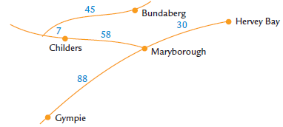

a) How far is it from Bundaberg to Hervey Bay?

b) How long will it take to drive from Bundaberg to Hervey Bay at an average speed of 80 km/h? Express your answer in hours and minutes.

Q2. At what time do you recommend Paul should leave Bundaberg to catch an 8 am whale watch boat in Hervey Bay?

Q3. A pod of whales swim at an average speed of 8 km/h during their 6000 km migration. How long does it take them to complete the trip?

Q4. Adult humpback whales are the fifth largest mammal on Earth. A large humpback whale can have a mass of 40 tonnes. How many students with an average mass of 70 kg have a mass equivalent to one 40-tonne whale?

Q5. Baby whales are born in tropical waters and their mothers feed them milk. Whale milk is very rich. It is 35% fat. How many litres of fat are contained in 250 litres of whale milk?

Q6. Baby whales increase their weight by 27 kg daily and increase their length by 26 cm monthly. A baby whale weighed 1 tonne and was 4·8 m long when she was born at the beginning of July. Estimate her weight and length when she and her mother left Hervey Bay at the end of October to swim back to Antarctica.
a) Length

b) Weight

Whale Watch Map
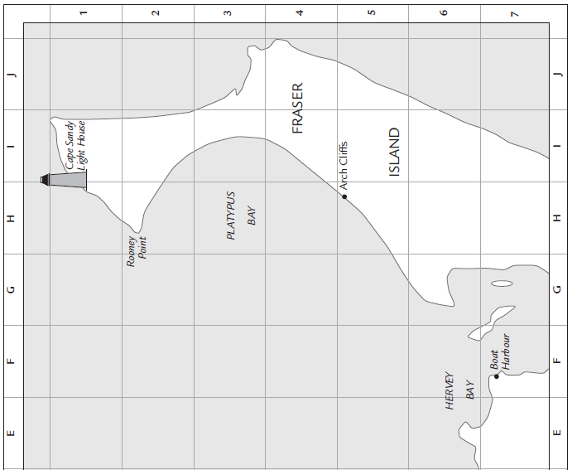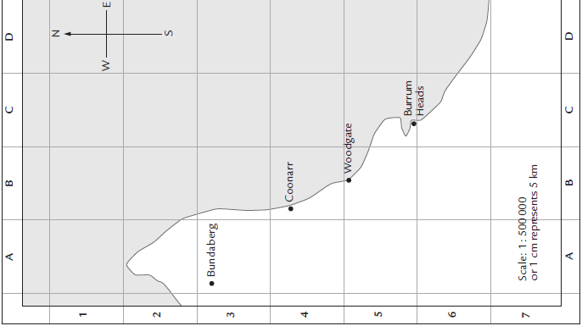

Q7. What town on the Whale watch map is located at map reference B5?

Q8. This graph shows the number of whales in Hervey Bay at different times during the year.

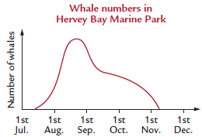

a) Trevor wants to go to Hervey Bay to see some whales. In which
months do you recommend he visit Hervey Bay?

b) For what fraction of the year are there whales in Hervey Bay Marine Park?

Q9. Neville and Vicki went on a whale watch trip from Hervey Bay. When the boat left Boat Harbour, it headed towards Rooney Point. Which of the following bearings could the boat be following?
a) 020° b) 070° c) 120° d) 200°

Q10. Use the scale on the map to calculate the distance between Boat Harbour and Rooney Point.

Q11. When John was checking the light at the top of Cape Sandy Light House, he saw a pod of whales 7 km due west of the light house. Show the position of the pod of whales on the map.

Q12. The first pod of whales that Neville and Vicki saw on their whale watch cruise was 20 km from Arch Cliffs and 15 km from Rooney Point.
- What length on the map represents 20 km?

- Put the point of a pair of compasses on Arch Cliffs and open the compass to the length representing 20 km.
Draw a circle in the water representing places 20 km from Arch Cliffs.
- Put the point of the compass on Rooney Point and open the compass to a length representing 15 km. Draw another circle on the map. This circle represents places 15 km from Rooney Point.
- Draw an X on the place where the two circles cross. This is the position of the whales.

Q13. Neville watched the whales swim until they were south-west of Rooney Point and north-west of Arch Cliffs.
- On the map show the route along which the whales swim.
- How far do the whales swim?

Q14. Neville heard that the number of humpback whales migrating along the east coast of Australia is increasing by 13% each year. In 2004 the whale population was 4000. Assume that the number of whales is increasing by 13% each year when you answer these questions.
a) How many whales were there in 2005?

b) Copy and complete this table of values.

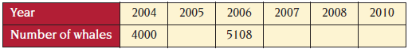

c) Which of these graphs best shows the future number of whales that will migrate along the east coast of Australia, if the number of whales continues to increase by 13% each year?

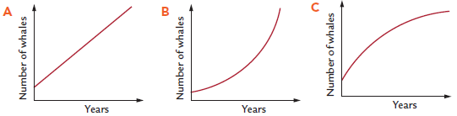

d) Suggest a reason why the number of whales can’t possibly increase by 13% each year indefinitely.

Map makers (also known as cartographers), builders and designers use scale drawings to show their ideas. Scale is chosen to make good use of the paper on which they are drawn.
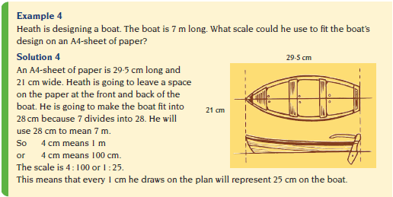

Exercise Set 2
Q1. What would be suitable scales for making scale drawings of these items on an A4 sheet of paper?
- a 14 m long truck (Hint: make the truck 28 cm long in the drawing)

- a 5 m long swimming pool (Hint: make the drawing 25 cm long)

- a 6 m long BBQ area (Hint: make the drawing 24 cm long)

Q2. Vesna is making a scale drawing of an ultralight trike. The ultralight is 5 m long and she is putting the drawing on a 55 cm wide piece of paper.
- Why would a drawing 50 cm wide be a suitable length for the drawing?

- What scale should Vesna use

Scale drawings can be used to solve problems.

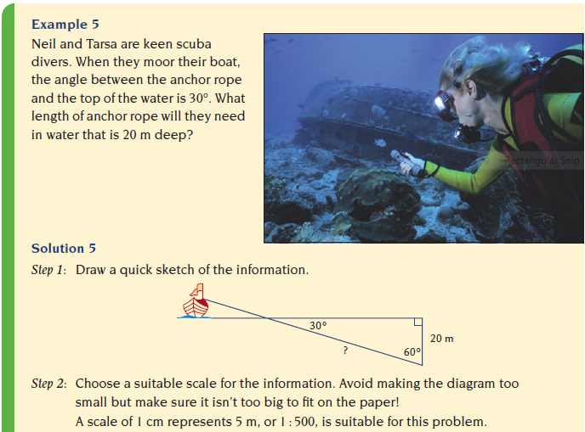
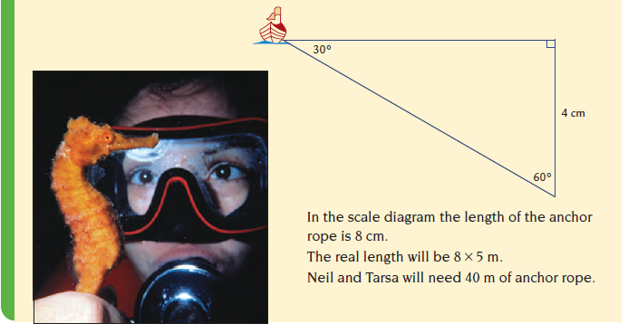

Exercise Set 3
Q1. When the sun’s rays make an angle of 30° with the horizontal, the shadow from the Gympie Pioneers statue is 9 m long. Use a scale of 1 cm to represent 1 m and make a scale drawing to calculate the height of the statue.
Use the attached blank paper.
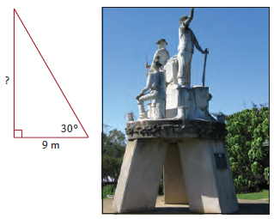
Q2. Jason wants to work out the width of the Thomson River near his favourite swimming hole. The diagram shows the measurements he took. Draw the diagram to scale and calculate the width of the river.
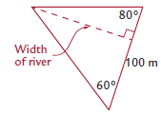
Q3. Adam measures some angles and the shadow from the Stockman’s statue. Use a construction to determine the height of the statue.
