Week
Term
2019
06
1
Goals

EM1
Calculations, percentages and rates; Measurement; Algebra; Graphs

Unit Goals
- understand the concepts and techniques in calculations, measurement, algebra and graphs
- apply reasoning skills and solve practical problems in calculations, measurement, algebra and graphs
- communicate arguments and strategies when solving problems using appropriate mathematical language
- interpret mathematical information and ascertain the reasonableness of solutions to problems.
This Week:
- Kilojoules, conversion tables, the athletic carnival

Theoretical Components

Practical Components

Resources:
PDF file: Week 6 Notes and Exercises
Knowledge Checklist
- The rate at which we use energy - kilojoules
- Converting km/h to mph and vice-versa
- Rates in use at an athletic carnival

Order
- Work through the Week 6 notes
- Complete all 3 Exercise Sets
- Do the investigation
- Come and see me and make sure you are up to date.

There are 3 Exercise Sets in the notes, complete these as you work through them, you can complete them on the sheets, or in your exercise books but I need to see that they are complete.

Jornal

No Investigation this week, you need to write your third journal (week 5-6).

QFO
Quiz/Forum/Other

No quiz for this week.

ESSENTIAL Mathematics 1

Week 6 NOTES and exercises

If you use more energy than you eat, then you will lose body weight. Similarly, if you eat more energy than your body uses, this energy will be stored as fat.
The number of kilojoules (a measurement of energy) your body requires each day depends on your age, gender and lifestyle.

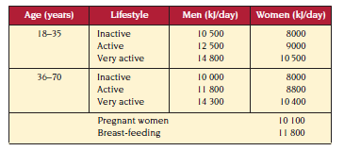

Exercise Set 1
Q1. Estelle is 18 years old. During the week she works in an office and is inactive, but on the weekends she is very active: jogging, swimming and cycling.
- How many kilojoules does Estelle use per day during the week?

- How many more kilojoules does Estelle use per day on the weekend than on weekdays (show working)?

- How many kilojoules does Estelle use per week (show working)?

Q2. How many kilojoules does a very active 40 year old male require per week (show working)?

Q3. According to the above table, how many more kilojoules per day does a Joanne need, now that she is pregnant, than her twin sister Assya, who is an active 20 year old woman (show working)?

Q4. Sarah’s mother is very worried. Sarah, aged 18 years, is very thin and refuses to eat more than 6000 kj per day. Every afternoon Sarah works out at the gym for two hours. Sarah’s mum knows that a gym workout can use 2500 kj per hour.
- How many kilojoules does Sarah use at the gym each day?

- How many kilojoules does Sarah have left from her diet for the remaining 22 hours of her day (show working)?

- What advice would you give Sarah’s mum?

Q6. This table shows the average length of time it takes a typical 18 year old to burn 1000 kj.
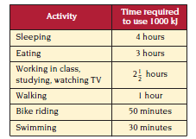
- How many kilojoules are used in swimming for 30 minutes (show working)?

- How long does it take to burn 500 kj while sleeping (show working)?

- Suzie, aged 18 years, leads a very active life. This is how she usually spends her day:

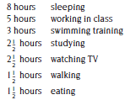
- According to the table above, how many kilojoules does Suzie use each day(show working)?

- If Suzie restricts her daily kilojoule intake to the amount shown in the table on P1, would she have a sufficient amount of kilojoules to meet het energy requirements (explain)?

Q7. This table shows another way of calculating kilojoule requirements.
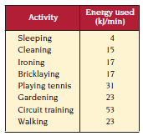

- How many kilojoules would you use doing these activities?
- Cleaning for one hour

- Bricklaying for 30 minutes

- Circuit traing for 2 hours

- How long would it take you to use 230 kj walking?

- Jodie uses 1240 kj playing tennis. For how long does she play tennis?

Converting quantities such as metres per second to kilometres per hour, temperatures from degrees Fahrenhiet to degrees Centigrade, is easy with a conversion table.

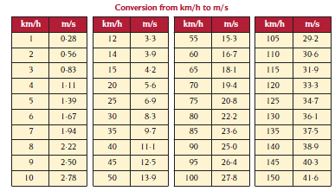

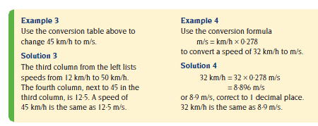

Exercise Set 2
Q1. Use the conversion table above to express the following speeds in metres per second.
- 20 km/h b) 9 km/h c) 65 km/h

Q2. Use the conversion table above to approximate the following speeds in kilometres per hour.
- 8 m/s b) 32 m/s c) 35 m/s

Q3. Kangaroos can bound at a top speed of 48 km/h. Approximately how many metres can they bound in a second?

Q4. A Peregrine falcon’s top flying speed is 200 miles per hour. Use the formula
m/s = miles/h x 1.609 x 0.278
to convert this speed into m/s (show working).

Exercise Set 3
Q1. Ananlogue stopwatches have two dials on their faces. The large dial measures seconds and the small dial measures minutes. What times are showing on these analogue stopwatches?

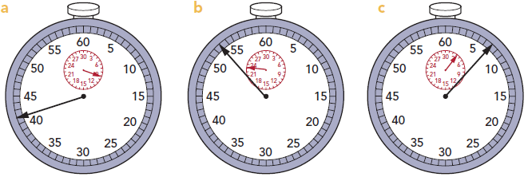

Q2. Brian takes 5 minutes and 48 seconds to complete a three lap event. What is the average time he takes to complete each lap? (answer in seconds)

Q3. The track events at the carnival include 36 sprint races and 20 hurdle races. Brian’s mother is a time-keeper for $\frac{2}{3}$ of the sprint races and $\frac{3}{5}$ of the hurdle races. For how many races is Brian’s mother a time-keeper (show working)?

Q4. The athletics carnival recorder writes these times for the 200 metre sprint.

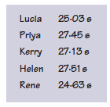
- What is the fastest time?

- How much faster is the winner than the person in second place?

- The race record is 22.78 seconds. How much slower than the record is the winning time?

- Write the names of the girls in the order in which they finish the race.

Q5. The diagram shows the measuring tape used in the long jump competition.

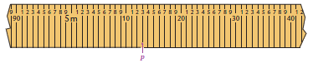
- Rene jumps to point P. How long is her jump?

- Mark these distances on the diagram.
- 5 m 23 cm (ii) 5.17 m (iii) 4.98 m (iv) 5.04 m

Q6. During the carnival, Rene and Brian keep a record of their individual championship points. First place is awarded 4 points, second place 3 points, third place 2 points and fourth place 1 point.
Rene scores 5 first places, 1 second place and 3 fourth places.
Brian has 2 firsts, 4 seconds, 4 third places and he finishes unplaced in 2 other events.
Does Rene or Brian have the larger number of championship points? How many more points does this person have (show all working?)

Q7. The qualifying jump height for the girls’ high jump is shown. What is the qualifying jump height?

