Week
Term 1
2020
7/8
Learning brief MM3:
Further differentiation and applications

Goals

By the end of this week, you should be able to:

- Use the increments formula: $δy≅\frac{dy}{dx}×δx$ to estimate the change in the dependent variable $y$ resulting from changes in the independent variable $x$
- Use derivatives and second derivatives to sketch curves and to solve practical problems

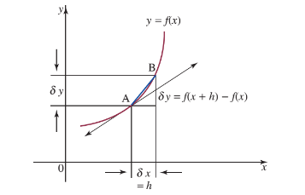

Practical Components

Theoretical Components

STEP 1
Resources:
Maths Quest Year 12 Chapter 7(printed copy), and Chapter 8 (pdf on Google Drive)

STEP 2
Do the mathspace.co questions:

Further Practice with Rates of Change

- Do Exercise 8E: Q3, Q4, Q6-8, Q12-15

Revision quiz on mathspace

Investigation

STEP 3
See next page.

Week 8 is test week
Prepare your double-sided summary sheet.

Remember to scan in when you come to the Maths Area and when you leave.

QFO
Quiz/Forum/Other

Investigation
Read the following document and complete the question.
An application of differentiation in the world of economics is that which surrounds marginal cost, marginal revenue and marginal profit.
All of these relate to an instantaneous rate of change (which we now know to be called the derivative) of some cost, revenue or profit functions.
Definitions
- Marginal Cost: the derivative of the cost function with respect to the production level
- Marginal Revenue: the derivative of the revenue function with respect to the production level
- Marginal Profit: the derivative of the profit function with respect to the production level

Example:
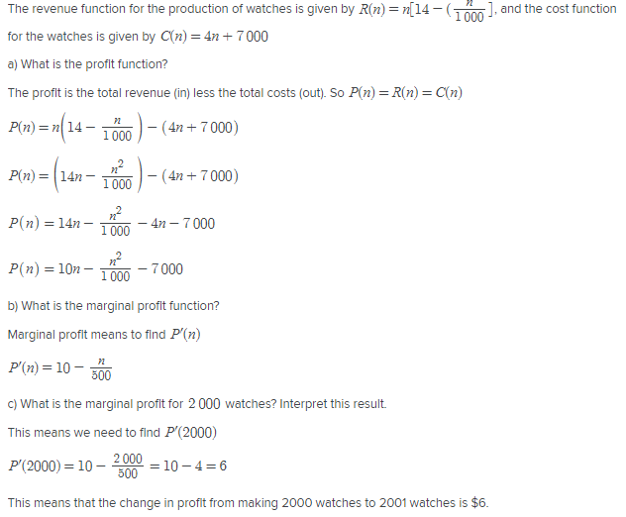

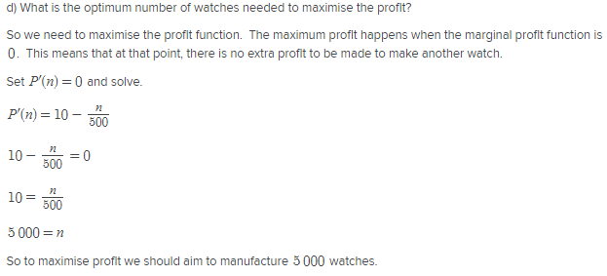

Question for you:

The cost of producing $x$ thousand books is given by ${\left(x+1\right)}^{2}-1$, measured in dollars. Each book is sold for $22.50 at the market so that $x$ thousand books are sold for $22500 $x$.
a) Let $P(x)$ be the profit from selling $x$ thousand books. Determine the expression for marginal profit.

b) what is the marginal profit for 10 thousand books? Interpret this result.

c) what is the optimum number of books needed to maximise the profit?

