By the end of this fortnight, you should be able to:
• understand probability distributions for discrete random variables
• distinguish between discrete and continuous random variables
• construct probability histograms
• compute the central tendency and variability of discrete distributions (i.e. find the mean and variance of a discrete probability distribution)
• compute the 95% confidence interval for a random variable, given the mean and the variance
Focus for Week 13
- Practise more applications of integration and area
- Catch up on overdue mathspace.co tasks
Goals

Week
Term
2020
15
2
Learning Brief MM3
area under curve

Theoretical Components

Practical Components

JacPlus eBook Year 12 Maths Quest Methods (dark blue book) Chapter 9
Read and view worked examples 18 to 28

Watch these YouTube videos:
Approximating area under a curve using rectangles:

http://www.rootmath.org/calculus/area-intro

Exact area under the curve using definite
integral:

http://www.youtube.com/watch?v=ODwkTt0RMDg&feature=relmfu

https://www.youtube.com/watch?v=GtCYrxxTjH4

https://www.khanacademy.org/math/ap-calculus-ab/fundamental-theorem-of-calculus-ab/fundamental-theorem-of-calculus-tut-ab/v/fundamental-theorem-of-calculus

Do the following questions
Ex 9G Q2a,e,f Q4, Q11, Q14, Q19,
Ex 9H Q1a,e,f,g Q5, Q11, Q13, Q14
Ex 9J Q1 Q3 Q5 Q10 Q11

Investigation

Please see next page

QFO
Quiz/Forum/Other

No quiz for this week

Week 15 Investigation

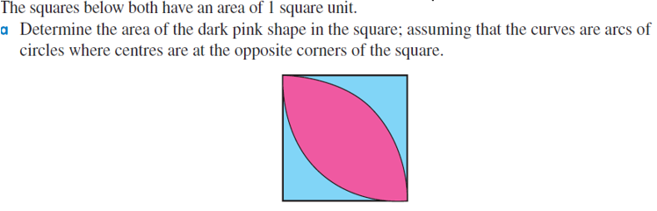
Answer: a. 0.571 $unit^{2}$

Hint: The centre-radius form of the circle equation is in the format (x – h)² + (y – k)² = r², with the centre being at the point (h, k) and the radius being "r".

