**Week**

**Term**

**2020**

11/12

2

By the end of this week, you should be able to:

* Integrate various functions by recognition, various rules and by substitution
* Integrate various functions using CAS
* Understand and use integration notation
* Use your CAS to integrate functions

09_equ-623a.png

09_equ-623b.png 09_equ-626a.png

**Learning Brief MM3:**

**Integrals**

Goals

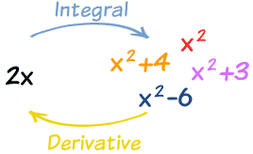

Practical Components

Theoretical Components

JacPlus eBook *Year 12 Maths Quest Methods* (dark blue book) Chapter 9 (Check GC for pdf)

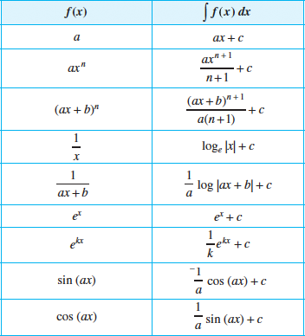

Read worked examples 1 to 9 on anti-differentiation.

Read worked examples 10 to 12 on integrating special functions.

View worked example 13, read examples 14 to 17 on integrating by recognition.

1. Watch this mini-lecture on Integration:

(a).<https://mathspace.co/textbooks/syllabuses/Syllabus-529/topics/Topic-10528/subtopics/Subtopic-138823/?searchString=integration&selectTextbook=false&activeTab=theory>

(b).<https://mathspace.co/textbooks/syllabuses/Syllabus-529/topics/Topic-10528/subtopics/Subtopic-138825/?searchString=integration&selectTextbook=false&activeTab=theory>

2. Make your notes on the examples shown.

JacPlus eBook *Year 12 Maths Quest Methods*

**Exercise 9A:** Q1 f,m,s, Q2 c,f, Q3, Q4, Q6,

Q7 j,k Q11 a,j Q12

**Exercise 9B:** Q1 a,p, Q2, Q4, Q5, Q6 a,j,w

Q7 c,e, Q12

**Exercise 9C:** Q1 a,c,e Q2, Q3, Q4 a,c Q5 a,c,

Q7 b Q9 Q11 Q13 Q15-17

Investigation

Complete the Quiz on mathspace

[Investigation Quiz](https://mathspace.co/student/tasks/CurriculumCustomTask-376111/)

QFO

Quiz/Forum/Other