Introduction to Matrices
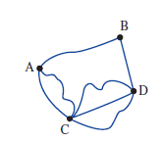
Four towns are connected by roads as shown in the figure. There is one road connecting A and B, two roads connecting A and C and so on. This information may be represented as shown in the table.

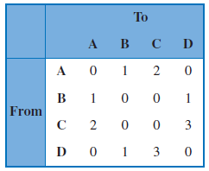

If the headings at the top and side of this display are removed, an array of numbers only is left:

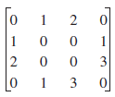

This array of numbers is called a matrix (plural, matrices).
The arrangement of numbers in matrices is an extension of our number system and, as we will see, the rules that govern matrix calculations have many similarities with the arithmetic of numbers. Matrices can be used to store information, solve simultaneous equations, find optimal solutions in business, analyses networks, predict final standings in a football season, encode information and devise the best strategies in game theory.

A
matrix
is a rectangular array of numbers arranged in rows and columns.
The numbers in the matrix are called the elements of the matrix.
The matrix above is a 4 × 4 matrix as it has 4 rows and 4 columns. We say the order of the matrix is 4 by 4.

The matrix below is a 3 × 2 matrix because it has 3 rows and 2 columns.

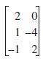

A matrix with m rows and n columns is called an m × n matrix. We say the order of the matrix is m × n.
The dimensions of a matrix are always given as the number of rows multiplied by the number of columns.

The elements of the matrix are referred to by the row and then by the column position. In the 3 × 2 matrix above, the row 1, column 1 element is 2, the row 3, column 1element is -1 and the row 1, column 2 element is 0.

We often use capital letters as symbols for matrices. Thus we may write
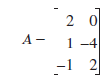
In general, the elements of a matrix A are referred to as a_{ij} where I refers to the row position and j refers to the column position.

For example, in the 2 × 3 matrix below
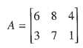
- element a₁₃ is in row 1, column 3 and its value is 4
- element a₂₂ is in row 2, column 3 and its value is 7

Example Interpreting the elements in a matrix.

Matrix B shows the number of boys and girls in Years 10 to 12 in a particular school.

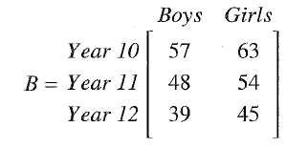
- the order of the matrix is 3 × 2 as there 3 rows and two columns.
- element b₁₂ _{is} in row 1 column 2 and its value is 63. There are 63 girls in Year 10.
- the number of girls in Year 12 is 45. This is element a₃₂
- the sum of the boys column gives the total number of boys ie 57 + 48 + 39 = 144
- the sum of the Year 11 row gives the number of students in Year 11 ie 48 + 54 = 102

A market stall operates on Friday and Saturday. Sales could be recorded by using matrix A.

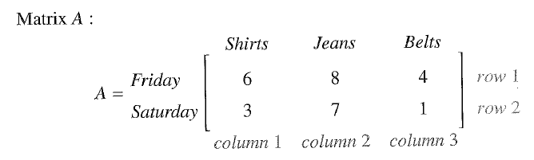

Rows Columns
Friday sales are listed in row 1 The number of shirts is shown in column 1
Saturday sales are listed in row 2 The number of pairs of jeans sold is listed in column 2
The number of belts sold is listed in column 3.

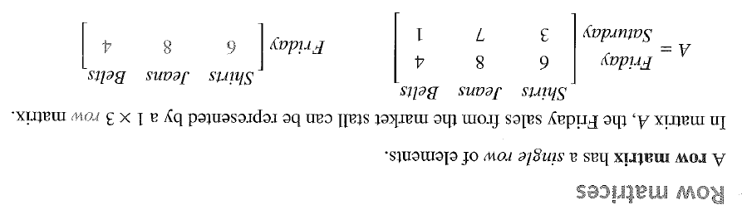

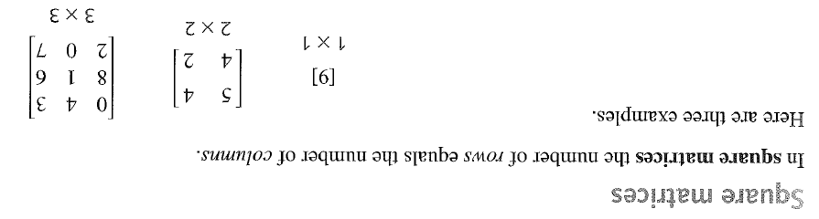

Exercise Set 1

Q1. Matrix C is shown below.

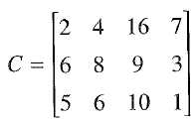

a) What is the order of matrix C

b) State the value of
(i) c₁₃ (ii) c₂₄ (iii) c₃₁

c) Find the sum of the elements n row 3.

d) Find the sum of the elements in column 2.

Q2. For each of the following matrices.

(i) state the order (ii) find the value of the required elements

a) Find a₁₂ and a₂₂
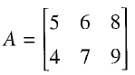

b) Find c₃₂ and c₁₂
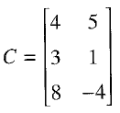

c) Find f₃₄ and f₂₃
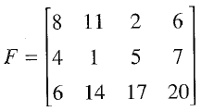

Q3. Some students were asked which of four sports they preferred to mplay and the results were entered in the following matrix.

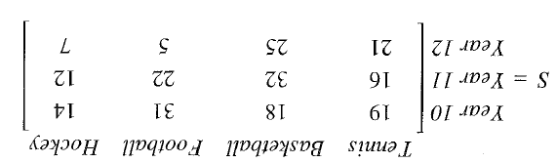
a) How many Year 11 students preferred basketball?

b) Write down the order of matrix X

c) What information is given by s₂₃ ?

d) Which sport was most popular. What column is this sport in?

Q4. Matrix F shows the number of hectares of land used for different purposes on two farms, X and Y. Row 1 represents Farm X and row 2 represents Farm Y. Columns 1, 2 and 3 show the amount of land used for wheat, cattle and sheep (W, C, S) respectively in hectares.

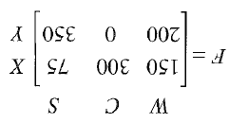
a) How many hectares ae used on:
(i) Farm X for sheep? (ii) Farm X for cattle? (iii) Farm Y for wheat?

b) Calculate the total number of hectares used on both farms for wheat.

c) Write down the information that is given by:
(i) f₂₂ (ii) f₁₃ (iii) f₁₁

d) Which elements of matrix F gives the number of hectares used:
(i) in Farm Y for sheep

(ii) on Farm X for cattle

(iii) on Farm Y for wheat?

e) What is the order of matrix F ?

Using Matrices
As seen at the beginning of these notes matrices can be used to model road networks showing the number of connections between each of the towns in the network.

Exercise Set 2

Q1. The road network shows roads connecting towns.

- In each case use a matrix to record the number of ways of travelling directly from one town to another.

- (ii)
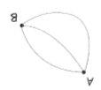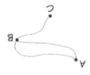

- (iv)
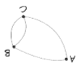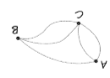

- What does the sum of the second column of each matrix represent?
- (ii)

- (iv)

Q2. a) In each case draw graphs to show the direct connections between towns A, B and C.
- (ii)
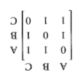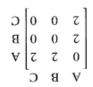

- State the information that is given by the sum of the first column in the matrices in Part a)
- (ii)

Addition and Subtraction of Matrices

Matrices can be added and subtracted. The rules for doing this are:
      - Matrices are added by adding the elements in the same position.
      - Matrices are subtracted by subtracting the elements in the same position.
      - Matrix addition and subtraction can only be done if the two matrices have the same order.

Example
a)
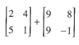
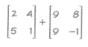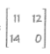
b)
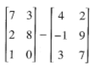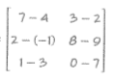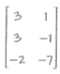

Exercise Set 3

Q1. Using the matrices given:
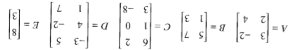
Find, where possible:

- A + B b) B + A

c) A – B d) B + E

- C + D f) B + C

Q2. The weights and heights of four people were recorded and the checked again one year later.

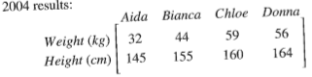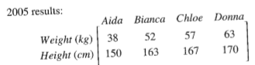
- Write a matrix that gives the changes in each persons weight and height after one year.

- Who gained the most weight?

- Which person had the greatest height increase?

