ESSENTIAL Mathematics 3

Week 11/12 NOTES and exercises

Finding The Hypotenuse

We can use Puthagoras’ Theorem to find the length of the hypotenuse in a rigth-angled triangle.

Example

Find the length of the hypoteuse h (use 1 decimal place).

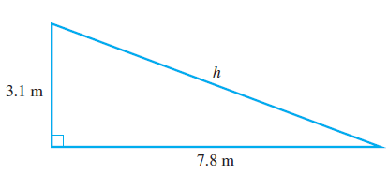
h² = 3.12² + 7.82²
= 9.61 + 60.84
= 70.45
h = √70.45
= 8.393 …
≈ 8.4 m

We can tell h ≈ 8.4 m is a reasonable answer by observing the diagram, which is drawn to scale. Also, 8.4 m is the longest side but not longer than the sum of 3.1 m and 7.8 m.

Exercise Set 1

Q1. Find the value of the pronumeral in each of these diagrams.

a) b)
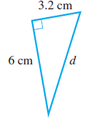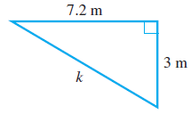

c) d)
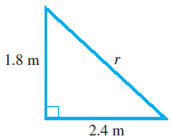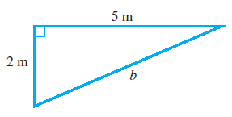

Example

Find the length of x
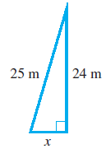
x is not the hypotenuse but one of the shorter sides.

25² = x² + 24²
x² = 25² – 24² It is easier to remember that you subtract when finding a shorter side.
= 625 − 576
= 49
x = √49
= 7 m

Q2. Find the value of the pronumeral on the shorter side in each diagram.

a) b)
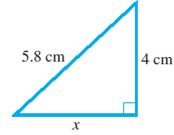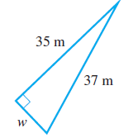

c) d)
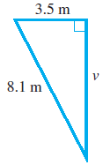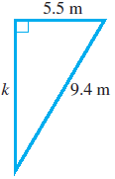

Q3. Find the value of the pronumeral in each diagram.

a) b)
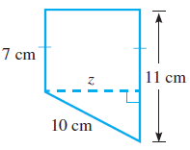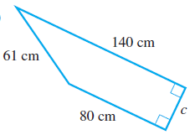

Applications of Pythagoras’ Theorem

Pythagoras’ Theorem can be used to solve problems that occur in the ’real’ world.

Example

A boat sailed 30 nautical miles due south, then 25 nautical miles due east. How far is it from
the starting point, correct to 2 decimal places?

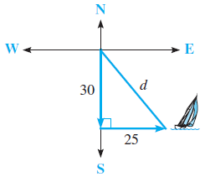

Let d be the boat’s distance from its starting point.
D² = 30² + 25²
= 900 + 625
= 1525
d = √1525
= 39.0512 …
≈ 39.05 nautical miles

Exercise Set 2

Q1. A gate has dimensions 3.8 m by 1.8 m. What is the length of its diagonal brace (to the nearest
centimetre)?
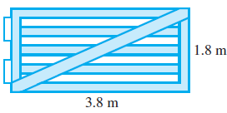

Q2. Vanessa calculated the distance across the lake by taking the measurements shown. What was the distance (to the nearest metre)?
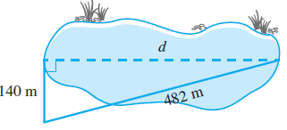

Q3. A 6 m ladder leans against a house so that its base is 2 m out from the bottom of the house. How far up the house does the ladder reach (to the nearest centimetre)?
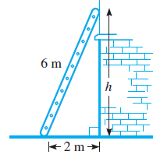

Q4. A yacht leaves Newcastle and sails 160 nautical miles due north. It turns and sails due east until it is directly 200 nautical miles from Newcastle. How far east did it sail? (Draw a diagram)

Q5. A playground slide is made up of two right triangles. Find, correct to the nearest centimetre:
(a) h, the height of the slide
(b) l, the length of the slide
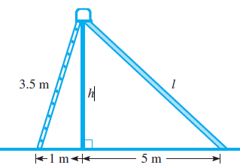

Q6. This diagram shows a boy flying a kite. How high is the kite above the ground ( to 1 decimal place)?
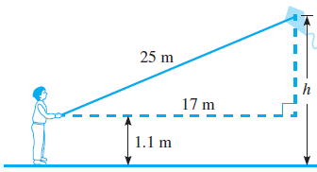

Q7. Jackie wants to use an old tennis-ball can as a pencil case. If this can has a diameter of 7.5 cm and a height of 20 cm, what is the length of the longest pencil that will fit inside the can (to the nearest millimetre)?
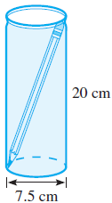

Q8. Mount Everest, the highest mountain in the world, is
8.86 km above sea level.
(a) If the Earth has a radius of 6400 km, what is the distance d (to the nearest kilometre) to the visible
horizon from the top of the mountain?
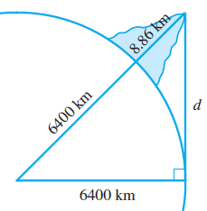

b) The formula
d = 8 $\sqrt{\frac{h}{5}}$
also gives the distance to the horizon in kilometres, where h is the height in metres.
Use this formula to calculate the distance d that can be seen from the top of Mount
Everest (to the nearest kilometre) and compare it with your answer from part (a).

The Tangent Ratio

Trigonometry is the mathematics of using angles and triangles to calculate lengths and distances that are either difficult or impossible to measure. It uses the three sides of a right angled triangle, each of which has a special name related to a particular angle in the triangle:
- opposite side: the side directly facing the angle, not joined to the angle;
- adjacent side: the side leading to the right angle (‘adjacent’ means ‘next to’);
- hypotenuse: the longest side (this has already been introduced with Pythagoras’ theorem).
The diagram shows the three sides related to angle θ in the triangle.

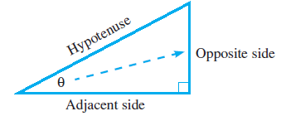

In trigonometry, three ratios are used: sine, cosine and tangent. We will first investigate the tangent ratio, abbreviated tan.

The tangent of an angle is the ratio of the length of the opposite side to the length of the adjacent side.

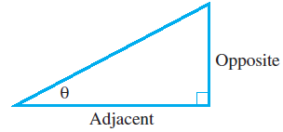
Examples

For ΔXYZ, write tan ∠Z and then express this ratio as a decimal.
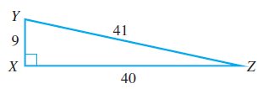
tan ∠Z = $\frac{opposite}{adjacent}$ = $\frac{9}{40}$ = 0.225

Calculate tan θ as a decimal correct to 4 decimal places.

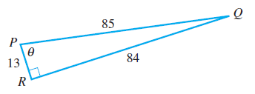
tan θ = $\frac{opposite}{adjacent}$ = $\frac{84}{13}$ = 6.4615

Exercise Set 3

Q1. Write tan θ as a ratio for each of these triangles.

a) b) c)
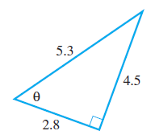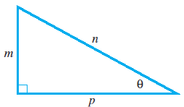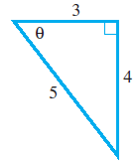

Q2. Calculate tan θ correct to 4 decimal places for each of these triangles.

a) b) c)
