**2016 SM4 Week 11 Investigation**

**PART A:**

A door-to-door telecommunications representative has recorded her day-by-day sales figures over a period of time. She knows that her probability of selling *X* packages on any one day follows the probability distribution shown in the table.



i. Find the value of *t*.

ii. Find the probability that she sells at least 2 packages on any one day.

iii. Find the probability that she sells at most 4 packages on any one day.

iv. Find the number of packages she can expect to sell each day.

v. Calculate the Var(*X*) and standard deviation of *X*, correct to 2 decimal places.

vi. Find (𝜇 − 2𝜎 ≤ 𝑋 ≤ 𝜇 + 2𝜎). Does this match expectations? `

vii. If the representative receives a commission of $25 per package sold and a bonus of $200 if she sells 4 or more packages in one day, find her expected daily earnings from commissions and bonuses.

viii. Given that the representative will sell at least two packages tomorrow, find the probability that she will get her $200 bonus.

**PART B:**

A company manufactures and sells product Xbar. The sales price of the product will be $6 per unit, and estimates of sales demand and variable costs of sales are as follows:

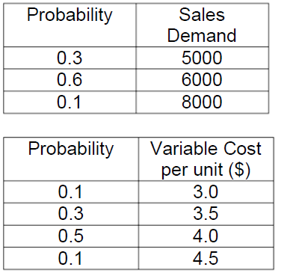

The unit variable costs are not conditional on the volume of sales demand, and the fixed costs are estimated to be $10000.

What is the expected profit?

Make sure your setting out is logical, complete and neat.