

Learning Brief

**MA1**

Matrices, Sequences & Mensuration

**Week**

**Term**

**2013**

02

1

Topic: Matrices

* understand the structure, properties and behaviour of matrices
* be competent in basic manipulations of matrices

Matrix representation, nomenclature

Arithmetic work with matrices

* Addition, subtraction, scalar multiplication

Goals

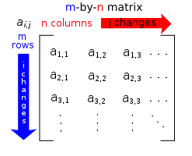

Practical Components

Theoretical Components

Matrix Representation

JacPlus **e-book 1:**

**Exercise 16A and Exercise 16B**

Addition, subtraction and scalar multiplication

**JacPlus e-book 2:**

**Exercise 12A**

**You should do enough questions in the exercises so that you feel competent. Do not waste time doing questions if you have a good idea how to do them…move on!**

Introduction to matrices:

<http://bit.ly/u9SwC6>

What is a Matrix - YouTube

**JacPlus e-book 1**: *Maths Quest 12* *:*

*Further Mathematics* Chapter 16

View e-lesson-tutorial on worked example 5

This is done by clicking the link in the text or the link below

**Jacplus e-book 2**: *Maths Quest 11* *:*

*Standard General Mathematics* Chapter 12

View e-lesson-tutorial on worked example 3

If the JacPlus books are not yet available online – check the resource folder for wk02 in cLc.

Investigation

Give examples to verify commutative and associative properties laws hold for addition and scalar multiplication with matrices. Check for subtraction. (see p819 e-book 1)

QFO

Quiz/Forum/Other

Next week there will be a quiz.

Go to the forum in cLc and discuss a real life use for matrices and why and how they are used. Hint : you may need to research…