

Learning Brief

**SM1: Number Patterns, Relations, Functions**

**Week**

**Term**

**2015**

01

1

By the end of this week, you should be able to:

* Describe the number system and recognise the different number types by notations
* Define a set, subset and universal set
* Draw a Venn Diagram to represent one or more sets
* Understand the basic rules/notations used in writing intervals
* Explain the relationship between a surd and a rational number

Goals

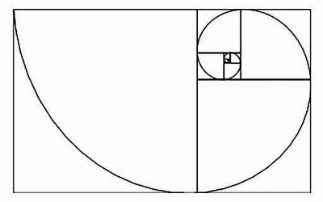

Practical Components

Theoretical Components

From *Cambridge*

Ex 2A Q1 (for this question use the Worksheet ‘Sieve of Eratosthenes’)

Q2 a) b) c) d) e) f)

Q3 a) b) c) d)

Q4 a) b) c) d)

Q5 a) b) c) d) Use your CAS

Q6 a) b) c) f) see Worked Exercise P33

Q7 a) b) d) f) g) h

Q8 a) b) c)

Q9, Q10 a) b), Q12 a) b)

Ex 2B Q2 a) b) Use your CAS

Ex 1J Q1 all, Q2 all, Q3 all, Q4 all, Q5 all, Q6 a) c) e)

Q7 all, Q8 all, Q9 a) b) c) d), Q10 a) b) c)

Q11 all, Q13 all, Q14 all,Q15

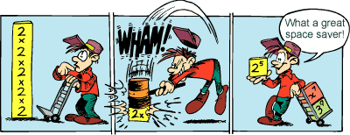

You need to read *Cambridge* Chap 2A and 2B on ‘Numbers’

Also read Chap 1J on ‘The Language of Sets’

It would be a good idea to make notes on the work covered in these sections.

The following websites are most useful. You can either print (though be careful of this as there are a lot of pages) or make brief notes.

Tests for divisibility – you can use these for simplifying fractions:

<http://www.mathsisfun.com/divisibility-rules.html>

Number types and notations:

<http://www.mathsisfun.com/sets/number-types.html>

Sets and Subsets:

<http://www.mathsisfun.com/sets/sets-introduction.html>

Sets and Venn Diagrams:

<http://www.mathsisfun.com/sets/venn-diagrams.html>

Interval notations:

<http://www.mathsisfun.com/sets/intervals.html>

Surds:

<http://www.mathsisfun.com/surds.html>

QFO

Quiz/Forum/Other

For this week you are to attempt this quiz.

<http://wps.pearsoned.com.au/nsm9_5153/20/5200/1331442.cw/-/1331444/index.html>