General Mathematics 3

Week 1 NOTES – Term 1

Buying a car can be a very exciting activity. However, there are a few pitfalls and wise consumers take the time to consider all the angles before they make their final decision. The website below provides some very useful factors to consider when buying a car.

http://www.comparethemarket.com.au/car-insurance/guides/10-trusty-tips-new-used-car-buyers/
Very few people can afford to pay cash for their first car. Most have to borrow money from their parents or a financial institution. Car finance can be very expensive. What seems like a small weekly, fortnightly or monthly amount can add up to a very large amount over a few years.

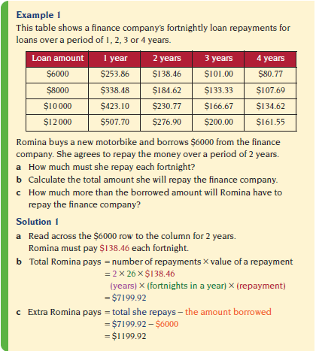

Exercise Set 1 (Use the table in the example to answer Questions 1 to 6)

Q1. Melinda borrows some money from the finance company. Her fortnightly repayments are $166.67 for
3 years. How much does Melinda borrow?

Q2. Ben wants to buy a car but he can only afford to repay $150 per fortnight.
a) What is the largest amount of money he can afford to borrow from the finance company?

b) What will be the value of his repayments and how long will it take him to repay this loan?

Q3. Jon borrows $12 000 to buy a car. He agrees to repay the loan over 4 years.
a) How much must Jon repay each fortnight?

b) How many fortnights are in 4 years?

c) Calculate the total amount Jon will repay the finance company.

d) How much more than the borrowed amount will Jon repay the finance company?

Q4. When Wendy bought a small car she borrowed $6000 over 3 years. Calculate the total amount she repaid over the 3 years.

Q5. Kevin wants to borrow $8000 to buy a ute.
a) How much will he repay the finance company if he borrows the money over:
(i) 1 year (ii) 4 years?

b) Why does it cost so much extra to repay the loan over 4 years than 1 year?

Q6. Mario needs a deposit of $1000 before he can borrow money to buy a car. He wants to buy a car priced at $9000. Mario has $300 in the bank and he can save $125 each week.
a) How many weeks will it be before Mario will have saved at least $1000?

b) How much will he need to borrow?

c) Mario decides to borrow the money from the finance company. Why shouldn’t he borrow the money over a period of 1 year?

Finance companies usually charge simple interest on their loans. When you borrow money with a simple interest loan, you pay the same amount of interest every year irrespective of the amount you have repaid the finance company.

A formula for simple interest

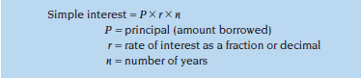

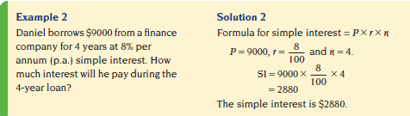

Exercise Set 2

Q1. Calculate the simple interest on each of the following loans.
a) $12 000 at 9% p.a. for 4 years b) $8000 at 6·5% p.a. for 7 years

Q2. Peter borrows $8000 at 9% p.a. How much interest does he pay:
a) per year? b) per month?

Q3. Maya wants to borrow $10 000. The finance company charges simple interest and it will lend Maya the money for 3 years at 7·5% p.a. or for 4 years at 5·9% p.a. Under which option will she pay the least amount of interest?

Q4. Nabil wishes to borrow $13 000 to buy a motorbike. He has the choice of two different finance packages.

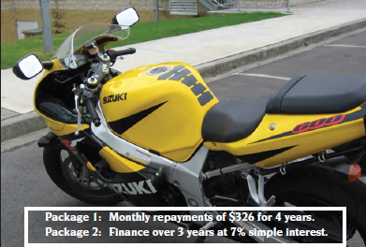

Which package do you recommend that Nabil take? Give reasons, including a calculation, for your answer.

All shoppers love a bargain. Salespeople often give customers a discount to encourage them to buy. A discount can be either a flat amount or a percentage off the value of the item.

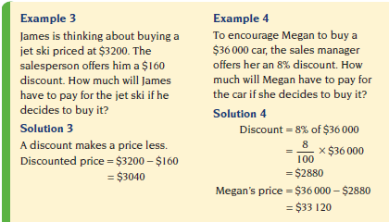
Exercise Set 3

Q1. A second-hand car is priced at $5800. The price is then reduced by $380. What is the new price of the car?

Q2. A trail bike was priced at $3695. When Bryce bought the bike he received a 15% discount. How much did Bryce pay for the bike?

Q3. Carole is an electrician and she receives a 6% trade discount when she buys her supplies. Last year she bought supplies that normally cost $72 000.
a) Calculate Carole’s discount.

b) How much did Carole have to pay for her supplies?

Q4. A store is having a ‘20% off everything’ sale. Customers who pay with cash receive a further 5% discount off the discounted price. Maddison bought some office equipment priced at $1670.
a) What is the price of the office equipment after the 20% discount?

b) Maddison pays with cash. How much does she pay? (Note: The 5% discount is calculated on the price after the 20% discount not the original price).

c) Is the 20% discount followed by a further 5% discount the same as one 25% discount? A simple way to do this is to calculate 25% of the original price, $1670 and compare it to the answer in Part b). How do you explain the difference?

Wise consumers shop around. They get prices from different retailers and they compare the prices to make sure that they get the best deal. Some people get influenced by a high trade-in price on their current car, when the total change-over price is what really matters.
Work through the questions in Exercise Set 4 to help Najal decide on the better deal.

Exercise Set 4

Najal wishes to buy a new car. She is comparing the deals she can get on identical cars from two different car dealers, Honest Joe and Star Cars.

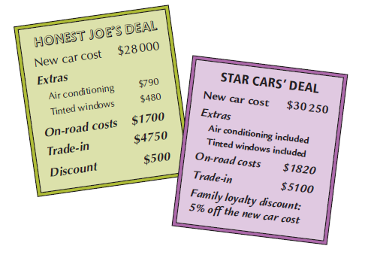
Q1. This is the calculation that Najal does on her calculator the first time she tries to work out the cost of the car from Honest Joe.
28000 + 790 + 480 + 1700+ 4750 + 500 = 36 220
a) She makes two errors in her calculation. What are the errors?

b) What is the correct price of the car from Honest Joe?

Q2. How much family loyalty discount will Najal receive in the Star Cars deal?

Q3. How much does the car cost from Star Cars?

Q4. What is the difference in the price of the car between the two deals?

Q5. Which deal do you recommend that Najal take? Why?

All goods and services in Australia are subject to a 10% Goods and Services Tax. This tax is known as GST. The Australian state and federal governments also charge excise, a form of tax, and fees.

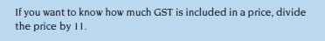

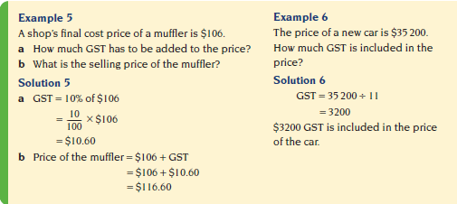

Exercise Set 5

Q1. Determine the final selling price of these items by adding GST.
a) seat covers $146 b) street directory $18

Q2. How much GST is included in these prices?
a) a motorbike priced at $10 120 b) a set of car tyres priced at $1232

Q3. Businesses with an ABN (Australian Business Number) can claim a refund for the GST the business pays when it purchases items for the business. Sonia has an ABN and she paid $67 100 for a new delivery van. How much GST can she claim back from the government from the purchase of the van?

