

**Week**

**Term**

**2014**

1

3

Learning Brief

**SM4 Probability & Statistics**

This week; an introduction to probability. By the end of this week you should be able to;

•Define experiment, outcome, event, probability and equally likely.

•Recognize the difference between outcomes that are equally likely and not equally likely to occur.

•Examine the sample space and probabilities for experiments.

•List all outcomes for single events, and for two successive events, in a systematic way: use a tree diagram to help to do this.

Goals

[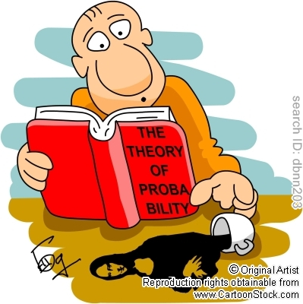](http://www.cartoonstock.com/newscartoons/cartoonists/dbn/lowres/dbnn203l.jpg)

Practical Components

Theoretical Components

**From *Reasoning and Data***

Introductory probability P32

Complementary events P35

Finite sample space P40

Mutually exclusive events P41

Successive outcomes (tree diagrams) P45

The following clips provide good overviews

Introductory probability

<http://www.youtube.com/watch?v=7rfz6LJri-E>

Independent and dependent events

<http://www.youtube.com/watch?v=kxWyRyCba6A>

Tree diagrams

<http://www.youtube.com/watch?v=xe3ou7riwK0>

**From Chap 11; Sections 11A, 11B and 11C**

For experimental probability look at;

<http://www.glencoe.com/sec/math/algebra/algebra1/algebra1_05/study_guide/pdfs/alg1_pssg_G111.pdf>

For an interesting look at several aspects of probability;’

<http://www.stat.columbia.edu/~madigan/1001-Fall2010/NOTES/p16.pdf>

The work for this term will come from two sources.

1. The book *Reasoning and Data*
2. The file Chap 11 *Mathematical Methods 11*

From *Reasoning and Data*

Exercises 2a All except 1, 2 11, 14, 15

2b All are suitable – make sure do 9 and 10

From Chap 11

Exercise 11A

11B

11C

Attempt as many as possible – but it is not necessary to do all questions.

Investigation

On HawkerMaths

QFO

Quiz/Forum/Other

None this week.