GM2 Week 1 Investigation
Your task is to draw a Mud Map of your travel route from home to Hawker College. Make sure you include approximate distances and the names of all relevant roads/streets/items of interest that would help someone with the directions if they did not know the way (as per the example).

Geoff is a member of the Gympie Historical Steam Trains Club. Next weekend history and train enthusiasts are coming to Gympie to ride on, and photograph, the Mary Valley Heritage Railway.
Geoff constructs a mud map to help visitors to the area find good photography sites and other interesting local attractions.
Gympie steam train map
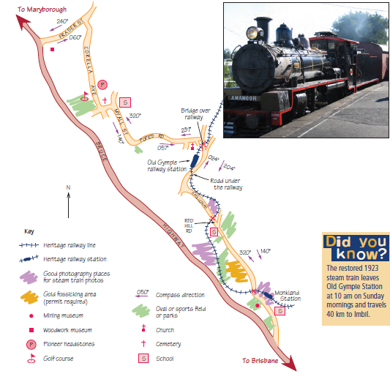
Questions
- Why do you think Geoff showed some schools and parks on his map?4

- Why did Geoff show two compass bearings on each section of road?

- How are the bearings in each pair of directions related to each other?

