

**GM1**

Food, Hospital, Earnings and Local Travel

Goals

Learning Brief

**Week**

**Term**

**2014**

01

01

Unit Goals

* calculate the energy value of various foods
* develop understanding of the energy needed for various activities
* interpret graphs and statistics as presented
* use, calculate and interpret medical formulas and interpret

This Week

* Intro

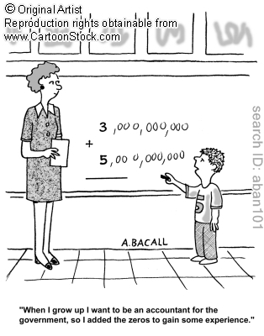

Theoretical Components

**Resources**:

*PDF file*: Week 1 Notes

*Text book references: NIL*

*YouTube Videos:* Linked in the PDF File

**This Week**:

There are 6 parts to this weeks work

1. Watch movie, "what would you do if money were no object" (link in the week 1 notes)

2. Complete the survey (QFO)

3. Write a mathematical question from my prompts (from week 1 notes)

4. Write a mathematical question from an image of your choice (from web page given in the week 1 notes)

5. Complete the investigation (how to learn a process)

6. Bring your work to me for signing off (and a brief chat as well)

Practical Components

Follow the Week 1 Notes file this week for instructions on what to do.

Investigation

Get the investigation off the Investigation PDF file (on the back of the brief)

QFO

Quiz/Forum/Other

This week you have a small survey to complete, it will help me do 2 things

1) to make sure you can log on to the quiz program we use this year

2) to tailor the maths that we do to things that are actually of interest and benefit to you in the future.

Go here <http://bit.ly/Xep0yO> to complete the survey. (there is also a link on the cLc and the hawkermaths.com website.)