Doctors and nurses are very busy people. By glancing at a patient’s graph they can obtain a lot of information quickly. A graph is a visual summary of information.
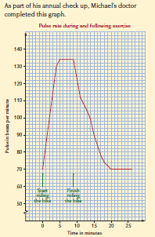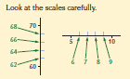
The title of the graph ‘Pulse rate during and following exercise’ tells us what the graph is about. The labels on the horizontal scale, ‘Time in minutes’, and the vertical scale, ‘Pulse in beats per minujte’, tells us how the pulse rate was measured.
Check the scale carefully. On the horizontal scale each interval represents 1 minute. On the vertical scale each interval represents 2 beats.
Exercise Set 1
Q1. Simon was in hospital recovering from having his tonsils removed.
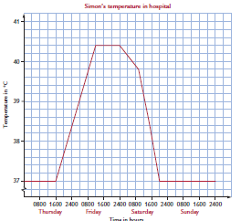
Use the graph to answer these questions.
- What does each unit represent on the
- horizontal axis? (ii) vertical axis?

- What was Simon’s temperature at 0800 hours Friday?

- When did Simon’s temperature first reach 38.3°C?

- How many degrees did Simon’s temperature go up between 1600 hours Thursday and 1200 hours Friday?

- What was Simon’s maximum temperature?

- How long was Simon’s temperature at this maximum level?

- Increase in temperature can indicate an infection. Simon’s doctor prescribed antibiotics.
- When do you think Simon started taking antibiotics? Give a reason for your answer.

- When did his temperature return to normal?

- When was Simon’s temperature falling the fastest?
Q2. Marco is a 4-year-old boy in a Developing country. His mother regularly brings him to the mission health centre to have his progress checked. The sister always measures his circumference. Abnormal head circumferences are an early indication of health problems.

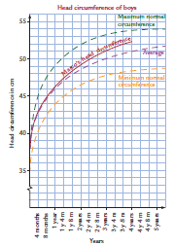
- What is the graph’s title?

- What is measured on the horizontal axis?

- What does one unit represent on the horizontal and vertical axis of the graph?

- How old was Marco when his head circumference was 50 cm?

- How much did his head circumference increase between his second and forth birthday?

- During the following year the sister took these measurements.
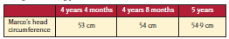

What observations and recommendations do you think the sister will make about Marco’s progress?

Q3. Ian’s normal blood pressure is 140/90 (which reads 140 over 90). Two numbers are always used to record blood pressure. The first number which is known as systolic pressure and is always the bigger number measures the pressure when the heart is pumping. The diastolic pressure, the second number, is the pressure when the heart is relaxed.
On a graph showing blood pressure, the systolic and diastolic pressures are both graphed with an X and joined together.

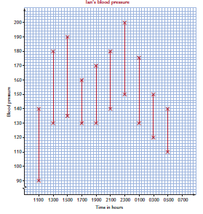
During an operation, the doctor discovers that Ian is allergic to anaesthetic. His allergy causes a dangerous increase in his blood pressure.
- What was Ian’s blood pressure at 1300 hours?

- When was Ian’s blood pressure 170/130?

- How often was Ian’s blood pressure being measured?

- At 1500 hours Ian was given a tablet to reduce his blood pressure. What was his blood pressure reading at 1700 hours?

- What happens to Ian’s blood pressure between 1700 and 2300 hours?

- Ian was given an injection at 2300 hours. What effect does this have?

Q4. When Jenny was 9 weeks pregnant she had a miscarriage and lost a lot of blood. At 13:15 hours when she arrived at hospital by ambulance, the hospital staff began to treat her low blood volume. The nursing staff recorded her blood pressure and pulse on the same graph.
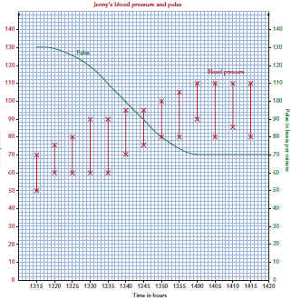
- How often was Jenny’s blood pressure recorded?

- What was Jenny’s blood pressure at 13:15 hours?

- How long did it take from the beginning of treatment at 13:15 hours for Jenny’s pulse to return to her normal 70 beats per minute?

- Jenny’s normal blood pressure is 110/80. When did her blood pressure first return to normal?

- What general observation can you make about the blood pressure and pulse of a person who has lost a lot of blood?

When exploring how common medical conditions are, the information might be represented in a graph. Deciding the type of graph to use to represent information can be a difficult task:

Types of Information | Suitable Graph
Categories which contribute to a whole  Eg the percentage of votes in an election going to different parties. | Pie chart or bar graph
Categories that are not linked to a whole  Eg quantity of paper recycled in different communities. | Column graph or bar graph
Information changes with time  Eg a patients temperature | Line graph (‘time’ on horizontal)
Two variables changing  Peoples shoe size compared with their height. | Line graph and scatter graph

Exercise Set 2

Q1. In the lead up to the Tidy Town’s competition the local high school organises a clean-up day. At the end of the day the items collected are classified and weighed as shown in the table.
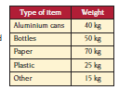
- Sonia draws a column graph to emphasis the quantities of each type of rubbish collected. The graph with the first two columns is shown below. Complete the last three columns.
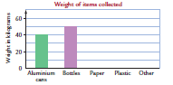
- Joseph chooses to use a divided bar chart to illustrate the rubbish composition. He makes the bar 10 cm long and he calculates that the total mass of the rubbish is 200 kg.
- Complete the calculations in the table.
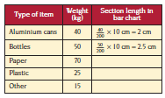

- Complete the divided bar chart below.
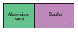

- Jacob presents the rubbish information in a sector graph. Complete the table and graph.

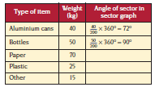
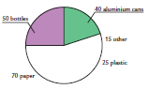
Q3. At an allergy clinic 160 people are tested for their major food allergy.
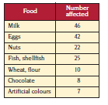
- What fraction of people have wheat or flour as major allergies?

- As part of a report on the incidence of allergies, Dr Hamilton wants to present his information in a sector graph.
- Complete the table to calculate the angle required for each sector.
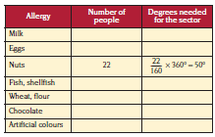

- Dr Hamilton draws a sector graph but she leaves out some of the labels. Complete labelling the graph.
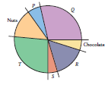

To avoid possible ambiguity or two different answers to the same calculation, mathematicians have a specific order in which calculations are completed. ie 3+ 4 × 5 cannot be allowed to equal both 35 and 23 (23 is the correct answer).
This is the agreed way to complete a calculation.
- Do what is inside the brackets first.
- Then do any multiplication (×) or division (÷). Always start at the left and work to the right.
- Then do any additions (+) and subtractions (-), again working from left to right.
Example: What is the value of 12 ÷ 3 + 4 × 5 ? Do multiplication and division first from left to right, then addition.
12 ÷ 3 = 4 and 4 × 5 = 20 and 4 + 20 = 24.
Example: Simplify 6 × (2 + 3) ÷ 10 Do brackets first, then multiplication and division from left to right.
2 + 3 = 5 and 6 × 5 $÷$10 is 30 ÷ 10 = 3
Exercise Set 3
Q1. Which of these statements is true and which are false?
- 8 + 2 × 3 = 14 d) (42 – 36) × 2 = 12
- 12 – 4 × 3 = 16 e) 24 ÷ 6 × 2 = 2
- 5 × 2² = 100 f) $\frac{10+8}{7-5 }$ = 9
Q2. What is the value of following expressions.
- 3 × (5 +4) d) (18 + 3) ÷ 2 × 3
- 8 × 2 – 3 × 5 e) $\frac{16+9}{5}$
- (12 – 9) × (7 – 2) f) $\frac{5+3 ×10}{5}$

Nurses regularly use formulas in their work. They calculate such things as:
- Quantities to mix to make a solution for cleaning wounds and infections
- The amount of liquid to put in an injection
- The number of tablets or capsules to give a patient.
Example: To solve the following problem, use the formula:
Amount required = $\frac{R}{A } ×$ v
Alan is suffering from severe kidney stone pain. His doctor prescribes 75 mg of pethidine. The ampoules of pethidine contain 100 mg (A) per 2 mL (v). Calculate the number of millilitres needed for the injection.
Amount required = $\frac{R}{A } ×$ v
Substitute the values from the question: R = 75, A = 100, v = 2
Amount required = $\frac{75}{100}$× 2
= 1.5 mL
Exercise Set 4
Q1. Ten-year-old Claudia is suffering from nasal and sinus congestion. She is prescribed 12 mg ® of Demazin syrup three times per day. Demazin syrup contains 3.75 mg (A) in every 5 mL (v).
Amount required = $\frac{R}{A } ×$ v
- How many millilitres must Claudia be given in each dose?

- Mark on this diagram the volume of Demazin Claudia must be given.
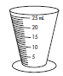
- Claudia has the first dose at 1015 hours. When can she have the next dose?

Q2. To help thin Kim’s blood after a blood clot the doctor prescribes 15000 units ® of Heptin. Each ampoule contains 25000 units (A) in 1 mL (v).
- Using the formula as before calculate the dose Kim requires.

- Mark on the diagram the level of Heprin Kim requires.

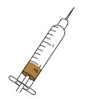

Q3. Fried’s rule can be used to calculate an infant’s dose of an adult’s medicine.

Dosage = $\frac{Age of infant (months ×adult dosage}{150}$

The adult dose of a medicine is 20 mL. Calculate the dosage for these children.

- Cathy, aged 18 months b) Todd, aged 2 years

Q4. A normal kitchen teaspoon holds 5 mL. Mrs Russel gives her son 3 teaspoons of medicine. How much medicine does she give her son?

Q5. The medical researchers, Young and Clark, developed rules for approximating the children’s dose of adult’s medicine.

Young’s rule: Dosage = $\frac{Age of child \left(years\right)×adult dose}{Age of child \left(years\right)+12}$

Clark’s rule: Dosage = $\frac{Weight of child \left(kg\right)×adult dose}{70}$

Emma is 8 years old and she weighs 35 kg. She is short and heavy for her age. The adult dose of the medicine her mother wants to give her is 20mL.
- How much medicine should Emma have according to;
- Young’s rule (ii) Clark’s rule

- The rules recommend Emma receive different amounts. Do you think Emma’s mother should use the formula based on age or weight? Why?

Q5. A boy’s height on his second birthday can be used to predict his adult height.
Predicted adult height (cm) = 1.75 × h + 20 where h = boy’s height on 2nd birthday.
On his second birthday Thomas is 88 cm tall. Predict Thomas’s adult height.

