Polynomials

Definitions
Polynomial: a polynomial, sometimes denoted P($x$), is an expression containing only positive whole number powers of $x$
Degree: the degree of a polynomial in $x$ is the highest power of $x$ in the expression
Coefficient: the number before a variable in an expression or equation (eg 7 in $7x$, and -8 in ${-8x}^{5}$)
Monic Polynomial: a polynomial where the leading coefficient of the polynomial is 1. (explained in detail below)
Constant term: the term without any x’s.... (eg -4 in $7x-4$)
Degree of Polynomial | Name
0
1 | linear
2 | quadratic
3 | cubic
4 | quartic
5 | quintic
6 | sextic or hextic
7 | septic or heptic
8 | octic
9 | nonic
10 | decic
100 | hectic

Example 1
$7x-4$is a polynomial of degree 1, a linear polynomial
$x^{2}+3x-10$is a polynomial of degree 2, a quadratic polynomial
$-2x^{3}-4$is a polynomial of degree 3, a cubic polynomial
$10$ is a polynomial of degree 0, (think of it as being ${10x}^{0}$)

Example 2
The following listed here are NOT polynomials
$$\frac{1}{x} x^{-2} \sqrt{x} 2^{x} \sin{x }$$

Polynomials or not: http://youtu.be/Lc9O-1joI24

Classifications
Polynomials can also be classified by number of non-zero terms..(how many terms there are).
Number of non-zero terms | Name | Example
0 | zero polynomial | 0
1 | monomial | $$x^{2}$$
2 | binomial | $$x^{2}+1$$
3 | trinomial | $$x^{2}+x+1$$
If a polynomial has only one variable, then the terms are usually written either from highest degree to lowest degree ("descending powers") or from lowest degree to highest degree ("ascending powers"). A polynomial in $x$ of degree n then takes the general form
$${{c_{n}x}^{n}+{c_{n-1}x}^{n-1}+…+{c_{2}x}^{2}+c_{1}x+c}_{0}$$
where
c_{n} ≠ 0, c_{n-1}, ..., c₂, c₁ and c₀ are constants, the coefficients of this polynomial.
Here the term c_{n}x^{n} is called the leading term and its coefficient c_{n} the leading coefficient; if the leading coefficient is 1, the polynomial is called monic.

11 Methods Book Ex 2A (all)

Adding and Subtracting Polynomials
Polynomials can be added and subtracted, the same algebraic rules apply regarding collecting like terms etc...

Example 3: Adding Polynomials
If Polynomial P= 5x + 7y and Q=2x-y find P+Q
$$\left(5x+7y\right)+\left(2x-1y\right)$$
$=5x+7y+2x-1y$ clear the parenthesis
$=5x+2x+7y-1y$ combine like terms
$=7x+6y$ add like terms

Example 4: Adding Polynomials
$$\text{If} P\left(x\right)=\left(x^{2}- 3x+6\right) \text{and} Q\left(x\right)= x-3x^{2}+x^{3} \text{find} P\left(x\right)+ Q(x)$$
$$(x^{2}-3x+6)+\left(x-3x^{2}+x^{3}\right)$$
$=x^{2}-3x+6+x-3x^{2}+x^{3}$ clear the parenthesis
$=x^{3}+x^{2}-3x^{2}-3x+x+6$ combine like terms
$=x^{3}-2x^{2}-2x+6$ add like terms

Example 5: Subtracting Polynomials
$$\text{If} R\left(x\right)=4x^{2}-4- 3x \text{and} Q\left(x\right)= x^{2}+4x-4 \text{find} R\left(x\right)- Q\left(x\right)$$
$$R\left(x\right)- Q\left(x\right)$$
$=\left(4x^{2}-4-3x\right)-\left(x^{2}+4x-4\right)$ write in as bracketed groups first
$=4x^{2}-4-3x-x^{2}-4x+4$ expand out the brackets (clear the parenthesis)
$=3x^{2}-7x$ collect like terms

Adding and Subtracting polynomials: http://youtu.be/KobevTfvXyg, http://youtu.be/AQfJPkrdWWg,

Exercise 1.1
- If $P\left(x\right)= 3x^{2}-7$, $Q\left(x\right)= 4x-7$, $R\left(x\right)= 2x^{2}+4x+7$ then find expressions in simplest form for:
  - $P\left(x\right)+Q\left(x\right)$
  - $P\left(x\right)-Q\left(x\right)$
  - $P\left(x\right)+R\left(x\right)$
  - $P\left(x\right)-R\left(x\right)$
  - $P\left(x\right)+Q\left(x\right)+R(x)$
  - $2P\left(x\right)-Q\left(x\right)$
  - $2R\left(x\right)+2Q\left(x\right)$
  - $P\left(x\right)×Q\left(x\right)$
- If $T\left(x\right)= 2x^{3}-2x^{2}+3x-8$ then determine the following:
  - T(0)
  - T(2)
  - T(y)
  - T(-2)
  - T(-1)
  - T(-x)
  - T(-3h)

Roots or Zeros of Polynomials
A root of a polynomial (also called the zero of the polynomial) is a solution of polynomial. If$a$ is a root, then $P\left(a\right)=0$. The fundamental theorem of algebra states that for any polynomial of degree$n$, that it has $n$ roots, (they may not be distinct or even real).

Factor Theorem
(Other explanations of factor theorem can be found here: Purple Math, Wikipedia, Wolfram Math World)
Factor Theorem helps us to factorise polynomials. Using an understanding of roots then we can find known factors.
If a polynomial $P(x)$has a root $=a$ , i.e., if $P\left(a\right)=0$ , then $x-a$ is a factor of $P(x)$.

Polynomial Division
(Other explanations of polynomial division can be found here: Purple Math, Wikipedia, Wolfram Math World)
Just like in real numbers, if you know one factor of a number, you can then use division to find the other... eg For our number 24, it may be known that 6 is a factor, to find the other we calculate 24÷6 = 4, and we have now found that 4 is a factor also. We can apply this practice to polynomials. If we have found one factor, $(x-a)$ for example, then you divide this into the polynomial$P\left(x\right)$, find another.
We will predominantly use polynomial division to factorise cubics. But it can be used to factorise any size polynomial.
11 Methods Book Ex 3B and 3E
Complete a selection of questions until you are getting the hang of it, both by hand and using CAS.

Polynomial division: http://youtu.be/l6_ghhd7kwQ

Factorising Quadratics and Cubics and Higher Order

Factorising Quadratics
Use any of the techniques we studies in Semester 1. (complete the square, by inspection, cross method, PSN method, difference of 2 squares etc..)

Factorising Cubics
General form for a cubic polynomial is:
$$ax^{3}+bx^{2}+cx+d$$
To be able to take advantage of an easy way to factorise some cubics, you need to be familiar with how the sum and difference of 2 cubes can look, here are some examples.
If you can recognise the forms then you can jump straight to these factorisations;

Sum of 2 Cubes:
$$a^{3}+ b^{3}=\left(a+b\right)(a^{2}-ab+b^{2})$$

Difference of 2 Cubes:
$$a^{3}- b^{3}=\left(a-b\right)(a^{2}+ab+b^{2})$$

Solving polynomial equations
Once we have a polynomial in fully factorised form, we can solve it or graph it easily.
To solve a polynomial that is in fully factorised form we apply the null factor law.
Here is an example:
Solve and Graph $P\left(x\right)=x^{3}-7x+6$
Step 1. Factorise P(x)
$$P\left(x\right)=x^{3}-7x+6 \\ =\left(x-1\right)\left(x^{2}+x-6\right) \\ =\left(x-1\right)\left(x+3\right)(x-2)$$
Step 2. Set to 0 and Use null factor law
$0=\left(x-1\right)\left(x-2\right)(x+3)$
so either
$$x-1=0$$  $$x=1$$ | OR | $$x-2=0$$  $$x=2$$ | OR | $$x+3=0$$  $$x=-3$$
So the solutions are
$$x=1, 2 or-3$$

To graph $P\left(x\right)=x^{3}-7x+6$, we use fully factorised form and then we identify
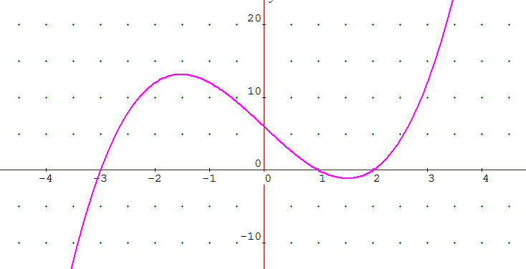
- roots
- y-intercept
- extrema behaviours (general shape)
$$P(x)=\left(x-1\right)\left(x+3\right)(x-2)$$
so roots are 1, 2 and -3
y-intercept is at x=0, which is at -1x3x-2 which is 6

11 Methods Book Ex 3G
Solving Polynomials
Do at least 3 from each of questions 1-5

11 Methods Book Ex 3I
Sketching Quartics
Q1, Q2
SM2 - Q10

11 Methods Book Ex 3H
Sketching Cubics
Do at least 3 from each of Q1-4, then Q5, Q7
SM2 - Q10

Sketching

Definitions
Sketch Vs Graph – the main difference between a sketch and a graph is the level of detail and accuracy. A graph is typically drawn with a ruler, to a scale. It has an accurate representation of slope, intercepts, and behaviour. A sketch is drawn quickly and only gives an impression or rough idea of the shape of the curve, indicating only a selected few points that demonstrate a placement of the curve on the coordinate plane.

Key Words you should understand
- Dilation: the dilation is a reflection of how steep a graph is
- Reflection: a description of the graph being reflected along an axis or line
- Translation (vertical and horizontal): a movement of the graph in a horizontal or vertical direction

Families of Functions
Through investigations and classwork you will have now developed the skills and tools necessary to identify the main attributes of the following families of functions.
A summary of these is listed on the next page.

End Behavior: http://youtu.be/PSGL95nQBy8

Finding equations from a graph: http://youtu.be/HdXjyHnNwKI
 | Quadratic | cubic | quartic | Quantic | hexic or sextic | heptic or septic
degree | 2 | 3 | 4 | 5 | 6 | 7
odd family or even family | Even | odd | even | Odd | even | odd
possible terms it could have | $x^{2}$, x, C (constant term) | $x^{3}$, $x^{2}$, x, C | $x^{4}$,$x^{3}$, $x^{2}$, x, C | $x^{5}, x^{4}$,$x^{3}$, $x^{2}$, x, C | $x^{6}, x^{5}, x^{4}$,$x^{3}$, $x^{2}$, x, C | $x^{7}, x^{6}, x^{5}, x^{4}$,$x^{3}$, $x^{2}$, x, C
positive basic form and curve sketch | 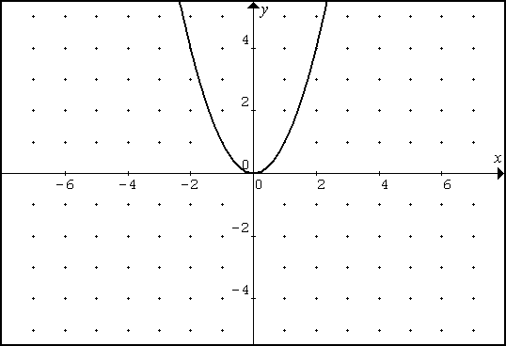 | 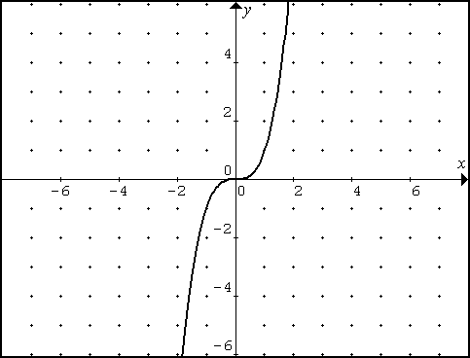 | 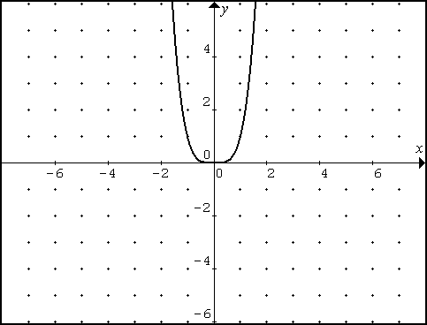 | 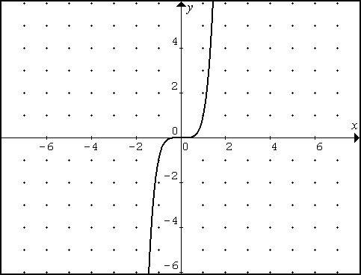 | 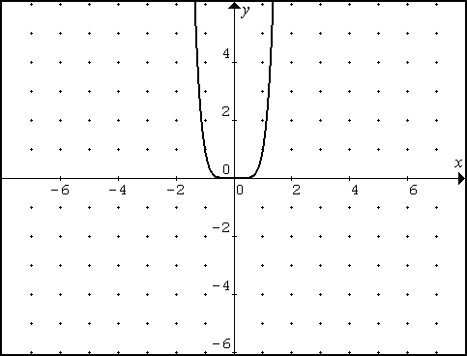 | 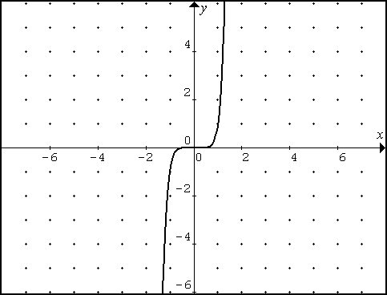
negative basic form and curve sketch | 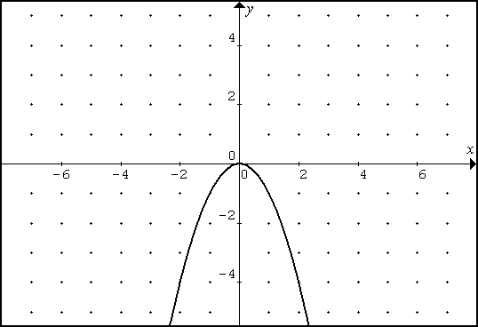 | 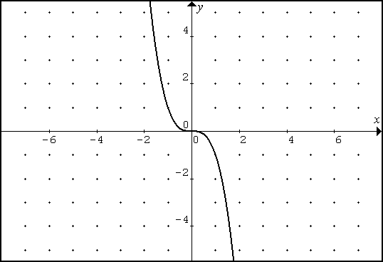 | 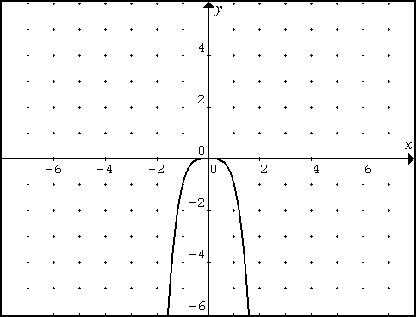 | 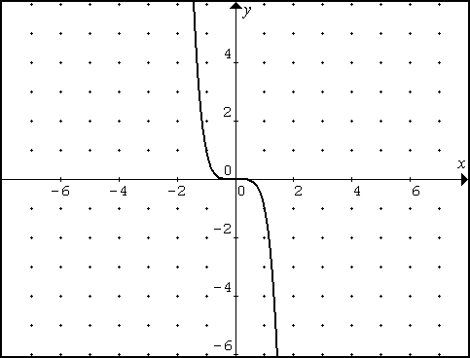 | 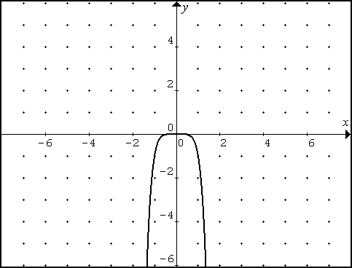 | 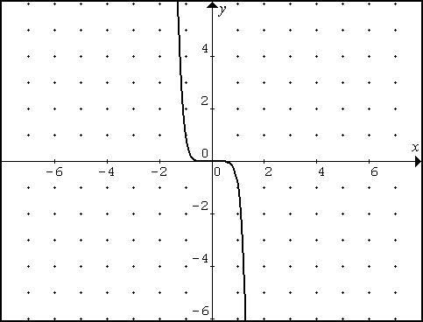
variations in curve shape | No variations in shape | 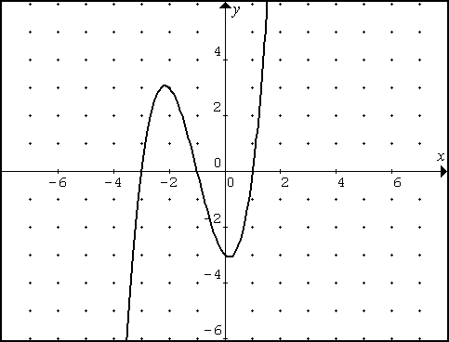  and its reflection | 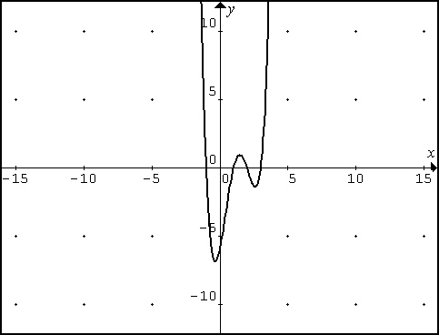  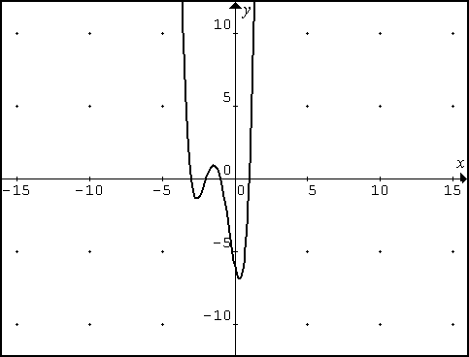  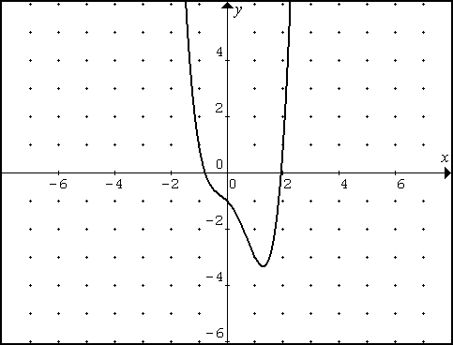 etc | 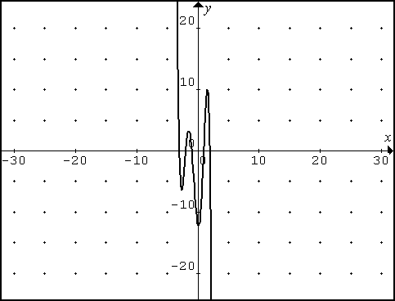  etc... | 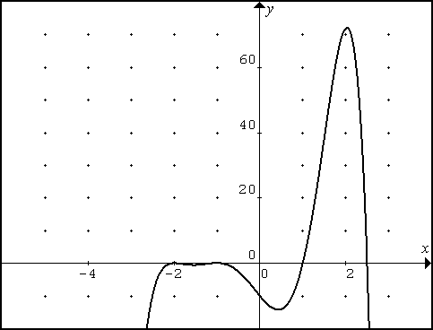  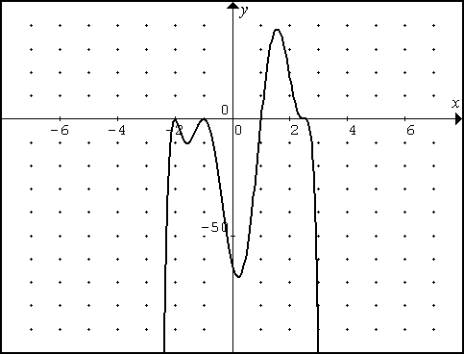 etc

Other Points to Note

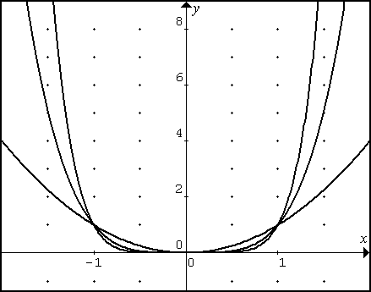
Shows the behaviour of $x^{6}, x^{4}, x^{2}$ as a family of even powered functions that get flatter and steeper as the degree increases.

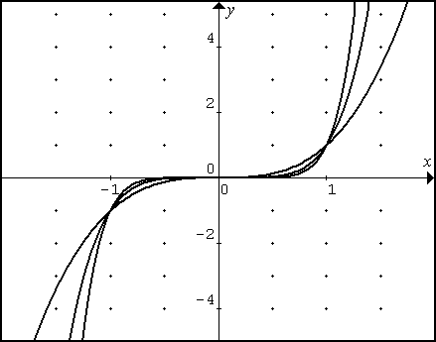
Shows the behaviour of $x^{7}, x^{5}, x^{3}$ as a family of odd powered functions that get flatter and steeper as the degree increases.

Other names of polynomials
Degree eight: octic
Degree nine: nonic
Degree ten: decic
Degree hundred: hectic

Interesting fact:
Quadratic was named as it came from $x^{2}$which was derived from the area of a square, which has four sides – an obscure link to 4 – (quad) but there none-the-less.

Identification of Roots
In fully factorised form, the roots of any polynomial can be easily identified.
The roots of a polynomial, (also called the zeros of a polynomial) are found by setting the polynomial equal to 0, then finding the solutions to the polynomial.
There are the n roots in an nth degree polynomial, (they may not all be real, or distinct).
Eg:
$$f(x)=\left(x-a\right)(x-b)$$
Has roots at $x=a$ and$x=b$. This is because is we set $f(x)=0$ then the only way this can happen is if $\left(x-a\right)=0$ or$(x-b)=0$, ie at $x=a and b$.
We also know that when we set $f(x)=0$, that this is the same process we use to find the x-intercepts. i.e. the roots are also the x-intercepts.
Knowing the x-intercepts, and the shape of a function will help with being able to sketch it.
The behaviour of a function at the roots, is similar to the behaviour of the family of functions it belongs to.
For example:
$$f(x)=\left(x-1\right){\left(x+2\right)}^{3}{\left(x-4\right)}^{2}$$
This is a degree 6 function, positive so has extrema values described by left up and right up.
It has a linear root at the position where $\left(x-1\right)=0$. This means that the function passes through the x-intercept 1.
A quadratic root at the position where $\left(x-4\right)=0$, indicated by this portion of the function ${\left(x-4\right)}^{2}$. This means that the function has a quadratic turn at the x-intercept 4.
And a cubic root at the position where $\left(x+2\right)=0$, indicated by this portion of the function: ${\left(x+2\right)}^{3}$. This means that the function has a cubic ‘kick’, at the x-intercept of -2.
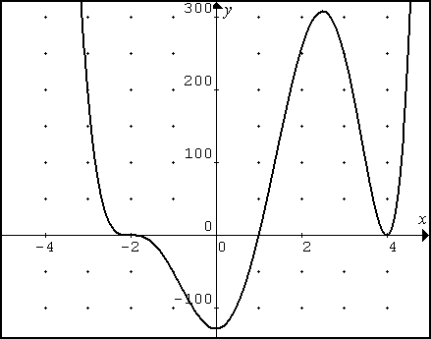
Putting this all together would yield a graph, or sketch if you hand drew it similar to this
It is important to recognise what we DO NOT KNOW when sketching – which is the height/depth of the peaks/troughs in the function. But for a quick sketch, the general shape is enough.

When sketching and identifying root behaviour the following table may be useful:
Degree of root | Name of root | Description of behaviour
1 | Linear | Straight through
2 | Quadratic | Bounce
3 | Cubic | Cubic Kick

Exercise 1.2
Sketch these higher order functions
- $M\left(p\right)=\left(p+1\right){\left(p-2\right)}^{2}$
- $n\left(k\right)=-k{\left(k+1\right)}^{2}$
- $b\left(g\right)=g^{2}\left(g+1\right)\left(g-2\right)$
- $j\left(f\right)=-{\left(f-1\right)}^{2}{\left(f+3\right)}^{2}$
- $y\left(x\right)=\left(x+1\right){\left(x-1\right)}^{3}{\left(x+3\right)}^{2}(x-9)$
- $y\left(x\right)=-x^{3}\left(x+1\right){\left(x-10\right)}^{2}$

Exercise 1.3
- CAS question. The polynomial function $S=-241t^{7}+1062t^{6}-1871t^{5}+1647t^{4}-737t^{3}+144t^{2}-2.432t$ models the speed (S) in m/s of a swimmer doing the breast stroke during one complete stroke, where t is the number of seconds since the start of the stroke. Graph this function. At what time is the swimmer going the fastest?
- The average amount of oranges (in pounds) eaten per person each year in the United States from 1991 to 1996 can be modelled by $f\left(x\right)=0.298x^{3}-2.73x^{2}+7.05x+8.45$ where x is the number of years since 1991. Graph the function and identify any turning points on the interval $0≤x≤5$. What real-life meaning do these points have?
- The producer price index of butter from 1991 to 1997 can be modelled by
$P=-0.233x^{4}+ 2.64x^{3}-6.59x^{2}-3.93x+69.1$ where x is the number of years since 1991. Graph the function and identify any turning points on the interval $0≤x≤6$.What real life meaning do these points have?
- Sketch the graph of polynomial function that has three turning points. Label each turning point as local maximum or local minimum. What must be true about the degree of the polynomial function that has such a graph? Explain your reasoning.

