2017 SMM1 Week 10 Investigation
Read the following example:

Determine algebraically whether f(x) = –3x² + 4 is even, odd, or neither.
If I graph this, I will see that this is "symmetric about the y-axis"; in other words, whatever the graph is doing on one side of the y-axis is mirrored on the other side:  This mirroring about the axis is a hallmark of even functions.  Note also that all the exponents are even (the exponent on the constant term being zero: 4x⁰ = 4 ×1 = 4).  But the question asks me to make the determination algebraically, which means that I need to do it with algebra, not with graphs. |  | 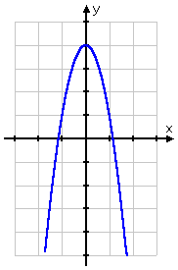
So I'll plug –x in for x, and simplify:
f(–x) = –3(–x)² + 4
= –3(x²) + 4
= –3x² + 4
My final expression is the same thing I'd started with, which means that f(x) is even.

Your task is to:
1. Find definitions for the following words: odd functions and even functions
http://www.mathsisfun.com/algebra/functions-odd-even.html

2. Using the method in the example above determine algebraically whether f(x) = 2x³ – 10x is even, odd, or neither.
Include a sketch of the graph in your answer.

