

**EM3**

Measurement, plans, graphs and data collection

Goals

Learning Brief

**Week**

**Term**

**2017**

11/12

2

Unit goals

* Understand the concepts and techniques used in measurement, scales, plans and models, graphs and data collection
* Interpret mathematical and statistical information and ascertain the reasonableness of the solutions

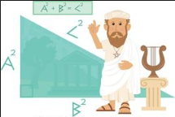

Theoretical Components

Practical Components

There are three Exercise Sets in this week’s booklet.

There are no Mathspace lessons this week.

**Resources**:

*PDF file*: Week 11/12 Notes and Exercises

This is a good link for finding the short side in a right-angled triangle.

<https://www.youtube.com/watch?v=izOnU4dCy_0>

**Knowledge Checklist**

* Finding the length of the hypotenuse
* Finding the length of a shorter side
* Applications of Pythagoras’ theorem
* Investigating the tangent ratio

**Order**

1. Work through the Week 11/12 notes and exercises
2. Do the investigation
3. Show me the completed booklet and investigation.

Investigation

Attached to the booklet and on HawkerMaths