2017 EM3 Week 11/12 Investigation
This investigation involves using Pythagoras’ Theorem in 3-dimensions.
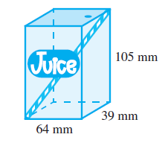
You are required to show that the length of the longest straw that can fit into the pack is approximately 129 mm.
Step 1
Find the length of the diagonal on the base of the fruit-juice pack. We assume that the angle between the 64 mm and 39 mm sides is 90˚.

Step 2
Use this length to form a right-angled triangle from the diagonal, the 105 mm side and the straw. Use Pythagoras’ Theorem to find the length of the straw.

