

Learning Brief

**SM4 Probability and Statistics**

**Week**

**Term**

**2014**

11

4

By the end of this week, you should be able to:

* understand probability distributions for discrete random variables
* compute the central tendency and variability of discrete distributions (i.e. find the mean and variance of a discrete probability distribution)
* compute the 95% confidence interval for a random variable, given the mean and the variance

Goals

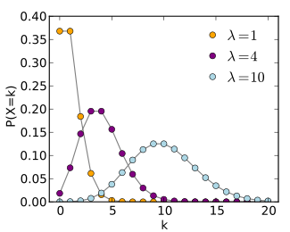

Practical Components

Theoretical Components

You will require the *PDF* file Chap 10 (on Google Classroom))

Do the following questions.

Ex 10B: 1, 3, 5,7 ,8, 13

Ex 10C: 1, 3, 7, 10, 12, 16, 18, 19

Ex 10D: 1, 3, 5, 7, 12, 13, 14, 15, 20

From Chapter 4 of Reasoning and Data:

Use the methods from Chap 10

Ex. 4C: Questions 4-7.

From the *PDF* file Chap 10:

• Read through Section 10B, 10C & 10D on Discrete Prob Distributions. Study and make notes on

Examples 12-32.

You will require Chapter 4 Reasoning and Data:

• This shows another method of finding variance.

Expected Value:

<http://www.knowmia.com/watch/lesson/2925>

Nice set of notes and useful examples:

<http://www.intmath.com/counting-probability/11-probability-distributions-concepts.php>

Investigation

On HawkerMaths.

None this week

QFO

Quiz/Forum/Other