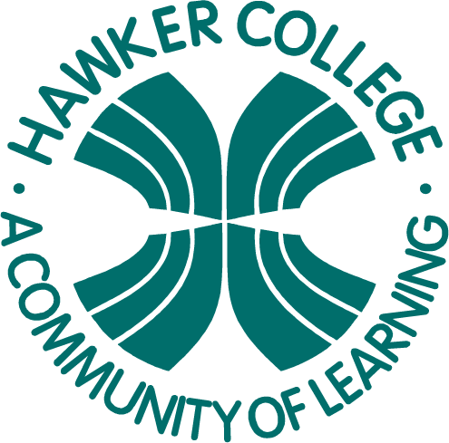

# GM4 Travel, Property and Applicable Mathematics

Learning Brief

**Week**

**Term**

**2016**

15

4

To finish this unit all the work covered this week involves basic skills and logic.

Goals

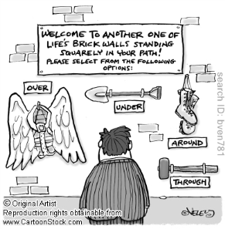

Practical Components

Theoretical Components

None this week.

Complete the exercises booklet. You can collect it from Aaron.

Investigation

Collect from Aaron

None

QFO

Quiz/Forum/Other