

By the end of this week, you should be able to:

* understand probability distributions for discrete random variables
* compute the central tendency and variability of discrete distributions (i.e. find the mean and variance of a discrete probability distribution)
* compute the 95% confidence interval for a random variable, given the mean and the variance

Learning Brief

SM4

Probability and Statistics

**Week**

**Term**

**2013**

11

4

Goals

Theoretical Components

Practical Components

You will require Chapter 10 of Quest Mathematical Methods 12 (Jacplus e-text):

•Read through Section 10B, 10C & 10D on Discrete Prob Distributions. Study and make notes on Examples 12-32.

You will require Chapter 4 Reasoning and Data (Fitzpatrick et. al.):

•Examples 12 – 13: pages 127-132.

(Do not go through 4.4, focus on 4.3)

Expected Value:

<http://www.knowmia.com/watch/lesson/2925>

Nice set of notes and useful examples:

http://www.intmath.com/counting-probability/11-probability-distributions-concepts.php

You will require Chapter 10 of Quest Mathematical Methods 12 (Jacplus e-text):

Do the following questions. Organise your solution neatly in your exercise book:

EX 10B: 1,3,7,8,13

EX 10C: 1,3,10,12,18

EX 10D: 3,5,6, 7,13, 14,15,20

You will require Chapter 4 of Reasoning and Data (Fitzpatrick et. al.):

Ex. 4C: Questions 4-8.

Investigation

See the next page.

There are two parts to this week’s investigation.

This will count as a **double investigation** for this week. Next week there will be a quiz.

There was a Week 10 forum – you had the choice of two topics:

* Comparison of scores
* Pascal’s Triangle

Make one post for one of the topics. Be sure to read responses for both.

Remember to access the cLc for message.

QFO

Quiz/Forum/Other

INVESTIGATION

**PART A:**

A door-to-door telecommunications representative has recorded her day-by-day sales figures over a period of time. She knows that her probability of selling *X* packages on any one day follows the probability distribution shown in the table.



i. Find the value of *t*.

ii. Find the probability that she sells at least 2 packages on any one day.

iii. Find the probability that she sells at most 4 packages on any one day.

iv. Find the number of packages she can expect to sell each day.

v. Calculate the Var(*X*) and standard deviation of *X*, correct to 4 decimal places.

vi. Find (𝜇 − 2𝜎 ≤ 𝑋 ≤ 𝜇 + 2𝜎).

vii. If the representative receives a commission of $25 per package sold and a bonus of $200 if she sells 4 or more packages in one day, fi nd her expected daily earnings from commissions and bonuses.

viii. Given that the representative will sell at least two packages tomorrow, fi nd the probability that she will get her $200 bonus.

**PART B:**

A company manufactures and sells product Xbar. The sales price of the product will be $6 per unit, and estimates of sales demand and variable costs of sales are as follows:

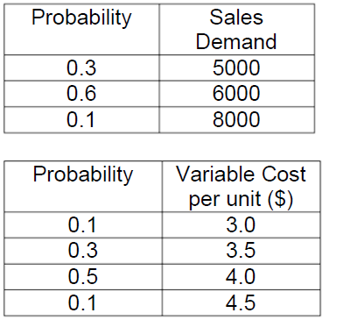

The unit variable costs are not conditional on the volume of sales demand, and the fixed costs are estimated to be $10000.

What is the expected profit?

Show your working for all questions.