General Mathematics

Week 1
Why maths? What's the point?
The purpose of this course is hopefully to give you some background skills so you can go off into the world after college and succeed at something that you really want to do! (and we think some maths can really help you with that!)

PART 1
Watch this movie http://www.youtube.com/watch?v=khOaAHK7efc

What would you do if money were no object??

PART 2
In order for me to get to know the future prospects and career interests of you, you now need to go and do this survey. I want to be able to find examples and contexts that relate to the interests of our group, so try and be honest and realistic.
Go HERE to do the survey. (http://bit.ly/Xep0yO)

The practical component of this week is about identifying mathematics in various situations.

Part 3
For this video and the next 2 images you are to come up with a question. A question that could be asked in a mathematics classroom. You do not need to solve the question.
http://www.youtube.com/watch?v=gDkd0Vaxf-c

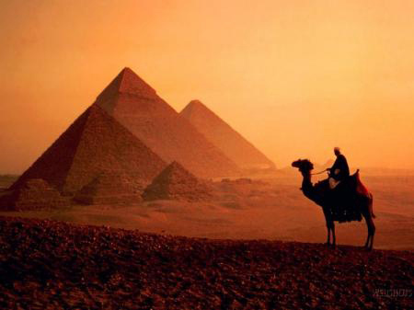
Image obtained from http://www.portpromotions.com/media/ecom/prodlg/1272055963_giza-pyramids-at-dusk.jpg

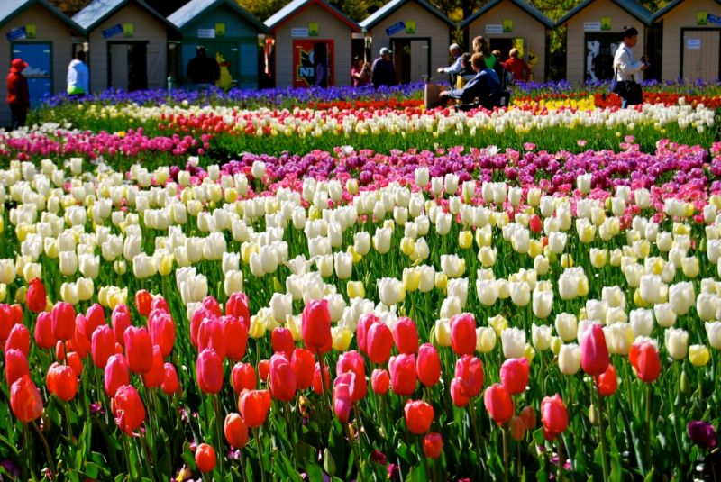
http://www.nothinglikeaustralia.com.au/uploaded_files/local/br/entry_uploads/large/1272838517_19965.jpg

PART 4
Find your own image from this website and create a question that is related to mathematics.
Paste a copy of the picture you use in your book, and write you question under it.
http://mathematicalimages.weebly.com/index.html

