2015 SM1 Week 1 Investigation

PART A: Prime factorisation

Use the section ‘Divisibility – HCL and LCM’ on P30 in Cambridge to answer the following – showing working

What is the prime factorisation of 84?
What is the prime factorisation of 72?
What are the GFC and the LCM of 84 and 72?

The following website may also be of help.

http://www.mathplayground.com/factortrees.html

PART B: Proof that $√2$ is irrational

How do we know that square root of 2 is an irrational number? In other words, how do we know that √2 wouldn't have a pattern in the decimal sequence? Maybe the pattern is very well hidden and is really long, billions of digits? Even if you check it till million first digits, maybe the pattern is just longer than you were able to print the digits out with your computer?
Here is where mathematical proof comes in. It does not rely on computers at all, but instead it is a "proof by contradiction"—if √2 WERE a rational number, then we'd get a contradiction.

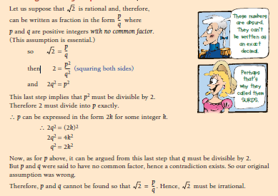

Use the above method to prove that $√5$ is an irrational number. It is important to be aware that there are other ways to prove that √2 (and √5) are irrational. You may like research and present an alternative proof.

