General Mathematics 2

Week 1 NOTES – Term 3

A rough, free-hand drawing that shows approximately where places are is called a mud map.

Example

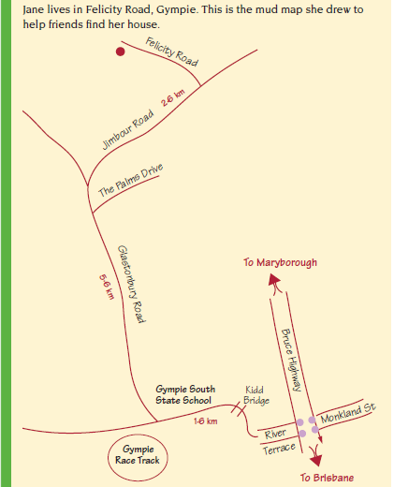

Jane wrote these instructions.
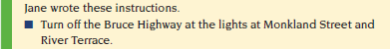
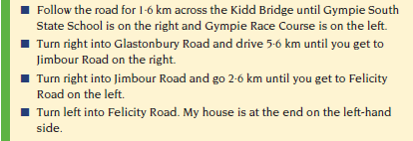

Previously we looked at basic compass directions. Now we will use a magnetic compass to give more accurate directions.
Reading a Compass.
Modern compasses have numbers from 0° to 360° around the outside. These numbers are used to specify direction. North is zero degrees and the degrees go around the compass in a clockwise direction.
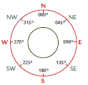
This diagram shows some directions and their bearings.
To avoid any confusion or misunderstanding three digits are always used for direction. Although the direction east is at 90°, in navigation it is referred to as 090°.
Example
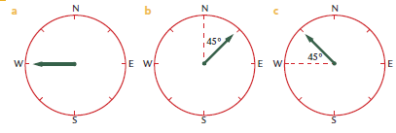
Compasses don’t point to the North Pole. They point to magnetic north. True directions and compass bearings are different. In most places on the east coast of Australia, magnetic north is between 10° and 13° east of True north.
Commercially available compasses
There is a wide range of commercially available compasses and they have several features in common: a needle point that points to north and an indication of other directions.
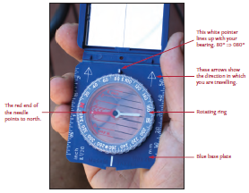

Measuring a direction
Follow these simple steps to find the direction in which you are travelling.
Step 1: Hold the compass in front of you with the arrow on the base plate pointing to the direction in which you are travelling. You must have the arrows pointing straight in front of you. If you don’t, the direction will be wrong.
Step2: Move the rotating ring until the red arrow on the base plate is directly under the red end of the needle.
Step3: Look at the white pointer at the top of the compass. This will be lined up with the bearing of the direction in which you are travelling. In the photo above, the person holding the compass is walking on a bearing of 080°.
Exercise Set 1
Q1. Write the directions shown in these diagrams in two different ways.
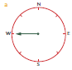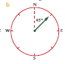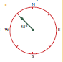
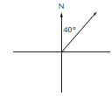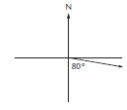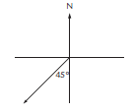

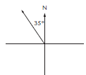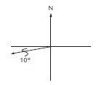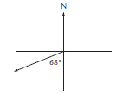

Q2. Write these directions as three-figure bearings.
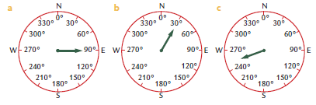

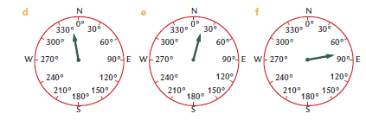

Q3. Use a compass to measure the bearing of
- Hawker College to Belconnen High.

- Hawker College to the ‘twin peaks’ (you can see these from outside the Canteen).

- What is the heading of the staff car park?

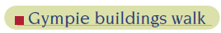
Mardi works in a Gympie tourist agency. She is designing a historical buildings walking tour of the area for visitors to Gympie.
Gympie Historical Walk
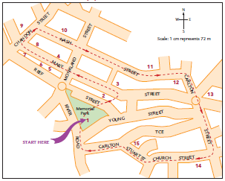
Key
- Bandstand in Memorial Park 2. The Memorial Gates 3. Mosaic amphitheatre
4. Old Bank of Queensland building, 1892 5. Victoria House, 1892
6. Numbers 216 and 218 in Mary St show typical ornate 1880’s buildings
7. Gympie Stock Exchange building, 1888 8. Smithfield Chambers Building, 1895
9. Old Gympie Post Office 10. Historic School of Arts building (now the town library)
11. The Lutheran Church 12. Restored Terrace buildings
13. Gympie Town Hall 14. St Patrick’s Catholic Church
15. Example of classic Queensland home architecture.

Exercise Set 2

Q1. On the map a distance of 1 cm represents 60 metres. Explain how you can calculate that the length of the historical walking tour is approximately 2.7 kilometres.

Q2. Mardi thinks that typical tourists on this tour will walk at an average speed of 2 km/h and that they will stop at each building for 5 minutes.
- Use the formula $Time= \frac{distance}{speed}$ to calculate the approximate time typical tourists will take to walk the tour if they don’t stop to look at any buildings.

- Establish the total time typical tourists will spend looking at buildings.

- Approximately how long do you think Mardi should tell tourists to allow for this walking tour?

Q3. Mardi has some photographs of buildings on the walk. On the map she would like to show the places where she took the photos. On the attached map of the Gympie Historical Walk show the places where the photos were taken on the walk.
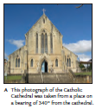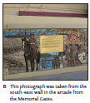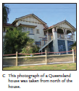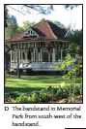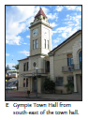
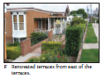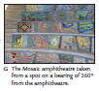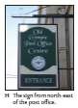
Q4. Mardi thinks that some tourists might like a shorter walking tour. Use the attached copy of the Gympie Historical Walk to show a shorter tour on the map. Include details of the length of the walk and the approximate time people should allow to complete the walk.

