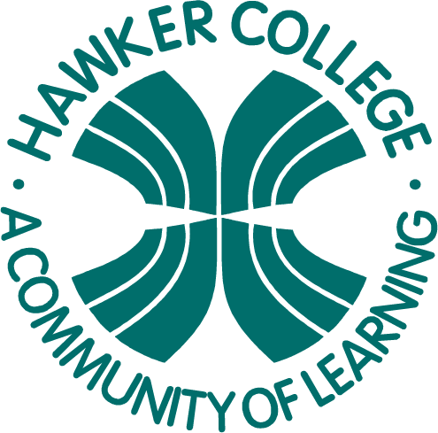

Goals

Learning Brief

GM2

Travel, Statistics and Trigonometry

**Week**

**Term**

**2014**

1

03

Specific Unit Goals:

* read and interpret maps and scale drawings

In this Brief we are looking at:

* Different types of maps including “Mud Maps”
* Compass direction
* Compass reading

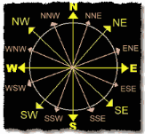

Practical Components

Theoretical Components

Do all the questions from the Booklet *Week 1 Notes and Exercises*

**Resources**

Booklet *Week 1 Notes and Exercises*

A mud map is a sketch or drawing of where places are. You should put in places of interest and approximate distances. – you have been given an example in the notes.

The clip below is a good overview of how to read a compass.

<http://www.youtube.com/watch?v=cUbPQQxSFWM>

You will need to go outside (with a compass) to do the practical activity.

Investigation

There are two parts to the investigation – both involve mud maps. The investigation is on HawkerMaths or collect a copy from Steve.

QFO

Quiz/Forum/Other

None this week.