

**Week 3**

**S2 2013**

GM2

Travel, Statistics and Trigonometry

Learning Brief

Unit Goals:

Read and Interpret Maps and Scale drawings

Plan Budget and Organise an Australian Driving Holiday

Goals

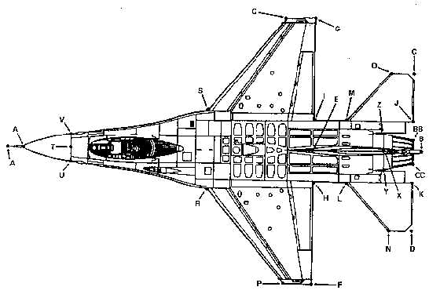

Practical Components

You may need to borrow a ruler and a protractor to do the exercises (this time). Remember that these will not be available for the test…

**Do WS 8.5 Question 1 p233**

**8.6 Question 1 p235**

**Do WS 8.7 Question 1 P237**

**8.8 Question 1, 2 p240**

Theoretical Components

**Scale Drawings:** These are used when the full sized item will not fit directly on your drawing paper. A scale is chosen to resize the drawing to fit on the page.

READ Example 4 on p233 and make notes in your workbook.

READ Example 5 on p234 and make notes in your workbook.

You should look at this link:

<http://www.youtube.com/watch?v=Cv7_CVD6_Yk>

Now DO WS 8.5 and 8.6 in the practical section 

**Accommodation**: In this section we will need to use the website:

[www.flightcentre.com.au](http://www.flightcentre.com.au) for our research. Remember to check the small-print as this can make a big difference to any decisions made about bookings.



Look for Investigation Worksheet 8.6 in the cLc.

Complete this - **making sure that you show working out.**

You need to show Aaron the completed worksheet and then keep it with the other investigations in your folder.

Quiz

No quiz this week

Forum

If you had the choice of destination for a two week Australian driving holiday and $1500 to spend – describe where you would go and how you would check that you kept inside your budget for the holiday.